Zaktravel Supplier Panel

CONTENT:

1. **SUPPLIER MANAGEMENT**
   * **1.1.Before adding to the supplier**
   * **1.2. Add supplier step by step**
   * **1.3. After adding the supplier**
   * **1.4. Inactive**
   * **1.5. Active**

**2. CAR**

* **2.1. Add Transfer Type**
* **2.2. Before Adding transfer**
* **2.3. Steps to add the transfer type**
* **2.4. After adding the transfer type**
* **2.5. Add Transfer**
* **2.6. After adding the transfer**
* **2.7. B2B Login:**
* **2.8. Car displayed on Front End**
* **2.9. Active and Inactive for car**
* **Markup for Car**
* **3.1. Before adding the Markup for car**
* **3.2. Add markup step by step**
* **3.3. There are two types of markup value**
* **3.4. Front End without adding markup (B2B):**
* **3.5. Markup list in admin panel for B2B**
* **3.6. Front end with Markup (B2B)**
* **3.7. Activation and Inactivation for markup**

**4. CAR BOOKING:**

* **4.1. Voucher page**
* **5. (B2C) Login**
* **5.1. Car displayed on Front End**
* **5.2. Markup**
* **5.3. Before adding the Markup**
* **5.4. Front End without adding markup (B2C)**
* **5.5. Add markup step by step**
* **5.6. List of markup in admin panel for B2C**
* **5.7. Front end with Markup (B2C)**
* **5.8. Car Booking (B2C)**
* **5.9. Voucher page for (B2C)**

**6. HOTEL:**

* **6.1. Hotel list and room allocation (add hotel)**
* **6.2. Before adding of hotel**
* **6.3. Steps to add hotel**
* **6.3. Steps to add hotel**
* **6.4.1. Before adding hotel type in supplier panel**
* **6.4.2. Steps to add the hotel type**
* **6.4.3. After adding of hotel type**
* **6.4.4. Steps to add hotel**
* **6.4.5. After adding the hotel in supplier panel**
* **6.4.5. After adding the hotel in supplier panel**
* **6.4.7. After adding room type in supplier panel**
* **7. View room detail (Add room)**
* **7.1. Add new room**
* **7.2. Steps to add the room information**
* **7.3. Steps to add Room Management**
* **7.4. After adding the room management**
* **7.5. Hotel detail**
* **7.5.1. Hotel basic information**
* **7.5.2. Add contact information**
* **8. Add room rate**
* **9. Cancellation Policy**
* **10. Hotel displayed on front end**
* **10.1. Activation and Inactivation for Hotel**
* **11. MARKUP for Hotel (B2B, B2C)**
* **11.1. Before adding the Markup for Hotel Admin panel (B2B)**
* **11.2. Front End without adding markup (B2B)**
* **11.3. Steps to add markup for hotel (Admin panel)**
* **11.4. Markup list admin panel for B2B**
* **11.5**. **Front end with Markup (B2B)**
* **11.6. Activation and Inactivation for markup**
* **11.7. Booking for Hotel (B2B)**
* **11.8. Voucher page for Hotel (B2B)**
* **12. (B2C) Markup:   
  12.1. Before adding the Markup for Hotel Admin panel (B2C)**
* **12.2. Front End without adding markup (B2C)**
* **12.3. Steps to add markup for hotel (Admin panel B2C)**
* **12.4. Markup list admin panel for B2C**
* **12.5**. **Front end with Markup (B2C)**
* **12.6. Activation and Inactivation for markup**
* **12.7. Booking for Hotel (B2C)**
* **12.8. Voucher page for Hotel (B2C)**

**13. FLIGHT:**

* **13.1. Before adding the flight**
* **13.2. Steps to add the flight**
* **13.3. After adding the flight**
* **13.4. Add Flight segment management**
* **13.5. Steps to add the Flight segment**
* **13.6. After adding the flight segment**
* **13.6. After adding the flight segment**
* **13.8. Steps to add the price for flight**
* **14. Flight displayed on Front End**
* **14.1. Active and Inactive for Flight**
* **15. MARKUP for Flight (B2B, B2C)**
* **15.1. Markup for B2B Flight**
* **15.2. Before adding the Markup for flight Admin panel (B2B)**
* **15.3. Front End without adding markup (B2B)**
* **15.4. Steps to add markup for Flight (B2B) Admin panel**
* **15.5. Markup list admin panel for B2B**
* **15.6**. **Front end with Markup (B2B)**
* **15.7. Activation and Inactivation for markup**
* **15.8. Booking for Flight (B2B)**
* **15.9. Voucher page for Flight (B2B)**

**16. Markup for B2C Flight**

* **16.1. Before adding the Markup for flight Admin panel (B2C)**
* **16.2. Front End without adding markup (B2C)**
* **16.3. Steps to add markup for Flight (B2C) Admin panel**
* **16.4. Markup list admin panel for B2C**
* **16.5**. **Front end with Markup (B2C)**
* **16.6. Activation and Inactivation for markup**
* **16.7. Booking for Flight (B2C)**
* **16.8. Voucher page for Flight (B2C)**

**17. BUNDLE DEALS:**

* **17.1. Before adding bundle deals**
* **17.2. Steps to add bundle deals (Flight+Hotel+Car)**
* **17.3. Flight segment Management**
* **17.4. Before adding segment**
* **17.5. Steps to add flight segment**
* **17.6. After adding segment**
* **17.7. Add Bundle Flight Pricing Management**
* **17.8. Before adding the price**
* **17.9. Steps to add the price**
* **17.9.1. Add/View Room type**
* **17.9.2. Before adding room type**
* **17.9.3. Steps to add the room type**
* **17.9.4. After adding room type**
* **17.9.5. Room Management (Add new room)**
* **17.9.6. Before adding room**
* **17.9.7. Steps to add the new room**
* **17.9.8. After adding the new room**
* **18. Gallery management**
* **18.1. Before adding gallery**
* **18.2. Steps to add the gallery**
* **18.3. After uploading**
* **18.4. Car Pricing**
* **18.5. Before adding car pricing**
* **18.6. Steps to add car price**
* **18.7. Created bundle deal (B2B, B2C)**
* **18.8. Front End (B2B, B2C)**
* **18.9. Booking Page (B2B, B2C)**
* **18.9.1. Voucher Page (B2B)**
* **18.9.2.** **Voucher Page (B2C)**
* **18.9.2. MARKUP for Bundle deals (B2B, B2C)**
* **18.9.3. Markup for B2B Bundle deal**
* **18.9.4. Before adding the Markup for bundle Admin panel (B2B)**
* **18.9.5. Front End without adding markup (B2B)**
* **18.9.6. Steps to add markup for bundle (B2B) Admin panel**
* **18.9.7. Markup list admin panel for B2B**
* **18.9.8**. **Front end with Markup (B2B)**
* **18.9.9. Activation and Inactivation for markup (b2B)**

**19. Markup for B2C Bundle deal:**

* **19.1. Before adding the Markup for bundle Admin panel (B2C)**
* **19.2. Front End without adding markup (B2C)**
* **19.3. Steps to add markup for bundle (B2C) Admin panel**
* **19.4. Markup list admin panel for B2C**
* **19.5**. **Front end with Markup (B2C)**

**20. (Flight Hotel)**

* **20.1. Flight segment Management**
* **20.2. Add Bundle Flight Price Management**
* **20.3. Add/View Room type**
* **20.4. Room Management (Add New Room)**
* **20.5. Gallery management**
* **20.6. Created bundle deals**
* **20.7. Front End**
* **20.8. Booking Page**
* **20.9. Voucher Page**
* **20.9.1. Without Markup Bundle deals (B2B), (Hotel Flight)**
* **20.9.2. Add Markup from Admin panel for bundle deals (B2B)**
* **20.9.3. With Markup Bundle deals (B2B), (Hotel Flight)**
* **20.9.4. Without Markup Bundle deals (B2C), (Hotel Flight):**
* **20.9.5. Add Markup from Admin panel for bundle deals (B2C)**
* **20.9.6. With Markup Bundle deals (B2C),(Hotel Flight)**

**21. (Hotel Car)**

* **21.1. Add/View Room type**
* **21.2. Room Management (Add New Room)**
* **21.3. Gallery management**
* **21.4. Car Pricing**
* **21.5. Created bundle deals (Hotel Car)**
* **21.6. Front End**
* **21.7. Booking Page**
* **21.8. Voucher Page**
* **21.9. Without Markup Bundle deals (B2B), (Hotel Car)**
* **21.9.1. Add Markup from Admin panel for bundle deals (B2B)**
* **21.9.2. With Markup Bundle deals (B2B), (Hotel Car)**
* **21.9.3. Without Markup Bundle deals (B2C),(Hotel Car)   
  21.9.4. Add Markup from Admin panel for bundle deals (B2C)**
* **21.9.5. With Markup Bundle deals (B2C), (Hotel Car)**

**22. BOOKING REPORTS**

* **22.1. Booking list for flight**
* **22.2. Booking list for Hotel**
* **22.3. Booking list for Car**
* **22.4. Booking list for Bundles**

**___________________________________________________________________**

**1. SUPPLIER MANAGEMENT:** In Supplier management Admin add the supplier and provide the privilege to the supplier to add Hotel, flight, car, Bundle deals and booking report.

**1.1 Before adding to the supplier:**

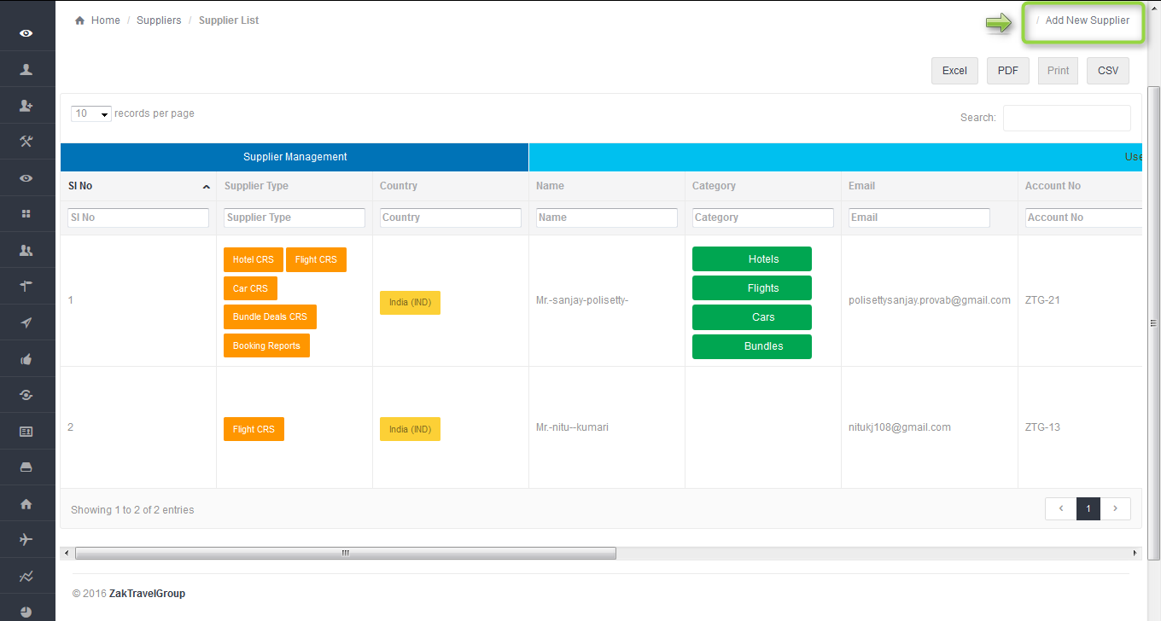

**1.2. Add supplier step by step:** After click on Add new supplier it will open one form to enter the supplier information. In the there is two option for password

1. Show – After click on show tab it will show the password whatever is entered.

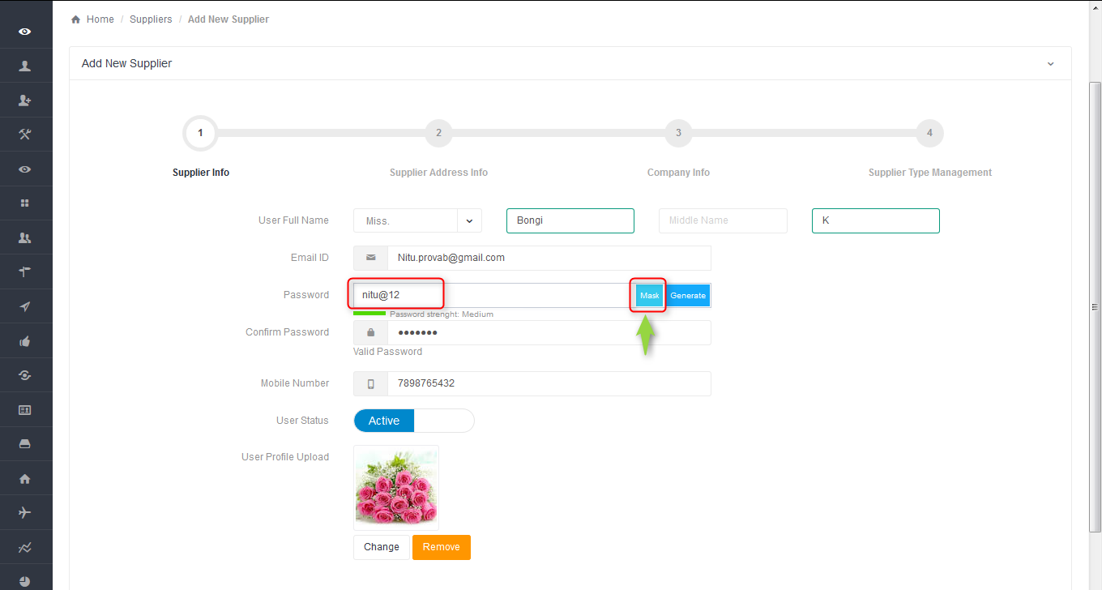

1. Generate – And after click on generate tab it will generate the password automatically.

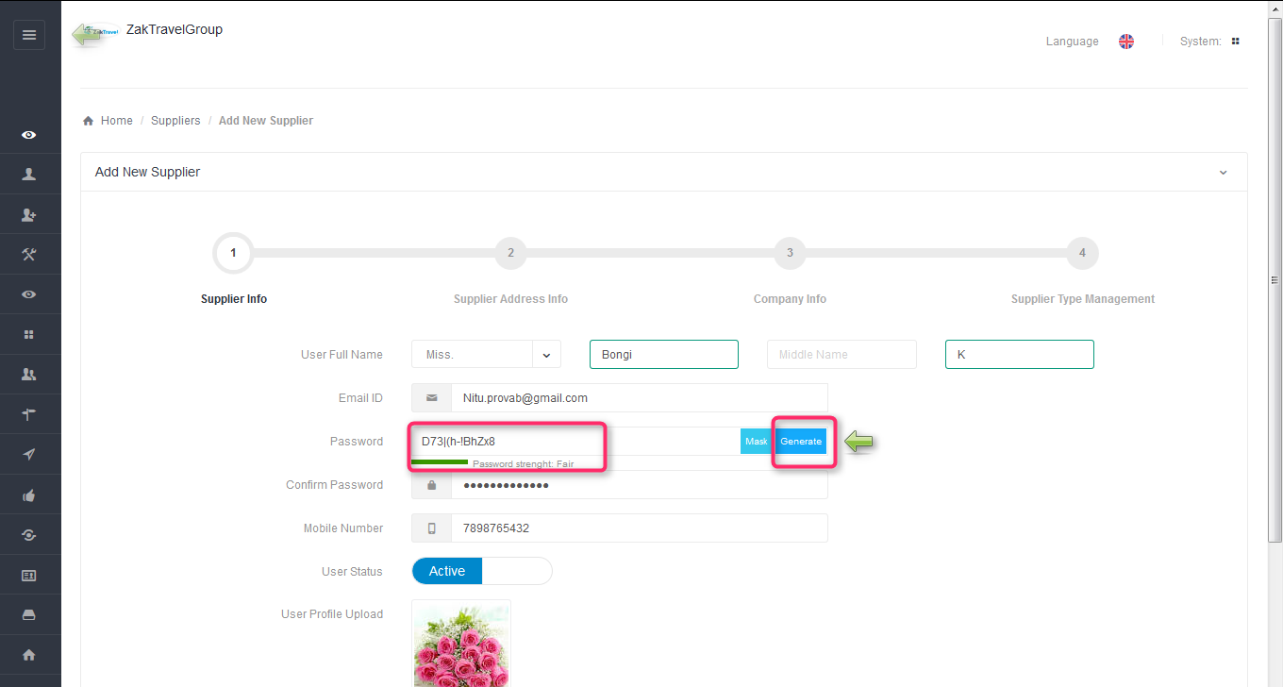

1. B)

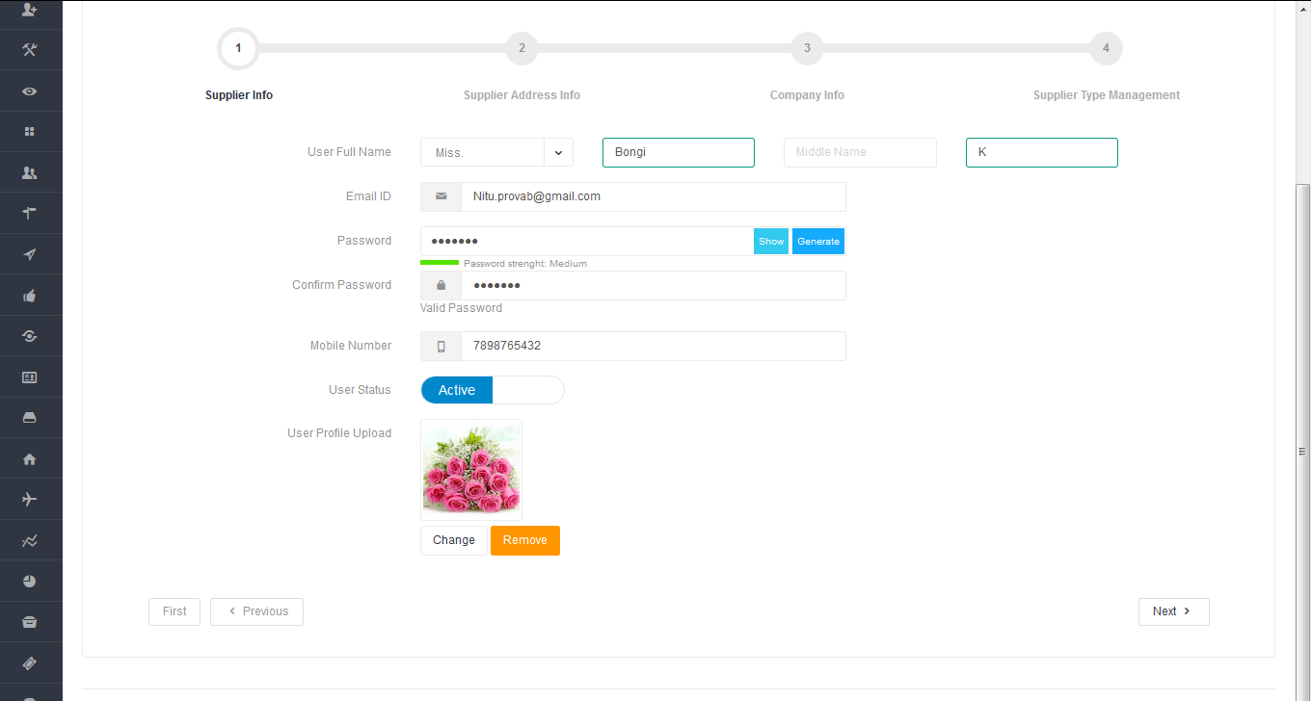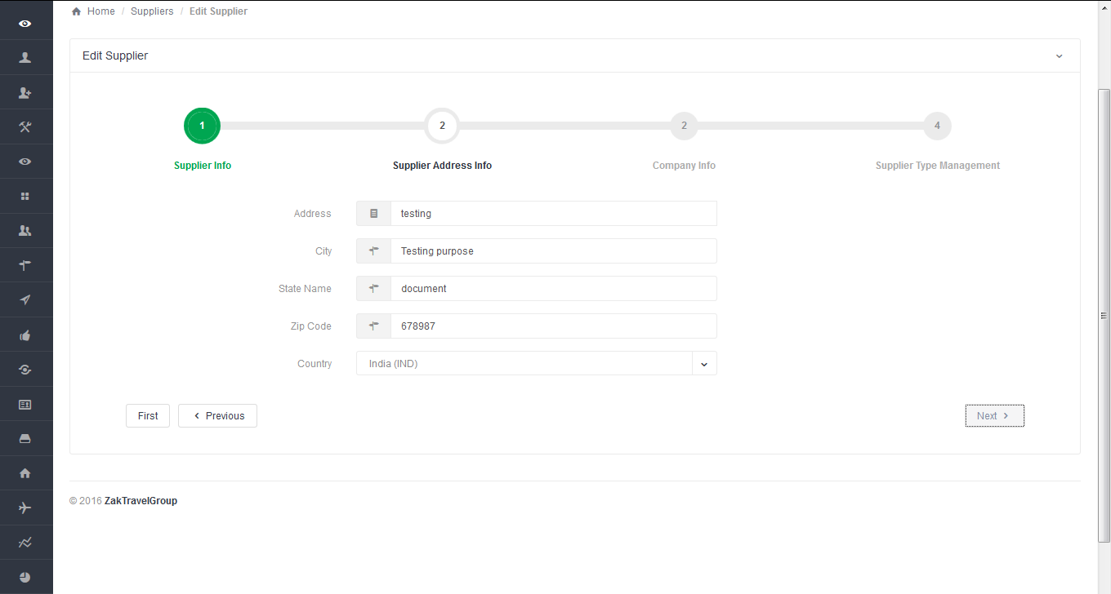

D) E)

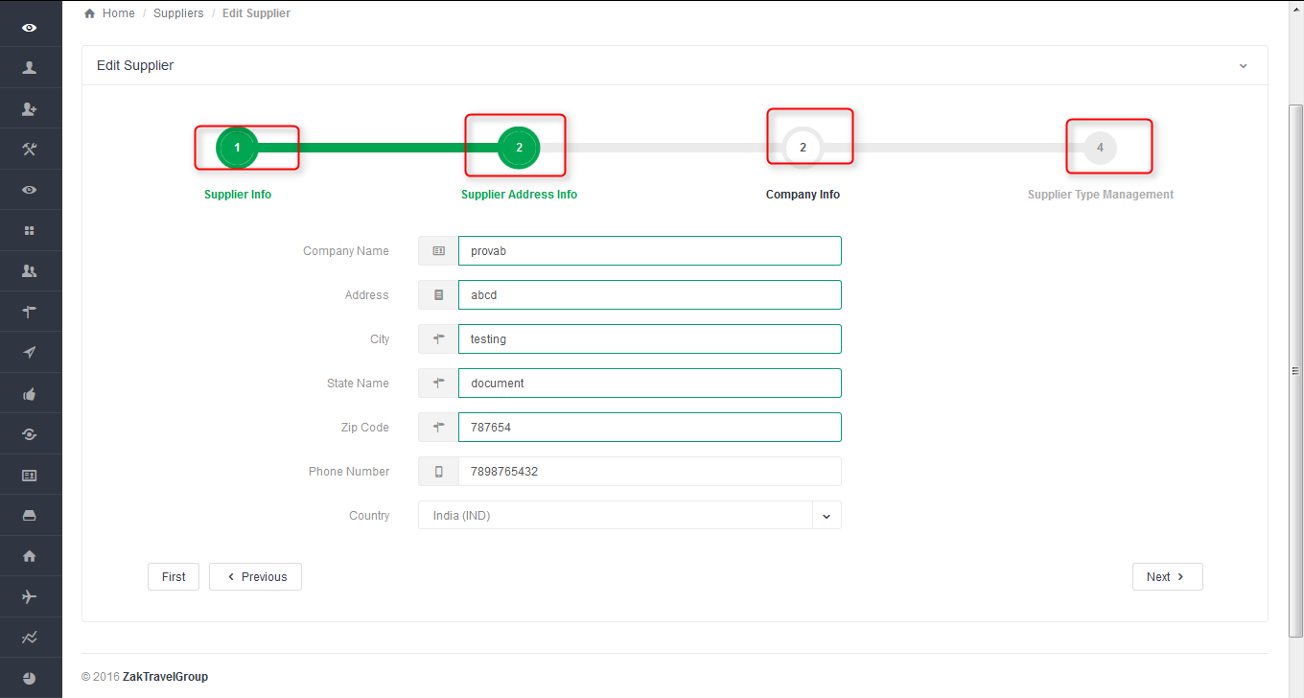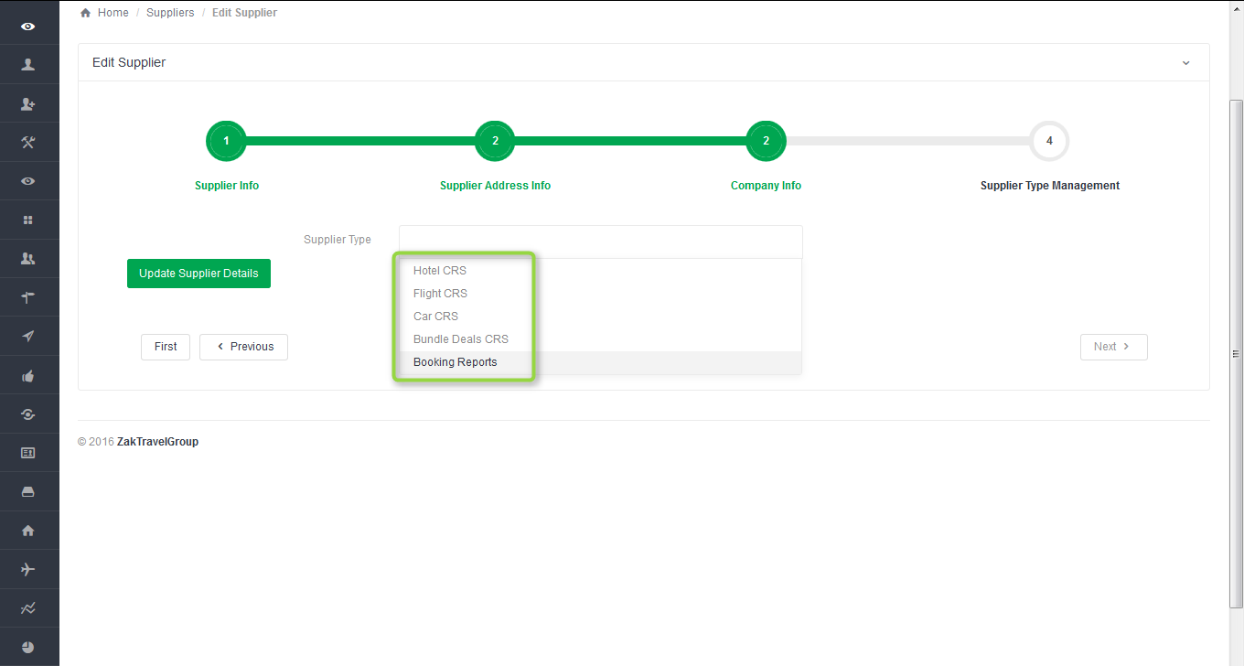

F)

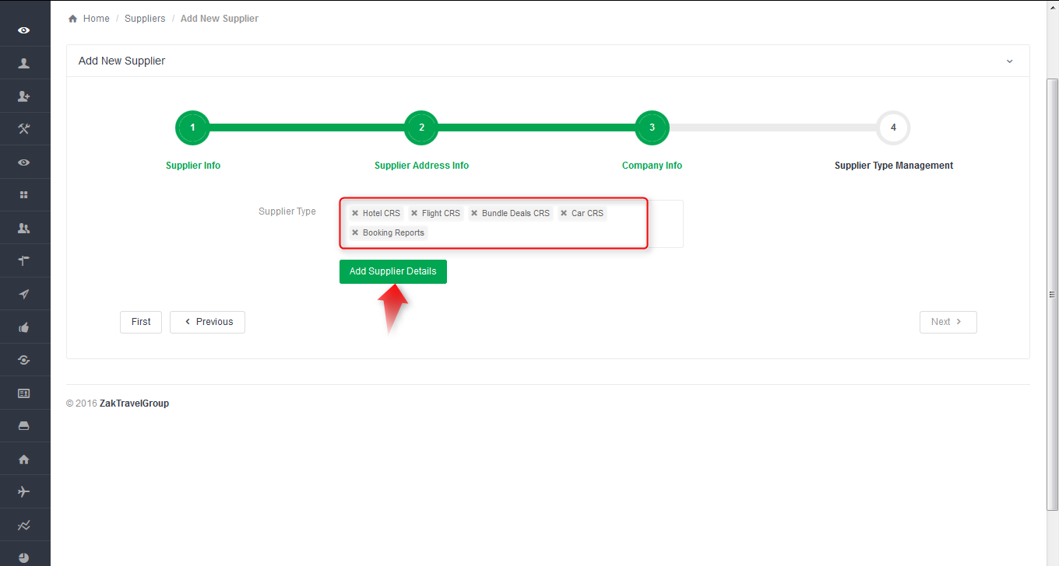

**1.3. After adding the supplier:** Now created supplier will display in the supplier list. And admin or supplier can edit, delete, Active or inactive the created supplier**.**

**http://provabextranet.com/WDMA/ZakTravelGroup_Dev/cpanel/supplier/supplier_list**

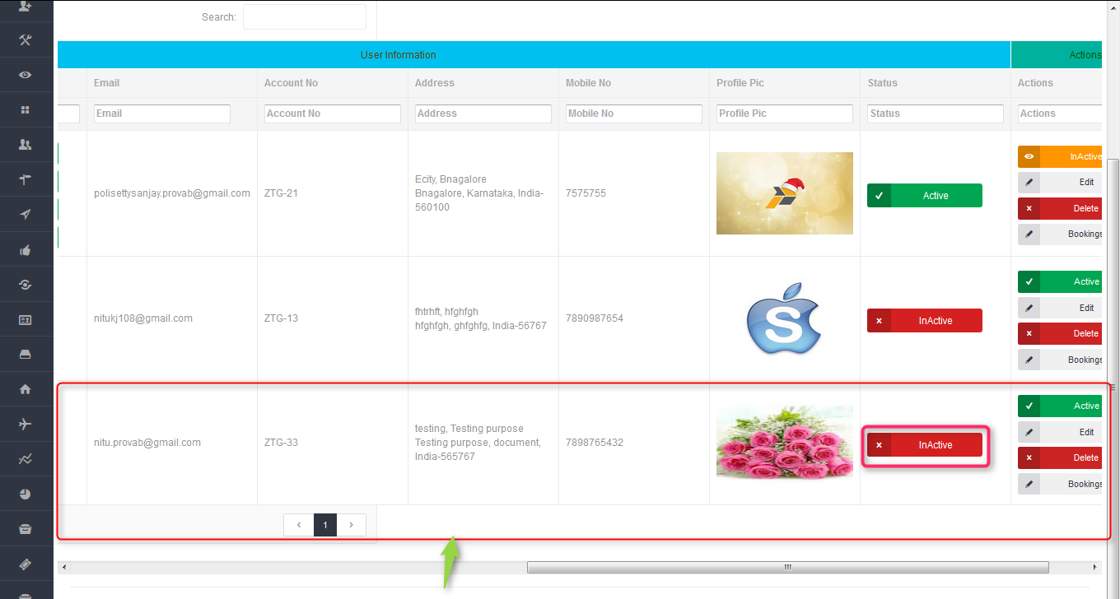

**1.4. Inactive** – After inactivation the supplier will get an email the account has been inactivated and will not be able to login, Error message will be displayed (Invalid login).

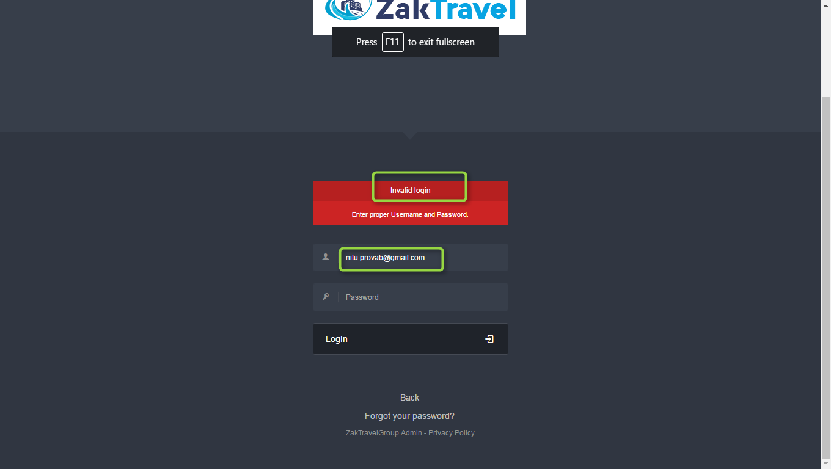

**1.5. Active** - After activation supplier will get an email the account has been activated and supplier can be able to login.

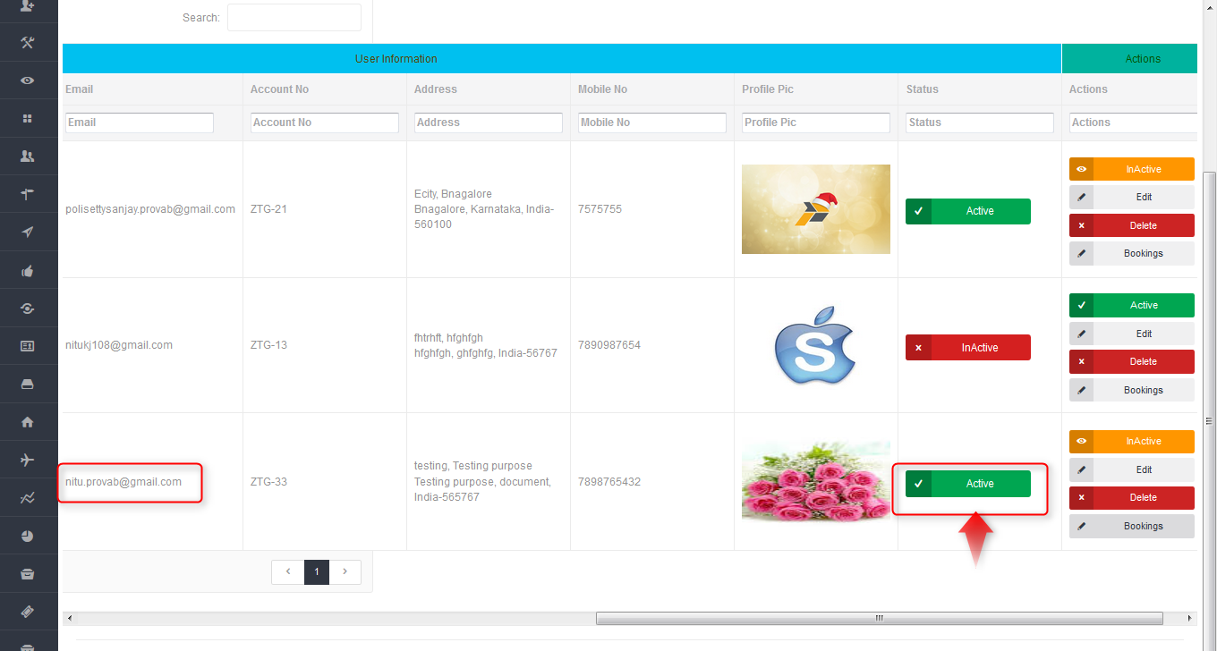

**After activation:**

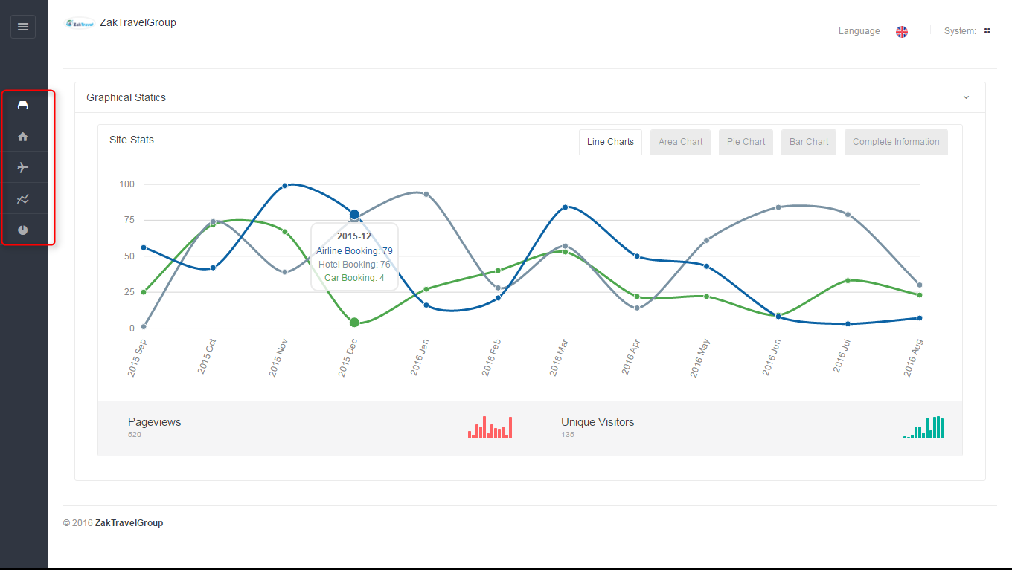

**2. CAR**

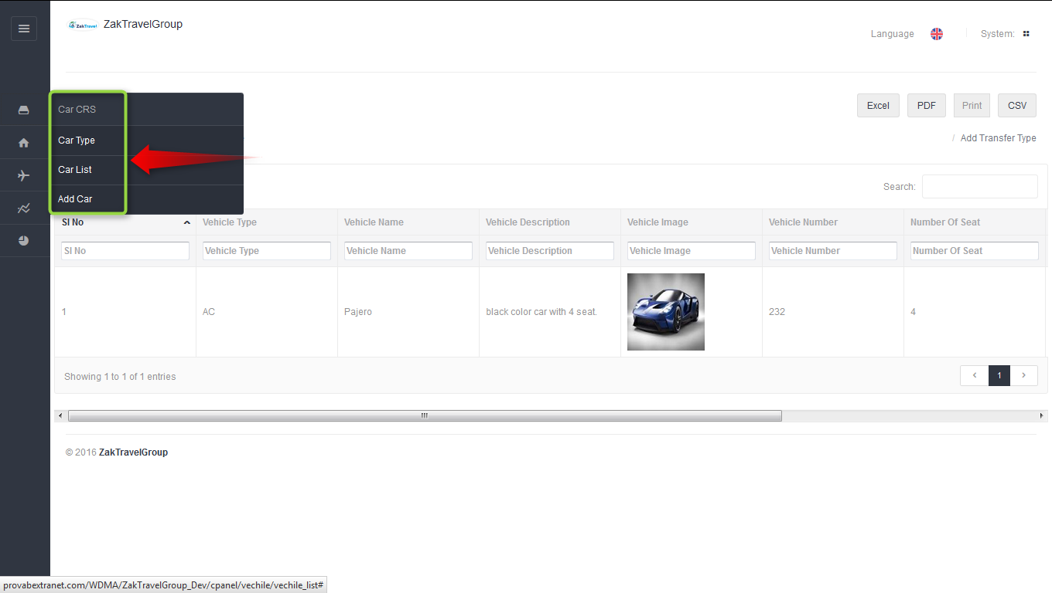

**2.1. Add Transfer Type:** Supplier can add the transfer or car type it include car name, number, descriptions image, seat etc.

**2.2. Before Adding transfer:**

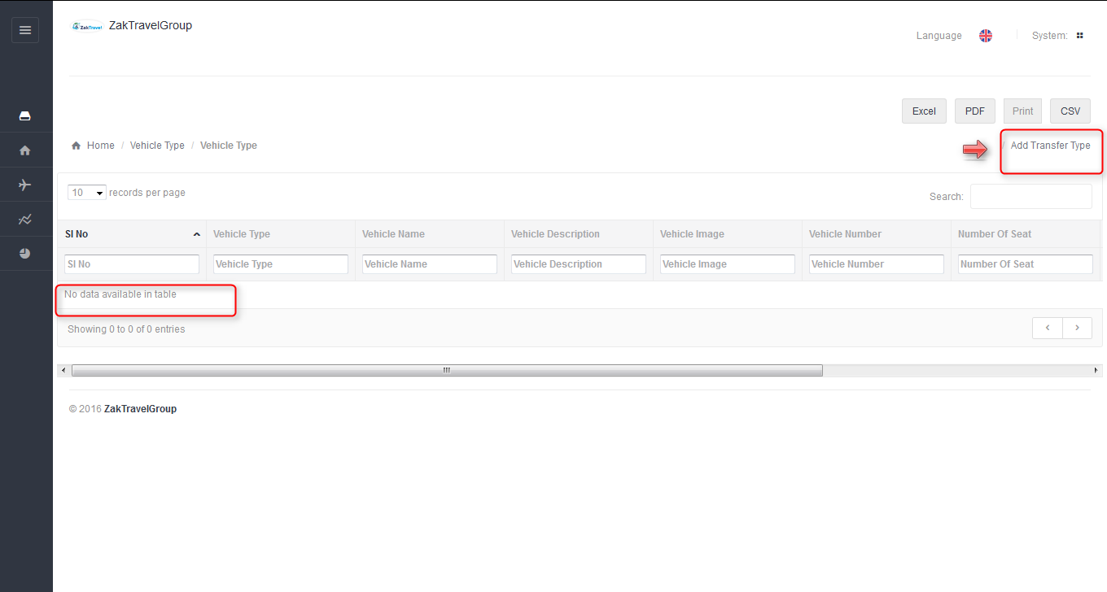

**2.3. Steps to add the transfer type:** For adding the transfer need to click on add transfer type and it will display the form to Fill appropriate values in the fields and make the status as active.

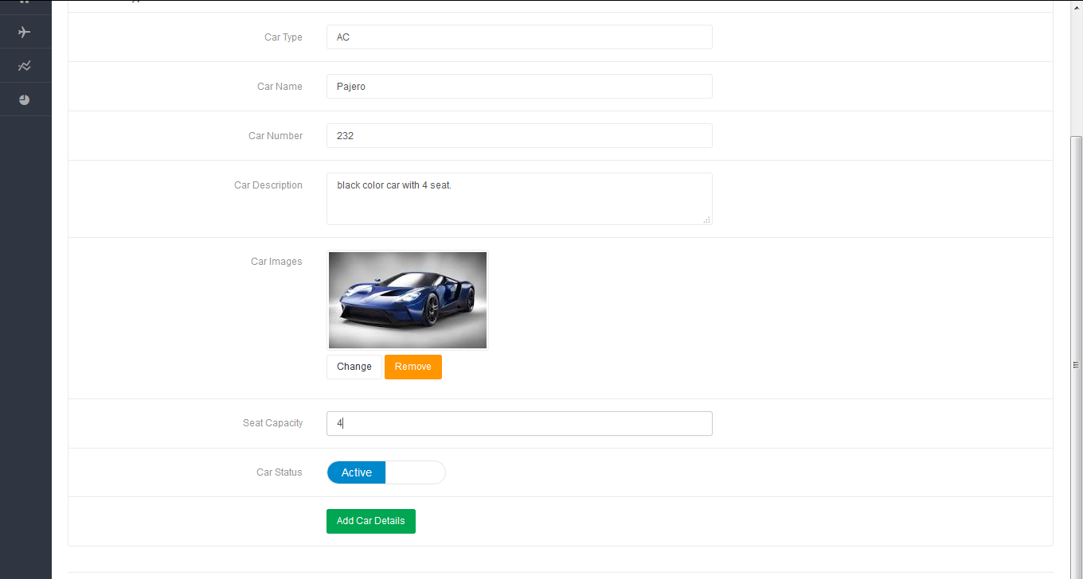

**2.4. After Adding the transfer type:** Transfer will display in the list after adding and supplier can delete, edit and change the status as active or inactive.

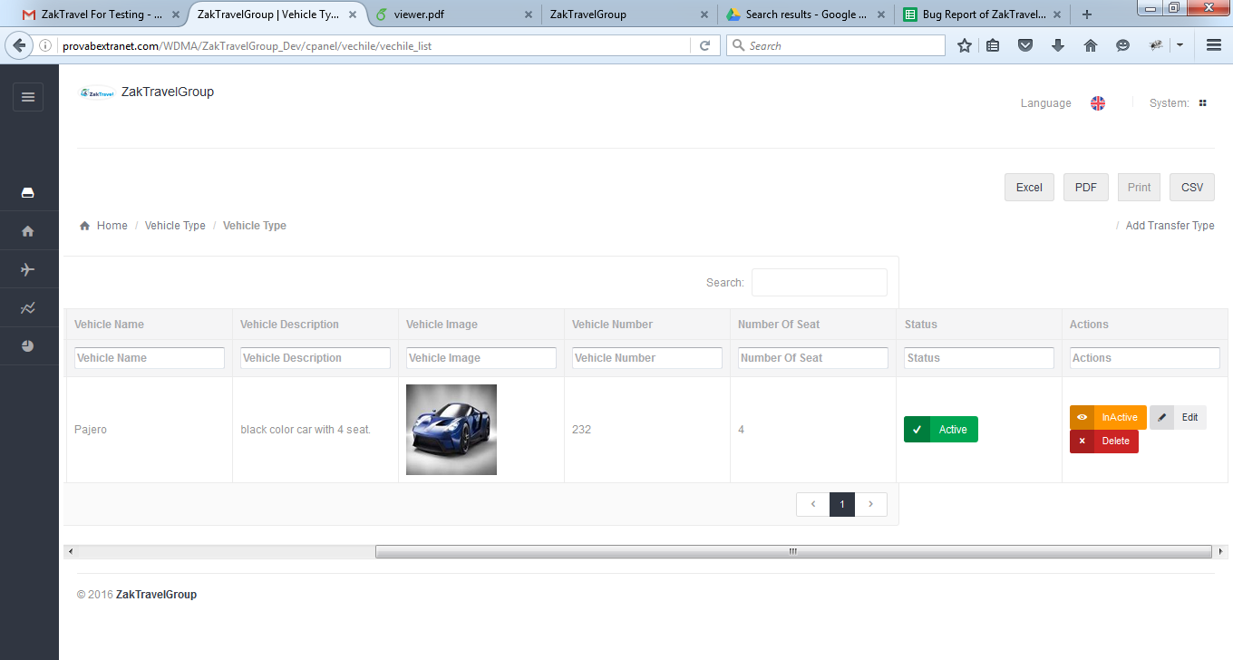

**2.5. Add Transfer:** Supplier add the transfer and while adding the transfer the form contains some field like country, city, and vehicle type which is Repopulated and price, etc.

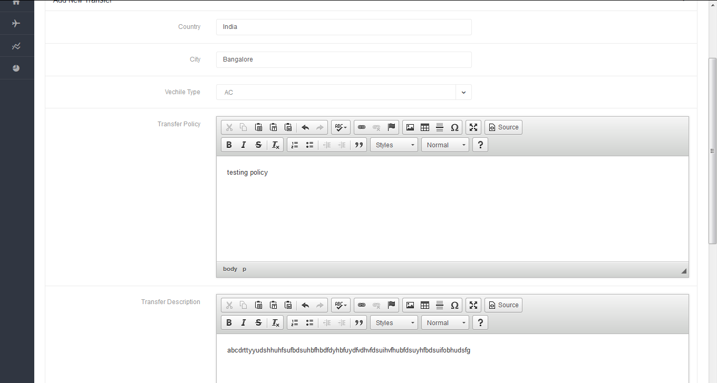

**2.6. After adding the transfer:** After adding the transfer it will display in the transfer list.

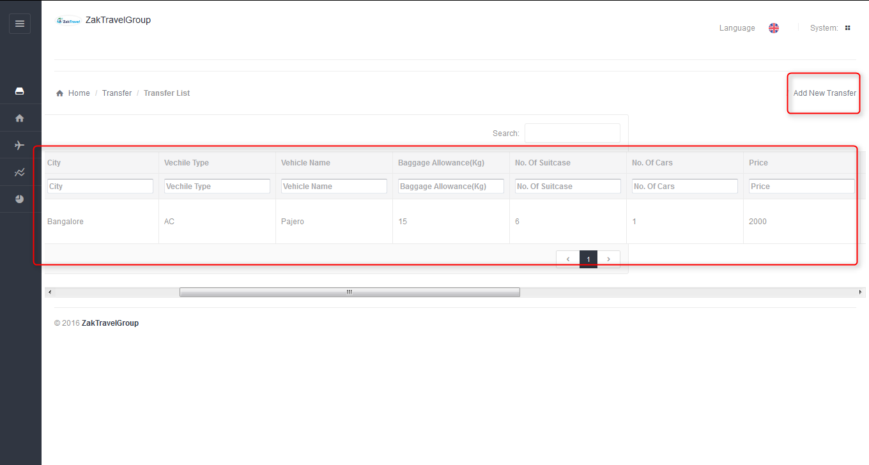

**2.7. B2B Login:**

The Agent Can login into his account using the following login panel with his created username and password…

-->Once the agent is login to his account he will be redirected to his home page to

Start the booking.

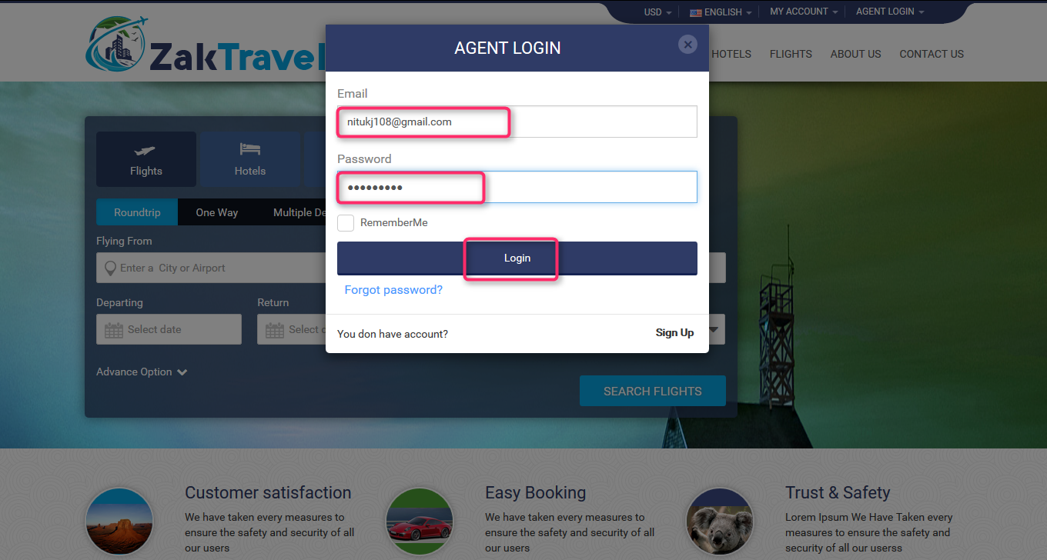  
If the user do not have a account they can sign up through filling the below details and agreed for ZaktravelGroup terms & Service policy.

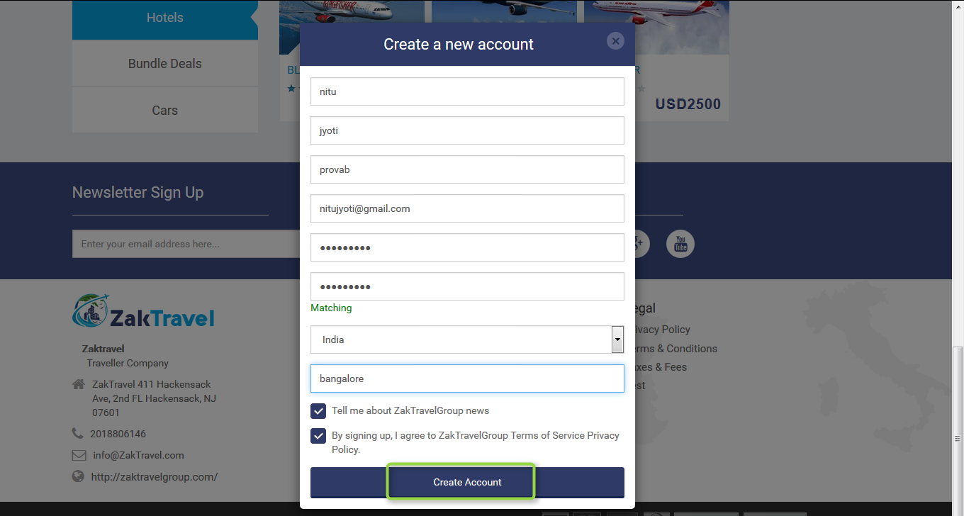  
**2.8. Car displayed on Front End:** After adding the details of transfer from supplier panel the transfer will be displayed on the front end and from where user can book the car.

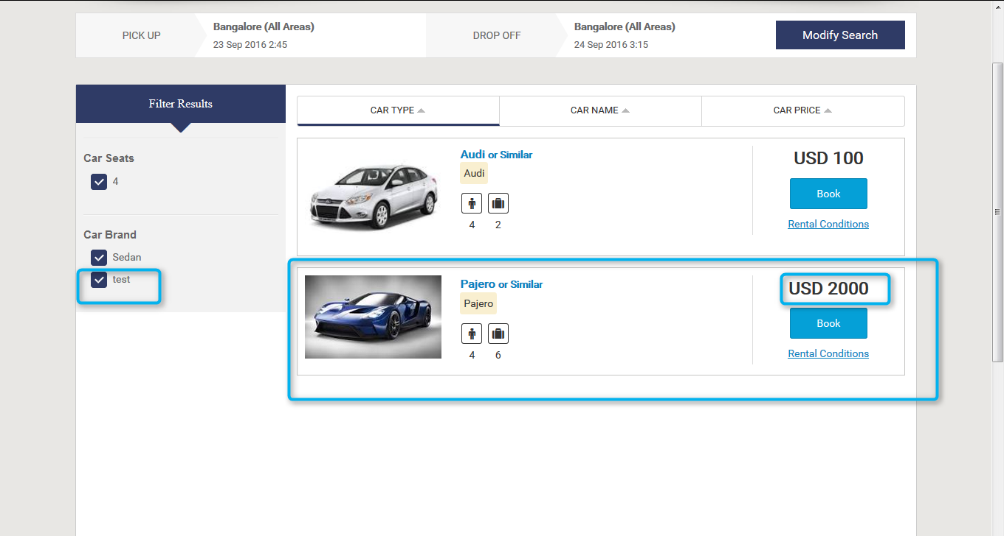

**2.9. Active and Inactive for car:** After change the status as inactive from the supplier or admin panel where car is added, the car will not be display on the front end for displaying need to change the status as active.

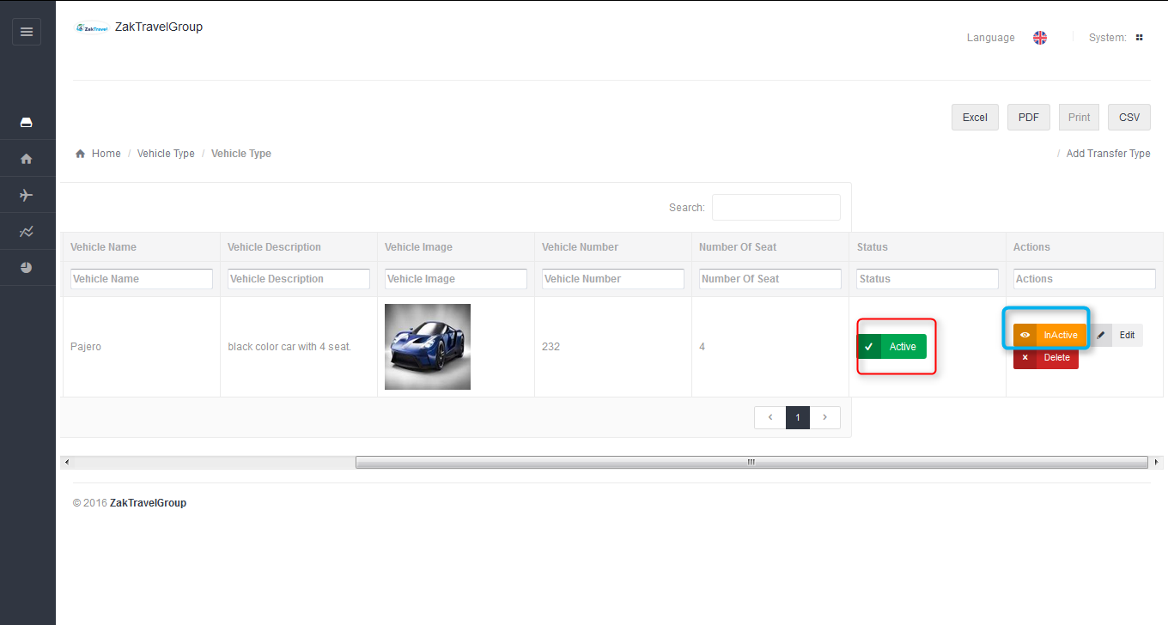

**Active**  **Inactive**

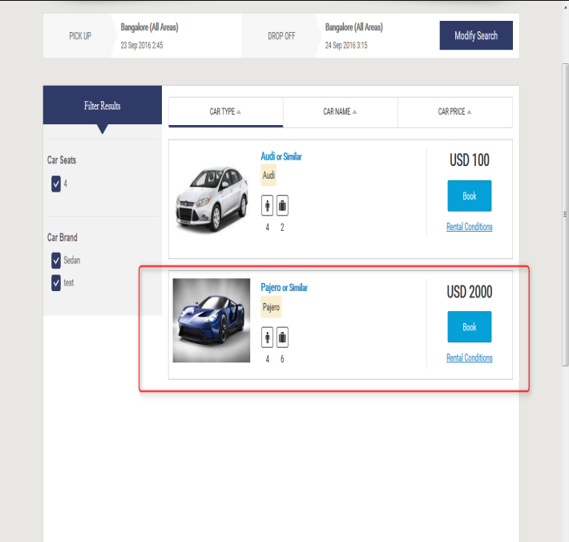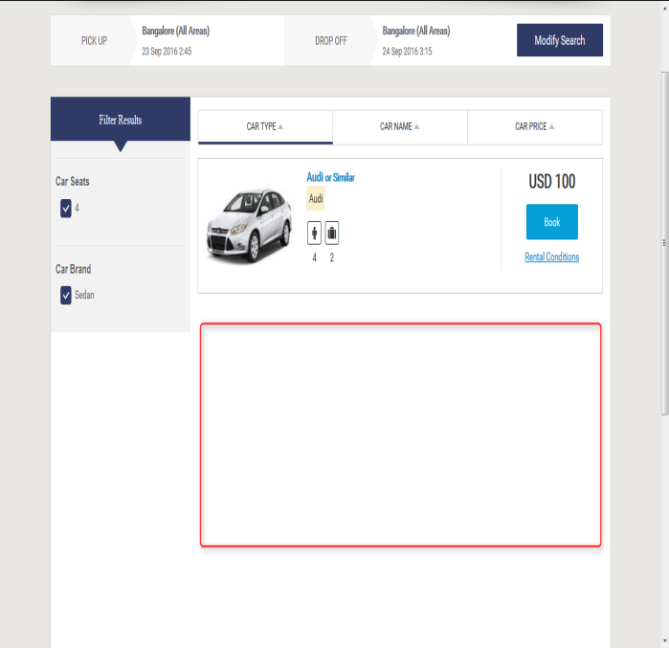

**3. MARKUP for Car**: Markup is added by the Admin, after adding the markup from admin panel the markup will be added with total fare and display on front end.

**3.1. Before adding the Markup for car:**

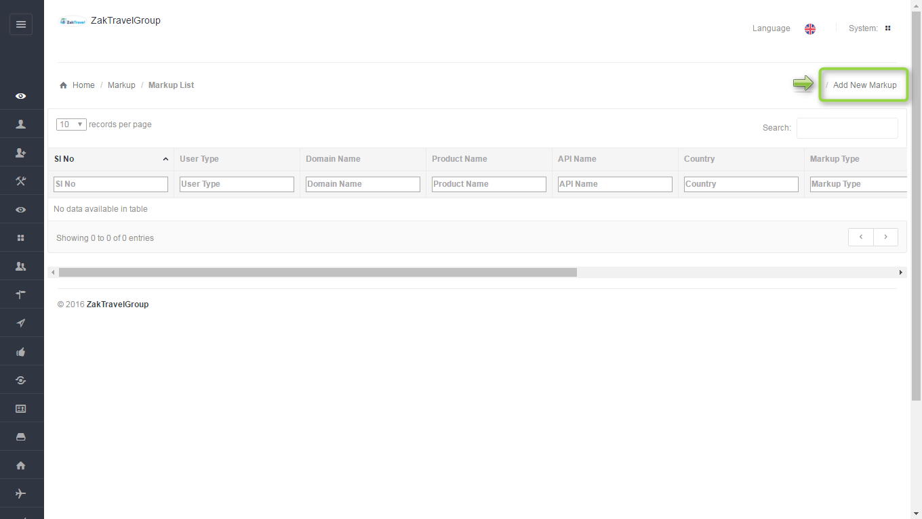

**3.2. Add markup step by step:** After click on add markup one form will be displayed and enter all the required information like user type, product, API, and markup value type, etc.

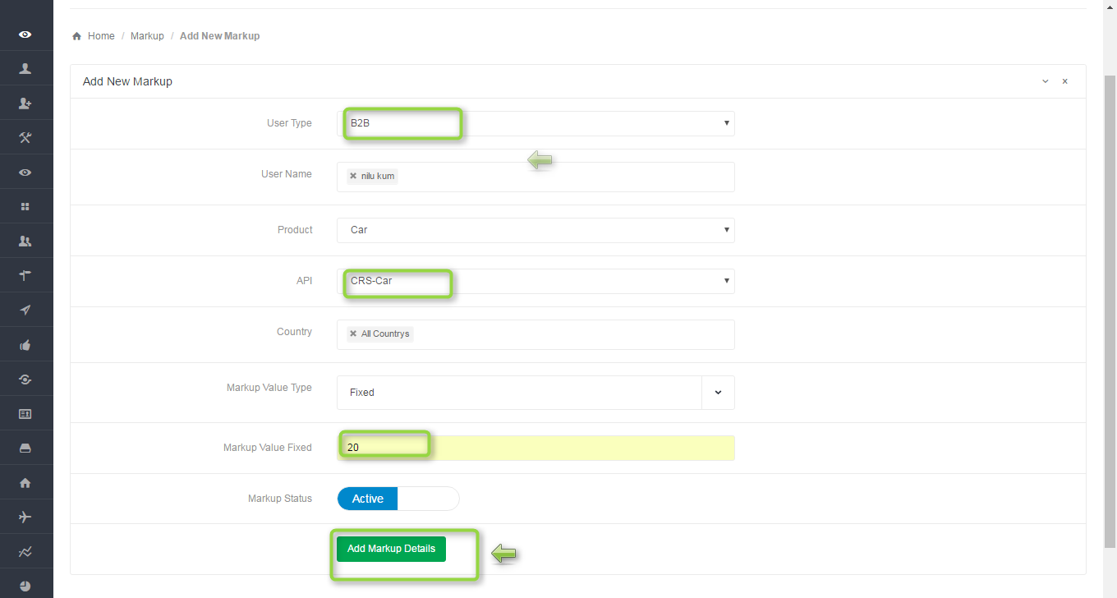

**3.3. There are two types of markup value:**

1) Percentage – The markup will add in percent (Example – Total fare =1000 and add 10% of total fare, now the total amount = 1100)

2) Fixed – Markup will be add in the fixed amount (Example – Total fare =100 and add 20 Rupees fixed amount with total fare, now the total amount = 120)

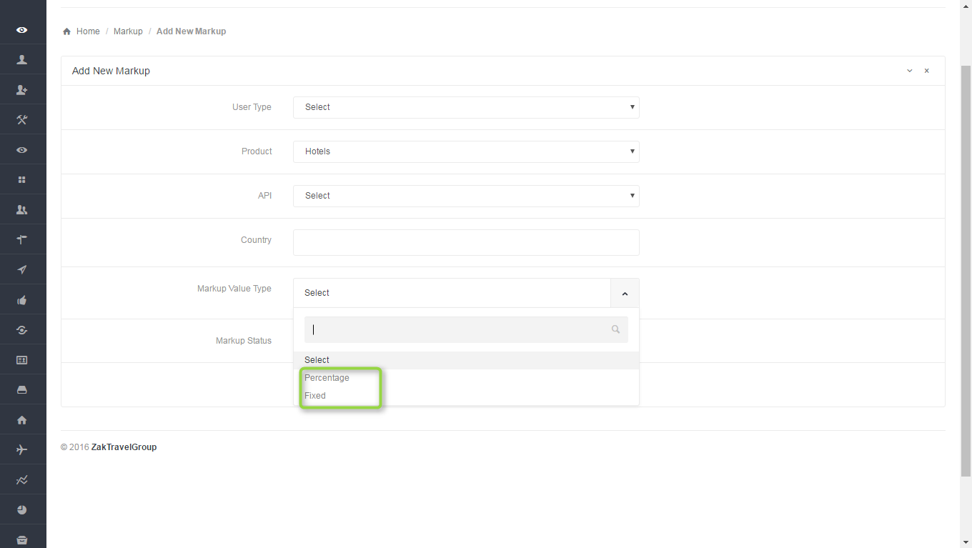

**3.4. Front End Without adding markup (B2B):** For a particular agentthe markup is not added with total fare so whatever the amount is added at the time of transfer creation that amount will be display only and total fare will display without markup.

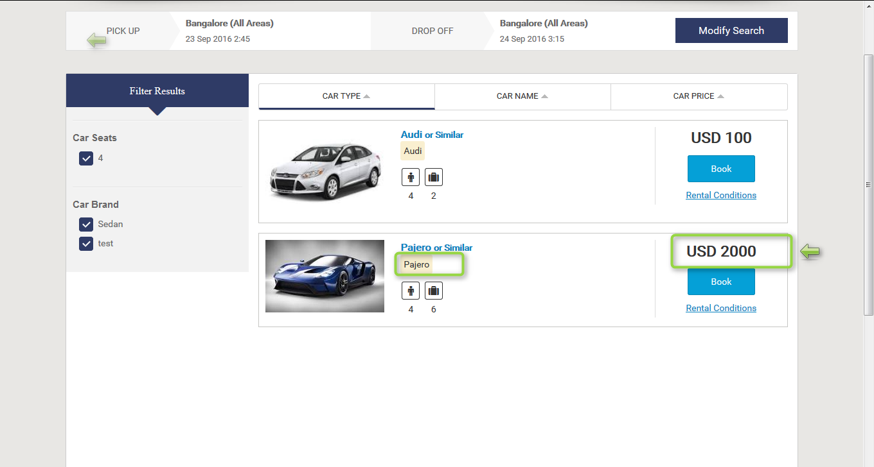

**3.5. Markup list in admin panel for B2B**: Here admin add the markup for particular agent , select the user type as B2B , user name means for which agent admin add the markup, product as a Hotel , API CRS Hotel , country and markup type. After adding the markup will display in the list.

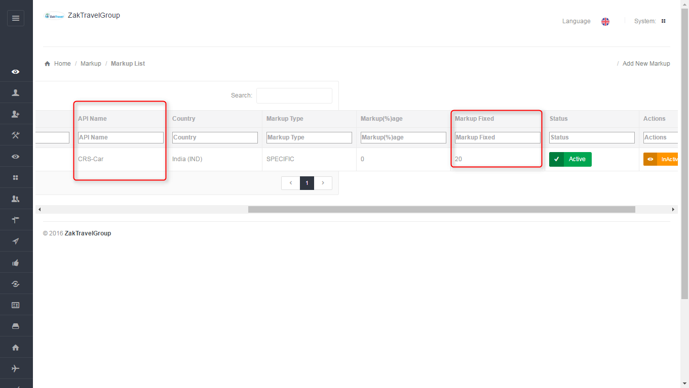

**3.6. Front end with Markup (B2B):** Now the added markup will be display with the total fare, for one day the markup added is 20 rupees now and markup will be added according to number of days.

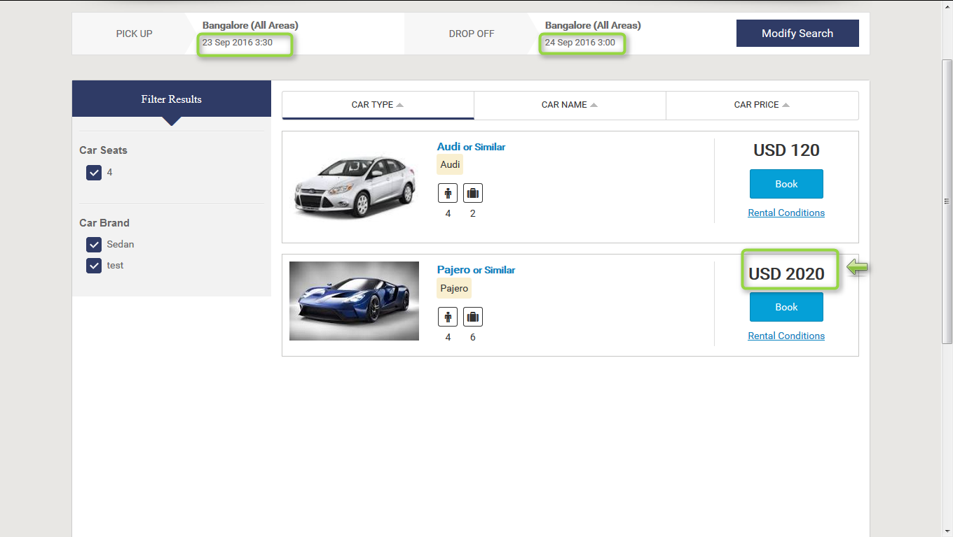

**3.7. Activation and Inactivation for markup:** After click on inactive the markup will not add with the total fare for adding the markup the status should be in active state.

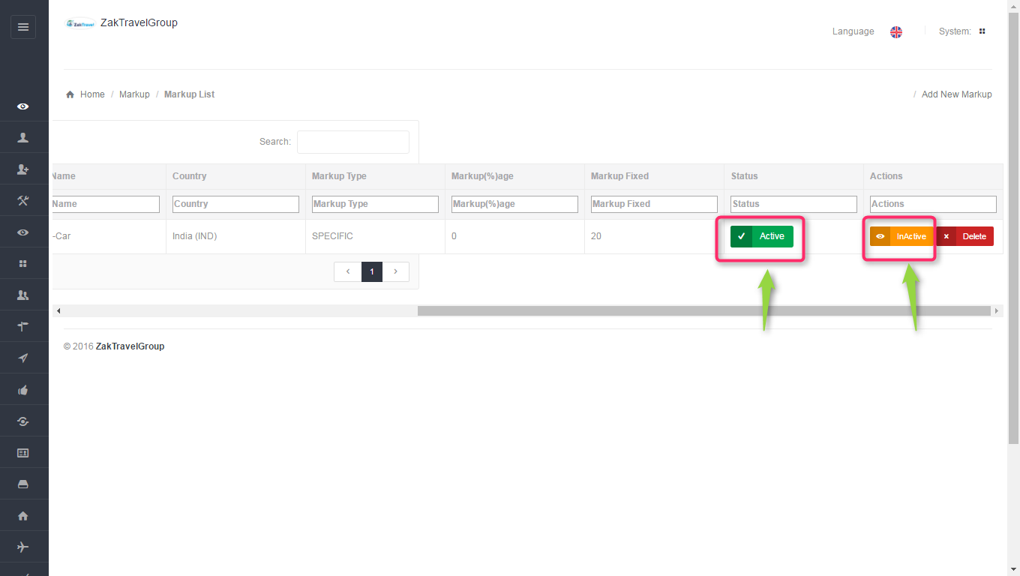

**Active Inactive**

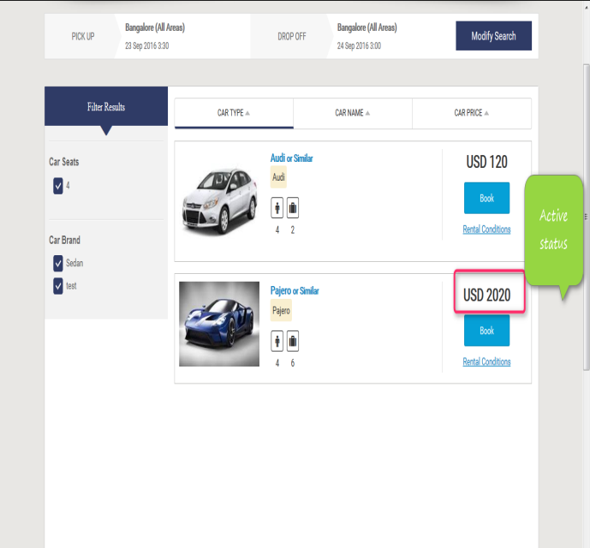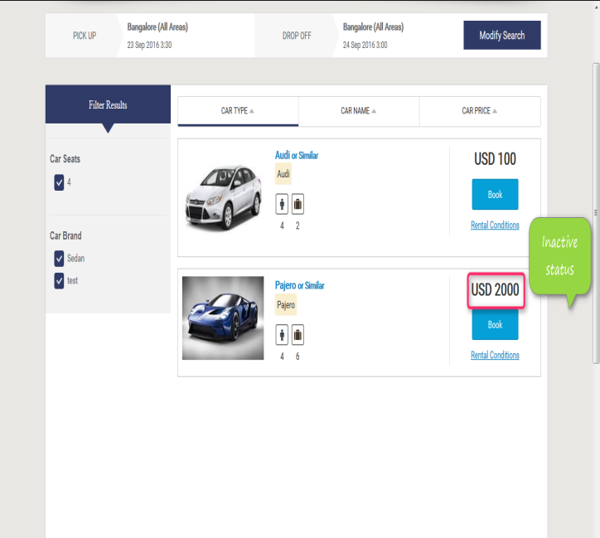

**4. Booking for Car:**

Users can book the particular car by providing their personal details. And they will get confirmation letter. Now click on car tab and provide all the valid detail and search for the car.

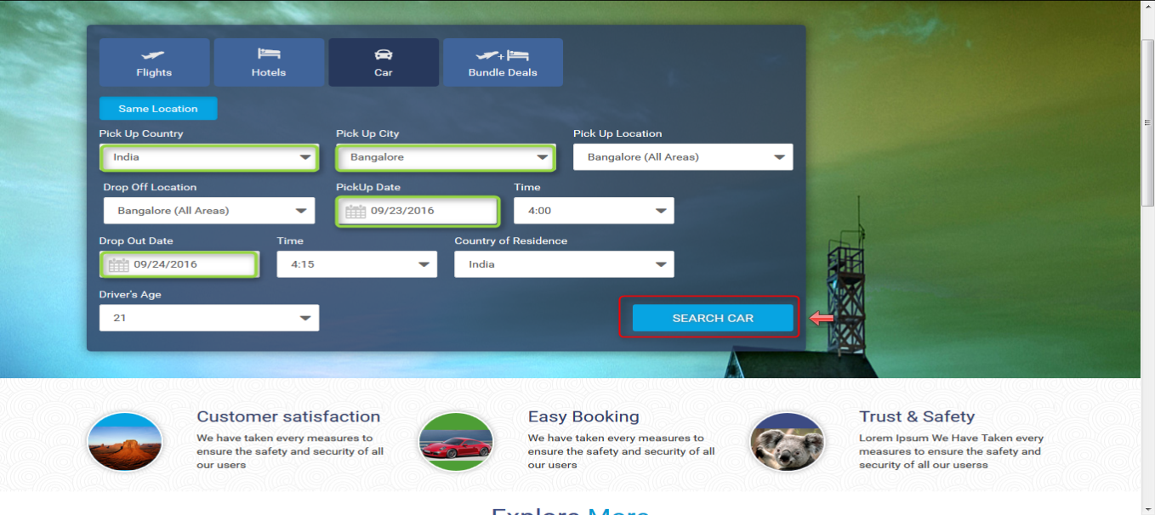

After Click on search button now car search result will displayed. So click on Book button for booking the car.

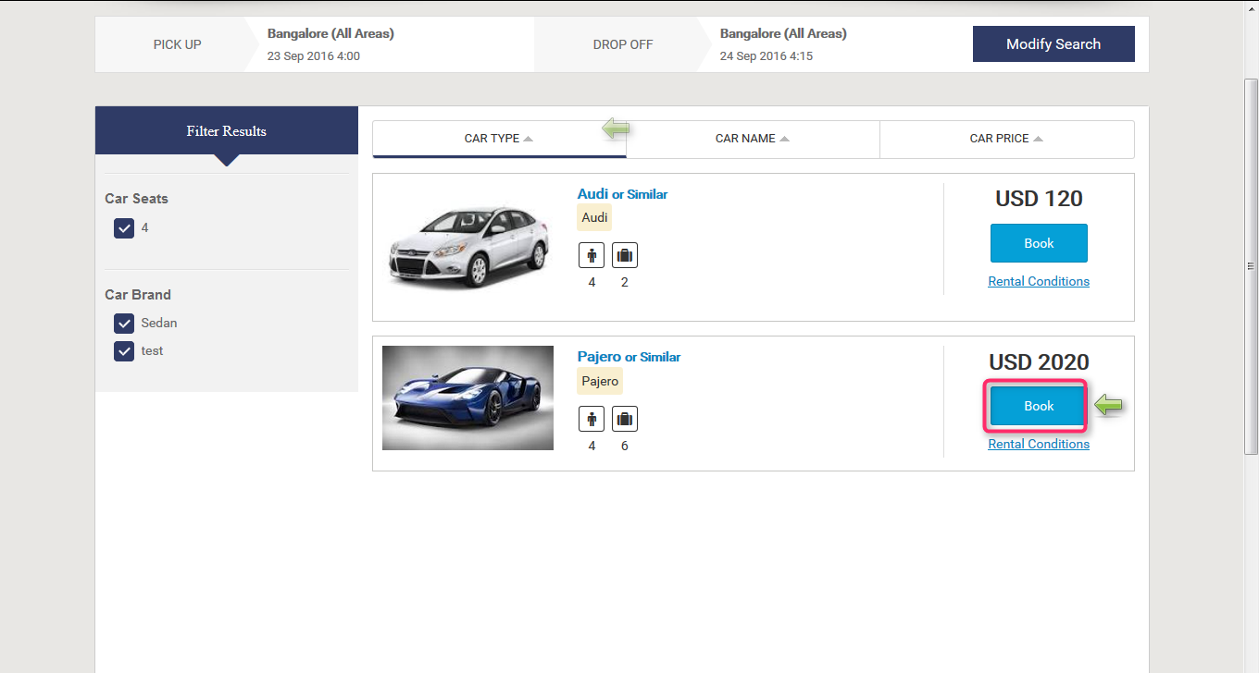

Now after click on book button it will open review, travelers and payment information and click on continue tab it will open the form to enter the personal information.

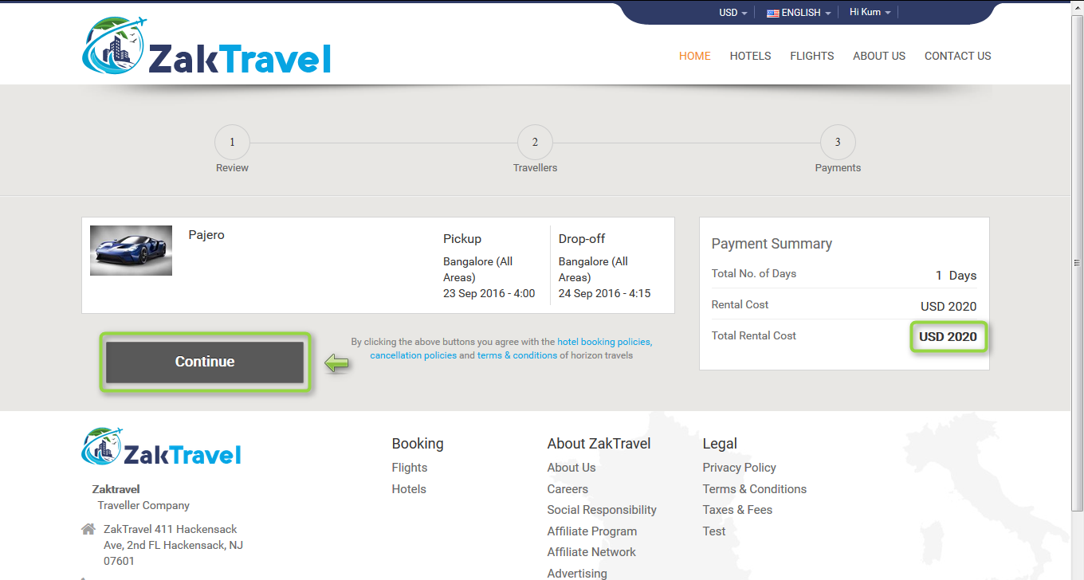

Provide all the valid information and click on continue button and check the check box for terms and conditions.

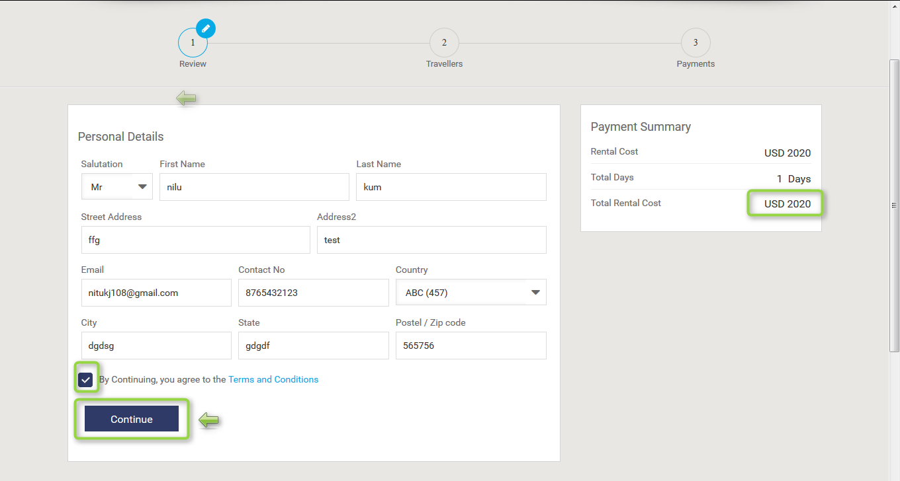

**4.1. Voucher page :** Voucher page display after providing all the information and click on continue button and everything will be present on the voucher page like booking status, reservation number, Traveler, date, amount etc.

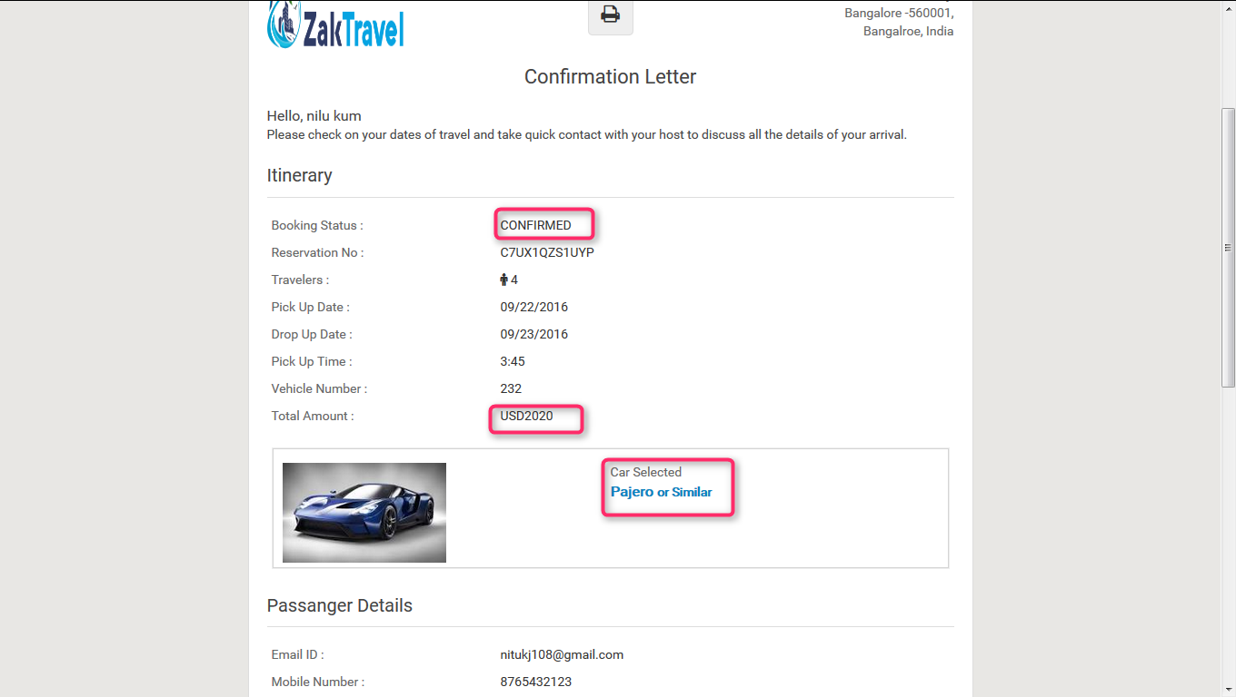

**5. (B2C) Login:**

The Customer Can login into his account using the following login panel with his created username and password...

-->Once the customer is login to his account they will be redirected to the home page to start the booking.

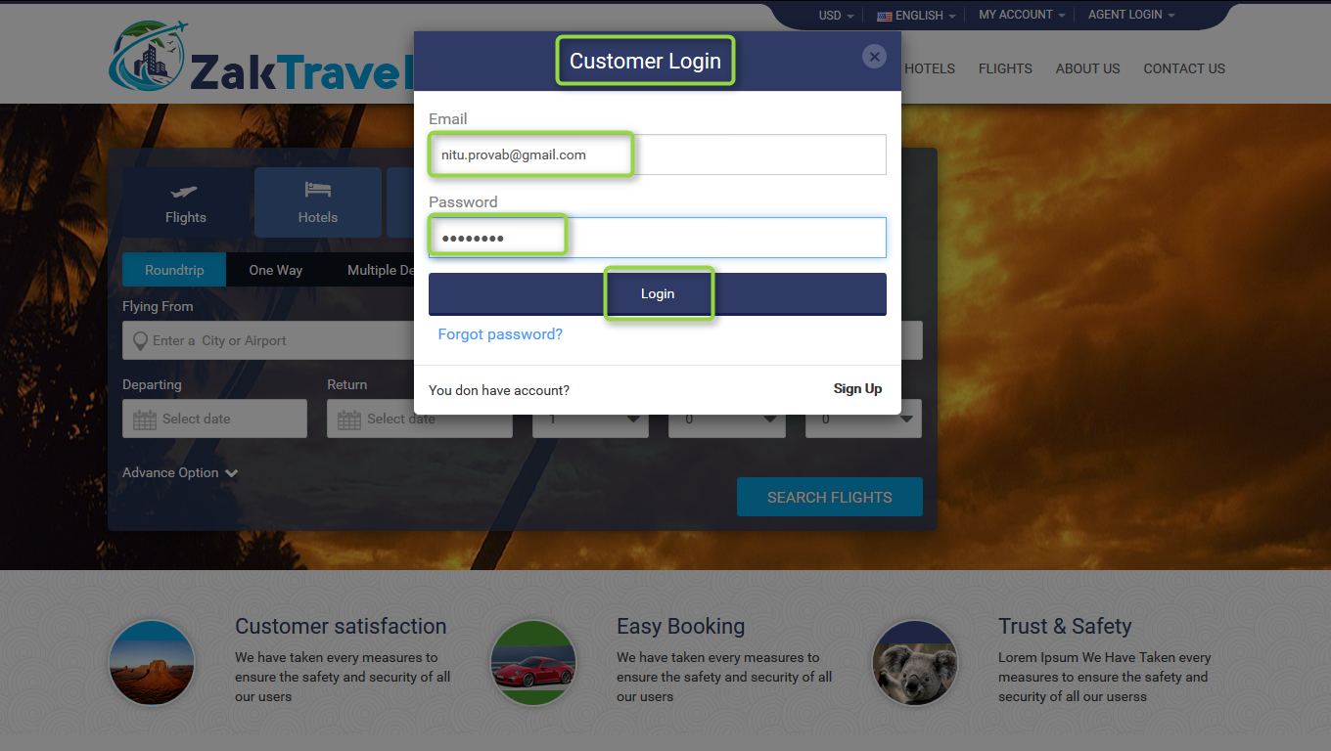

If the user do not have an account he can sign up through filling the below details and agreed for Zaktravelgroup terms & Service policy.

**5.1. Car displayed on Front End:** After adding th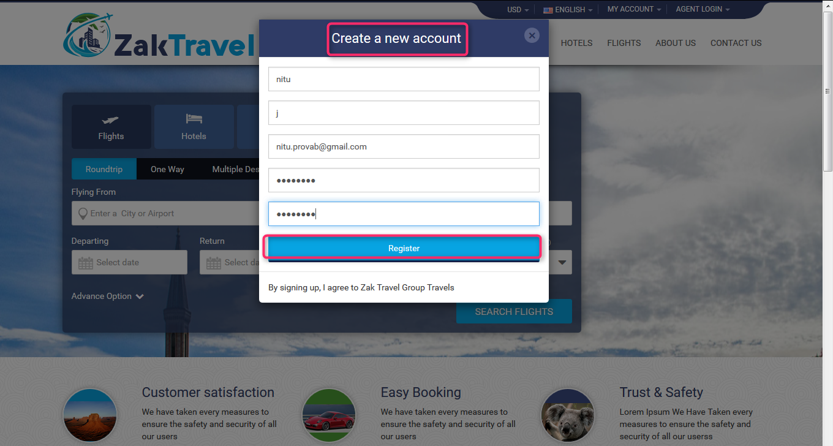e details of transfer from supplier panel the transfer will be displayed on the front end and from where user can book the car



**5.2. MARKUP**: Markup is added by the Admin, after adding the markup from admin panel the markup will be added with total fare and display on front end.

**5.3. Before adding the Markup:**

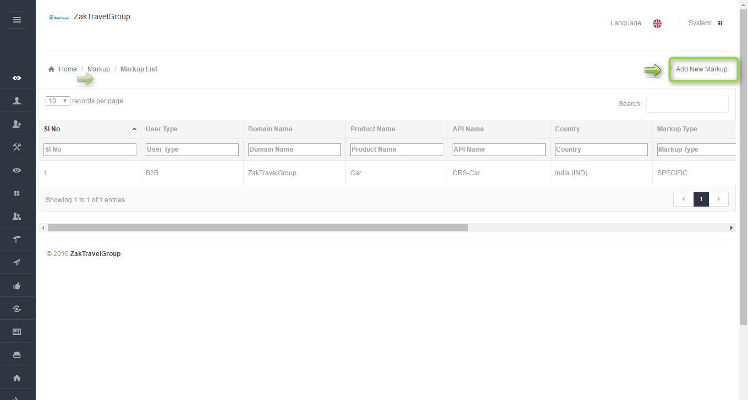

**5.4. Front End Without adding markup (B2C):** For a particular agentthe markup is not added with total fare so whatever the amount is added at the time of transfer creation that amount will be display only and total fare will display without markup.



**5.5. Add markup step by step:** After click on add markup one form will be displayed and Enter all the required information like user type, product, API, and markup value type, etc.

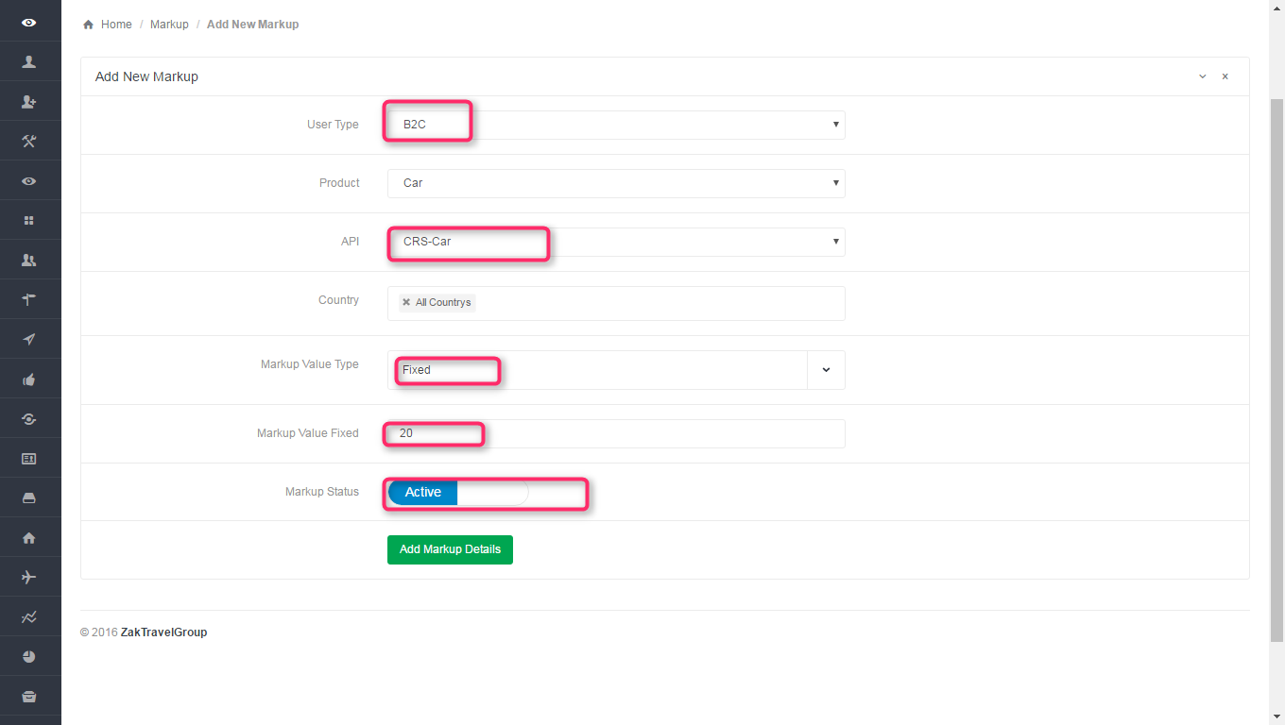

**5.6. List of markup in admin panel for B2C**: Here admin add the markup for particular agent, select the user type as B2C, product as a car, API CRS car, and country and markup type. After adding the markup will display in the list.

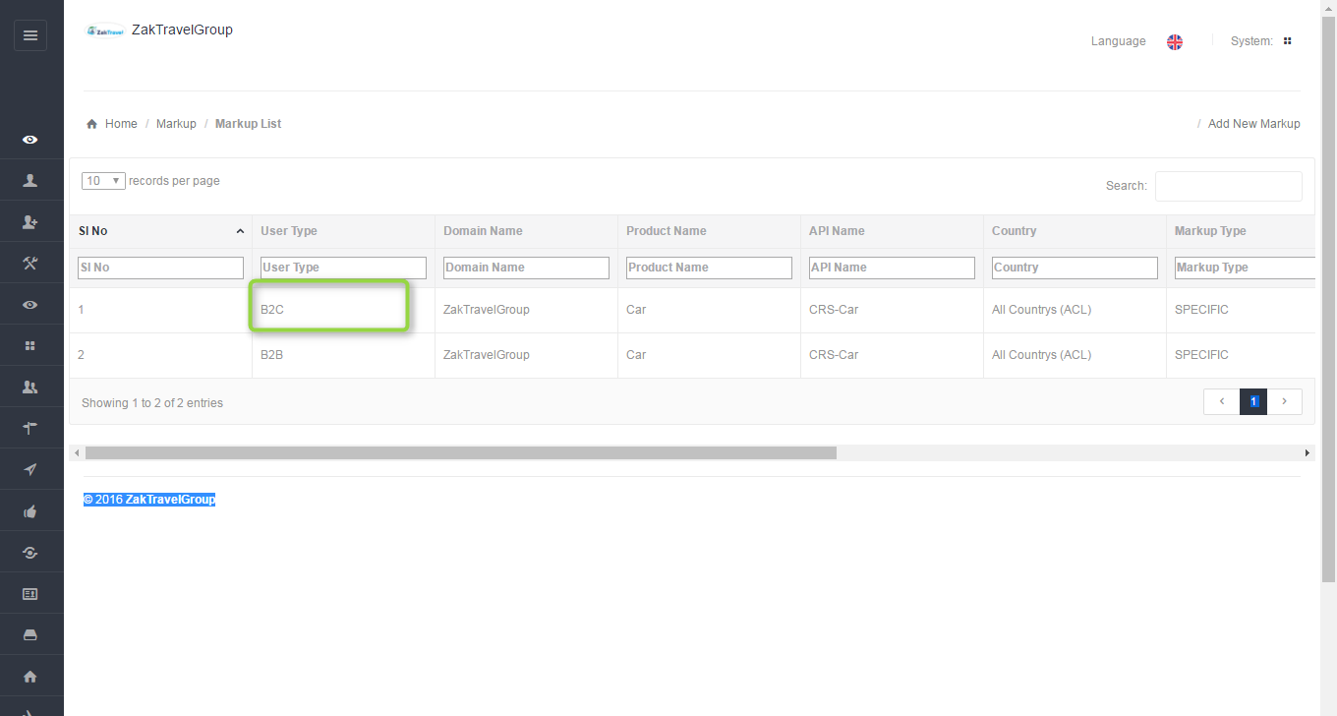

**5.7. Front end with Markup (B2C):** Now the added markup will be display with the total fare, for one day the markup added is 20 rupees now and markup will be added according to number of days.



**5.8. Car Booking (B2C):**

Users can book the particular car by providing their personal details. And they will get confirmation letter. Now click on car tab and provide all the valid detail and search for the car.

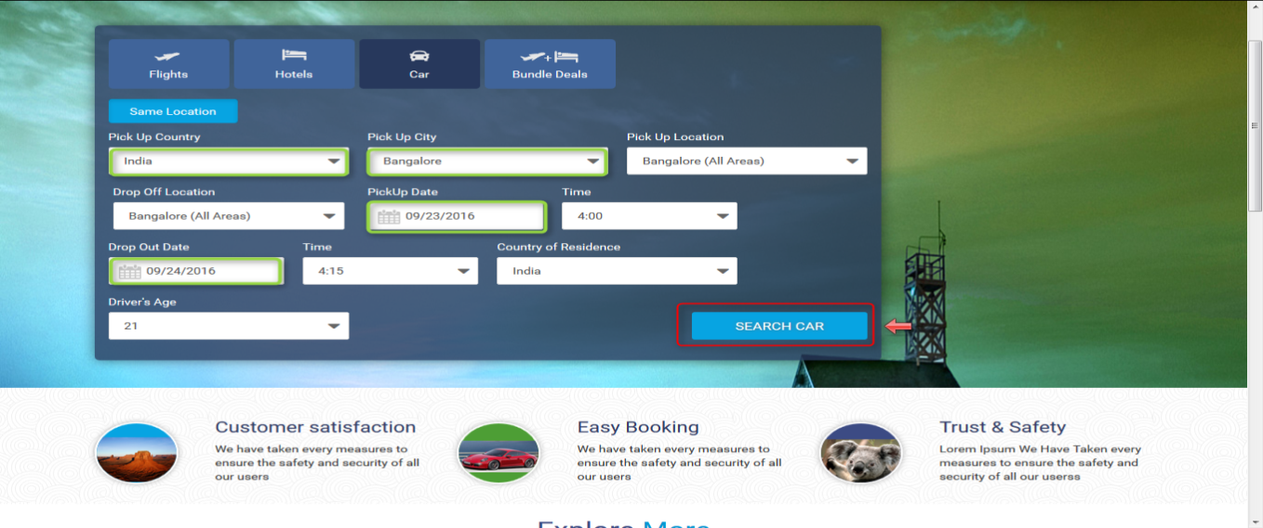

After click on search for the car now search result will displayed. So click on Book button for booking the car.



Now after click on book button it will open review, travelers and payment information and click on continue tab it will open the form to enter the personal information.



Provide all the valid information and click on continue button and check the check box for terms and conditions.

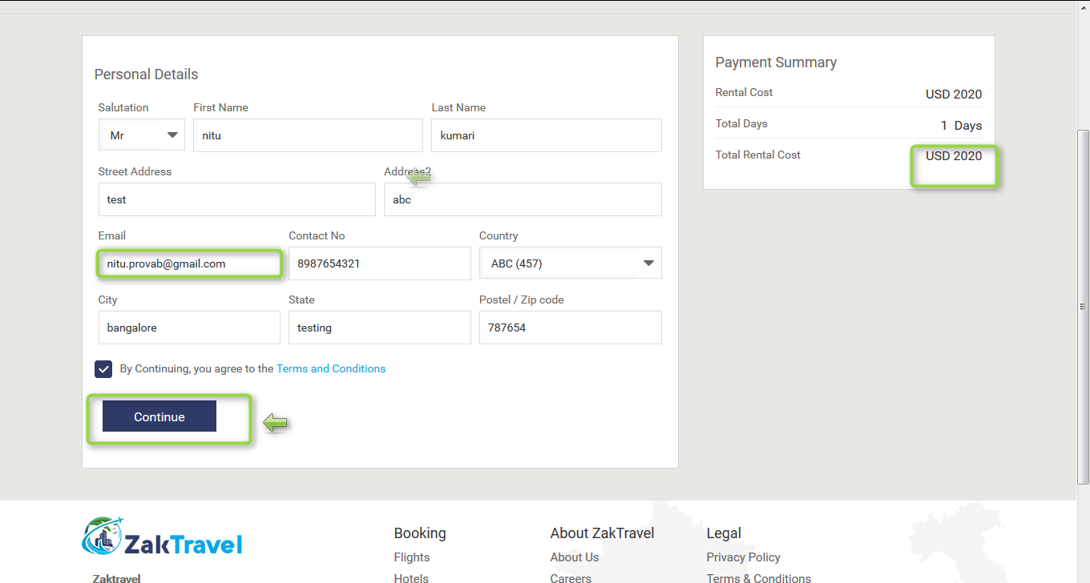

**5.9. Voucher page for (B2C)**: Voucher page display after providing all the information and click on continue button and everything will be present on the voucher page like booking status, reservation number, Traveler, date, amount etc.

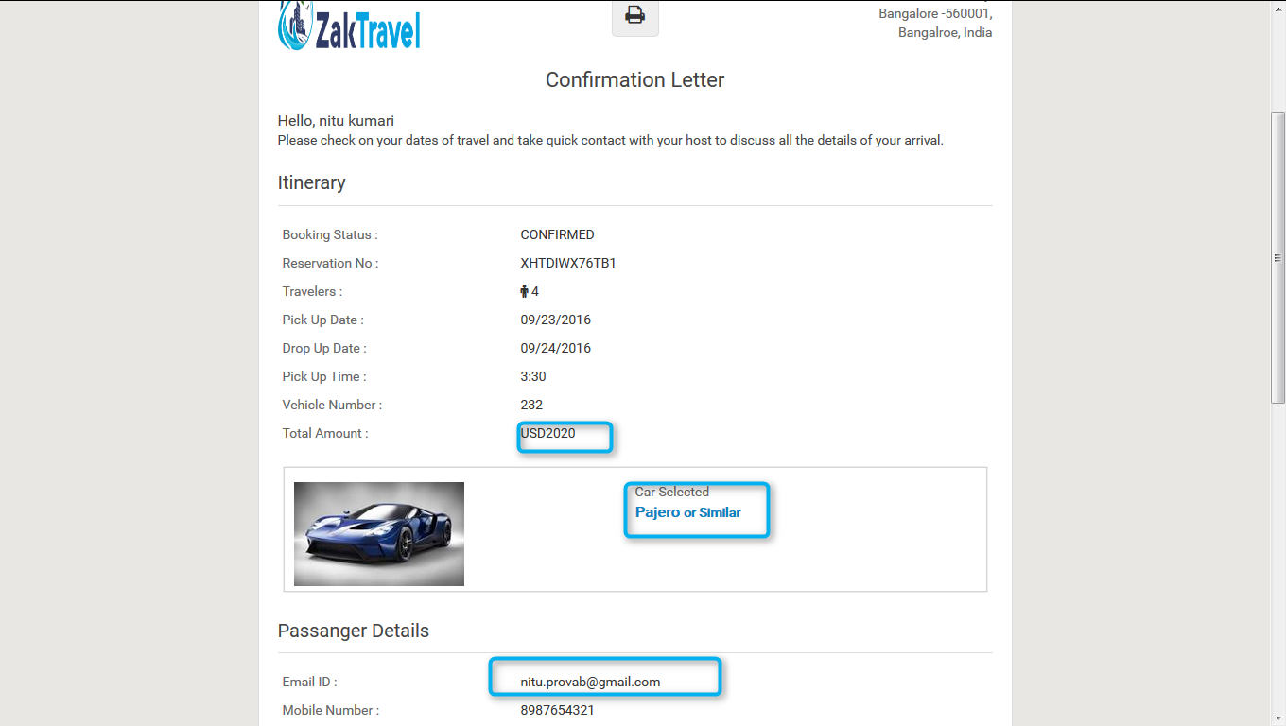

**6. HOTEL:**

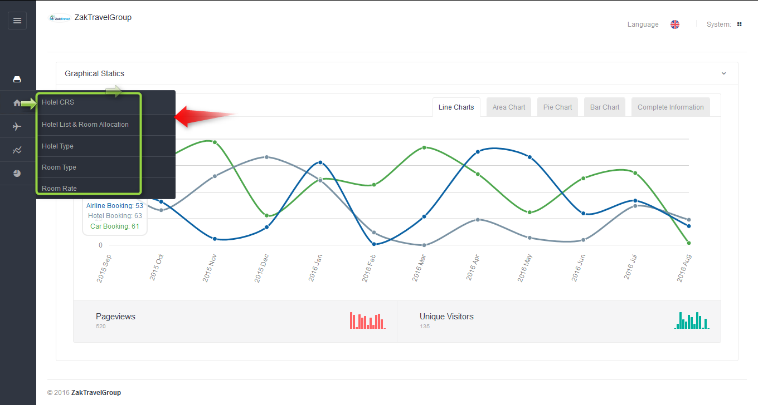

**6.1. Hotel list and room allocation (add hotel):** Supplier can add the hotel which contain hotel type, name, code, rating, information, location and country etc

**6.2. Before adding of hotel:** The hotel will not display in the list before adding.

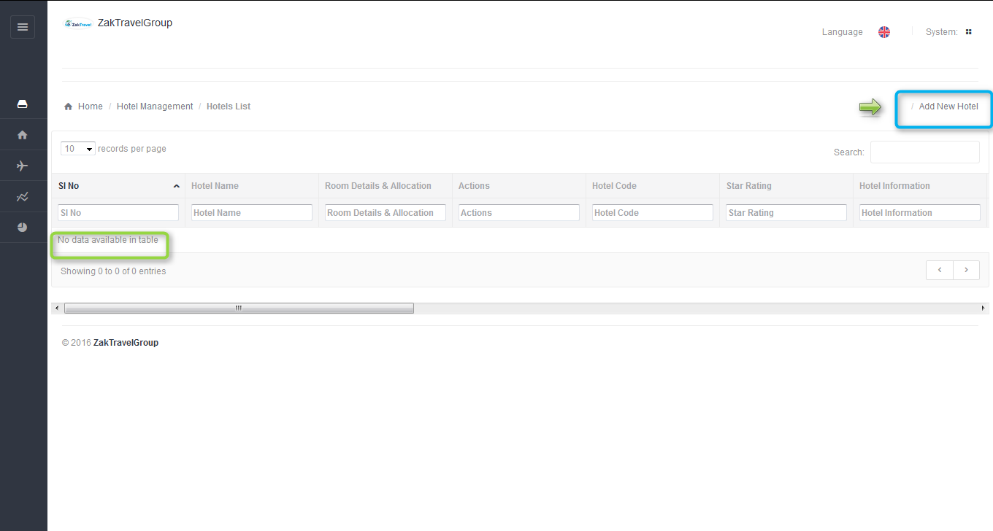

**6.3. Steps to add hotel:** After click on Add hotel it will open one form enter all the valid information and click on add hotel.

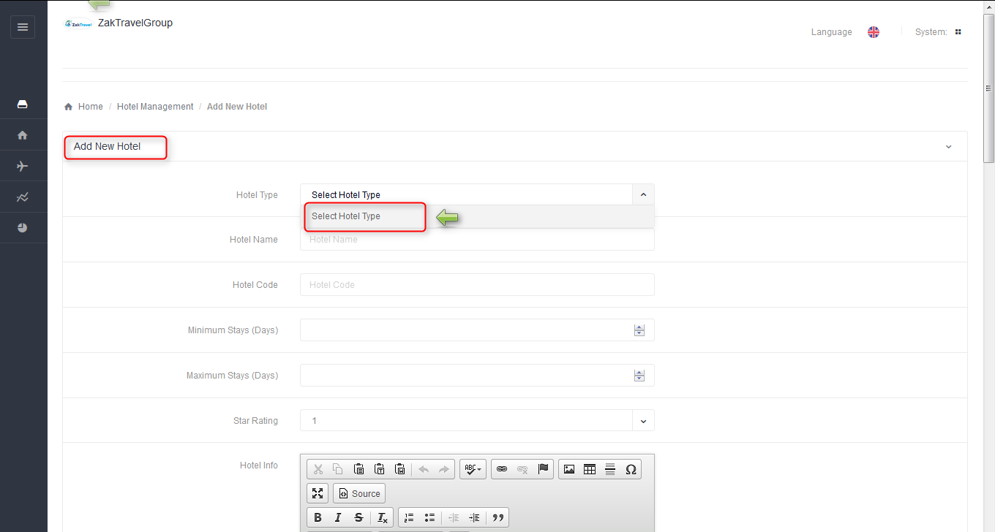

-While adding the hotel first need to select hotel type but it’s not displayed any hotel type because first of all supplier need to add hotel type and then hotel type will be display in the drop down.

**6.4. Add hotel type:** After adding hotel type only it’s possible to add the hotel.

**6.4.1. Before adding hotel type in supplier panel:** The hotel type will not display in the list before adding.

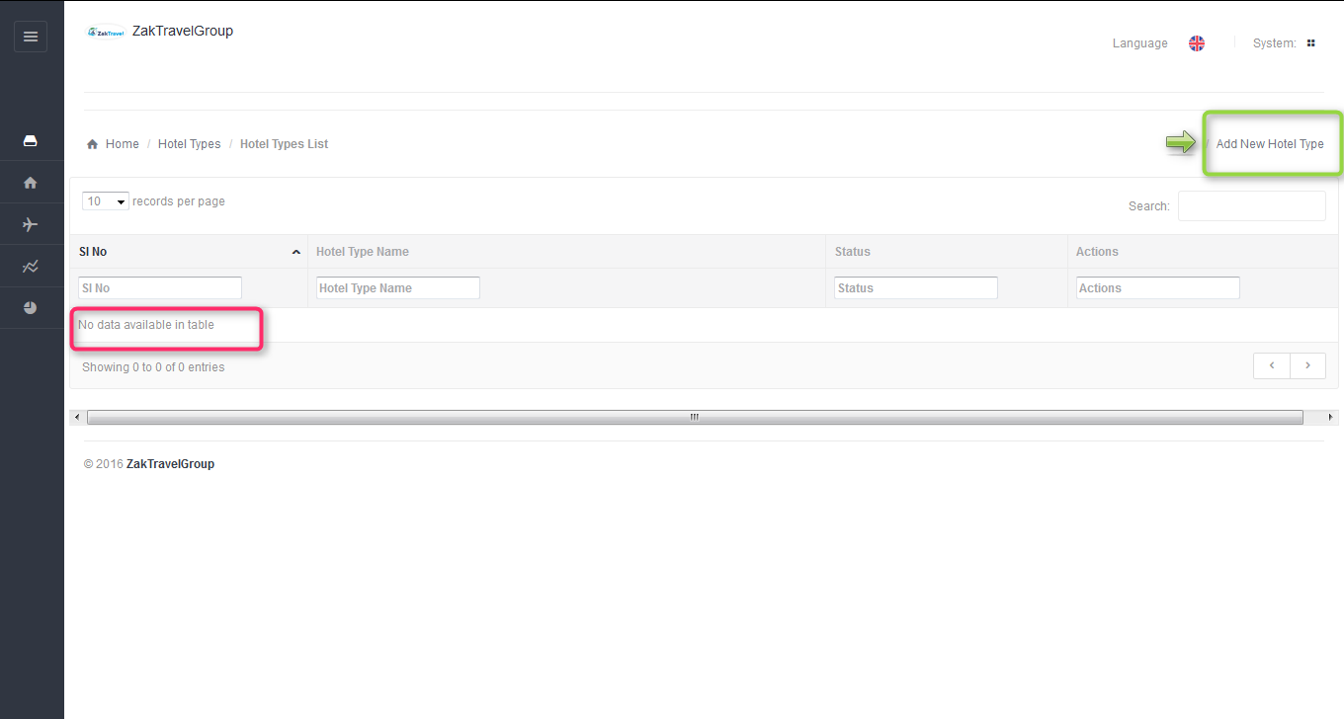

**6.4.2. Steps to add the hotel type:** After click on add new hotel type it will display one form to enter the hotel type details and enter all the valid information and click on add hotel type.

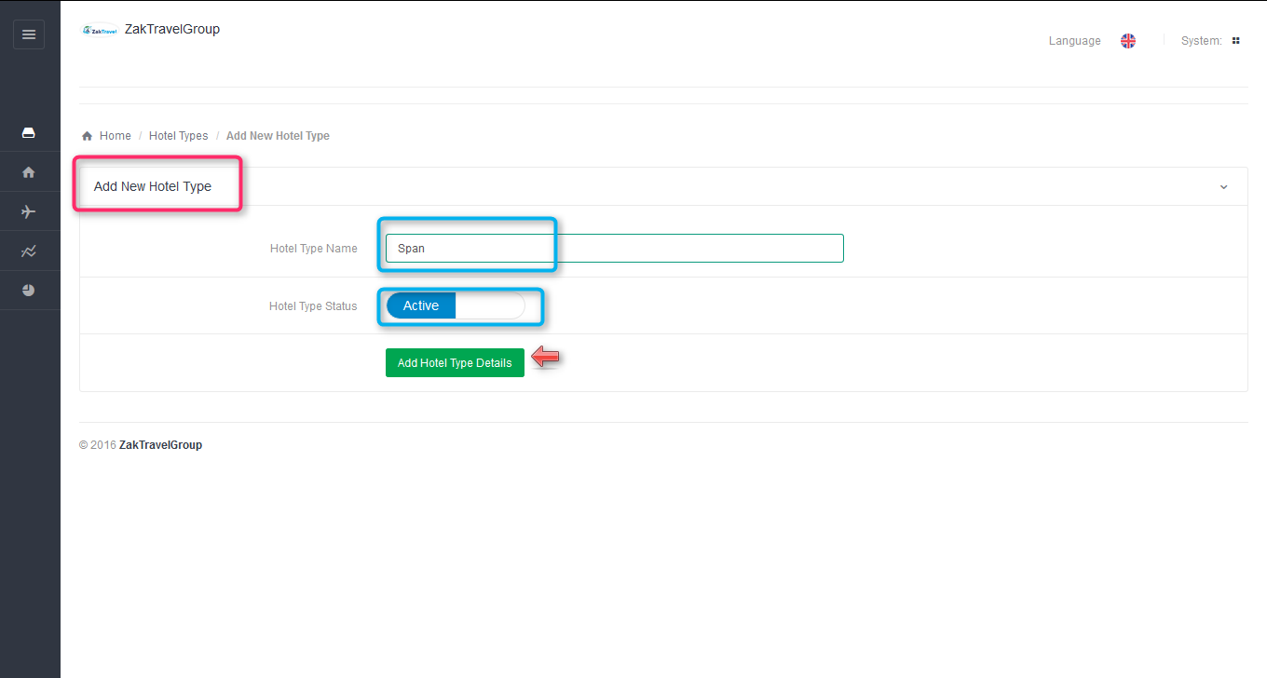

**6.4.3. After adding of hotel type:** After adding the hotel type it will display in the list in supplier panel.

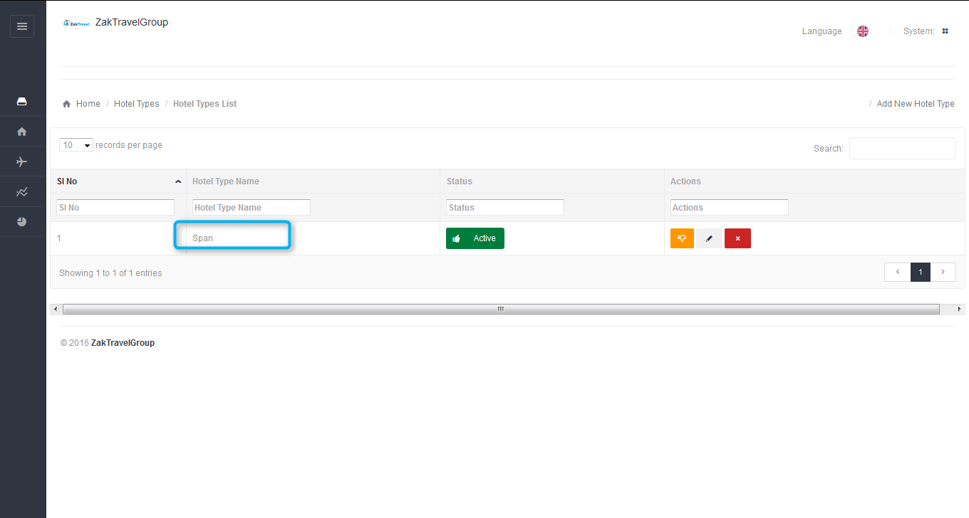

**6.4.4. Steps to Add hotel:** Click on Add hotel and enter all the information and select hotel type which is added before “span” it will display in the hotel type dropdown list.

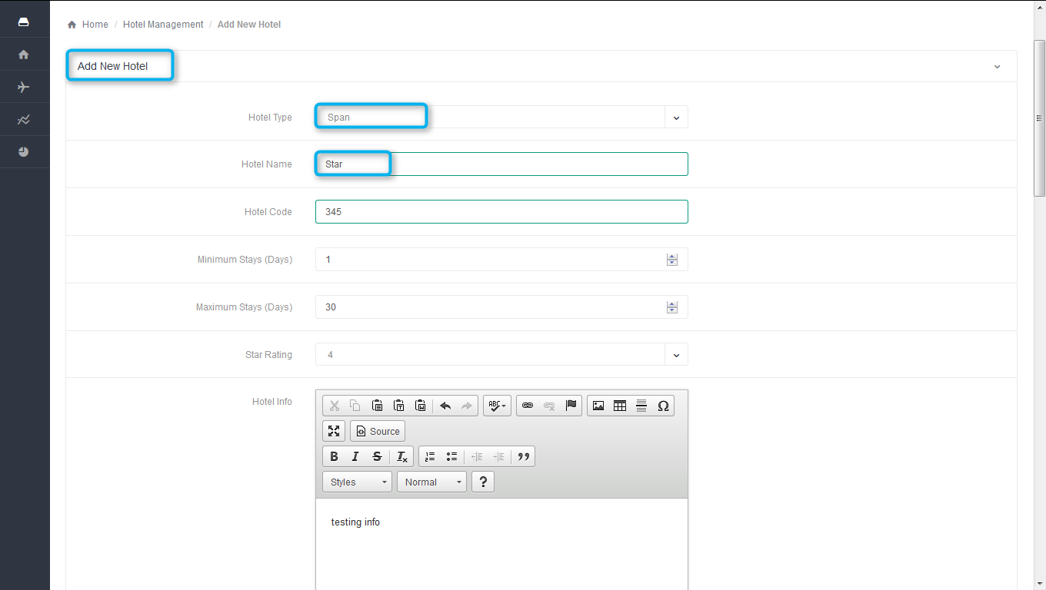

**6.4.5. After adding the hotel in supplier panel:** NowAdded hotel will be displayed in hotel list.

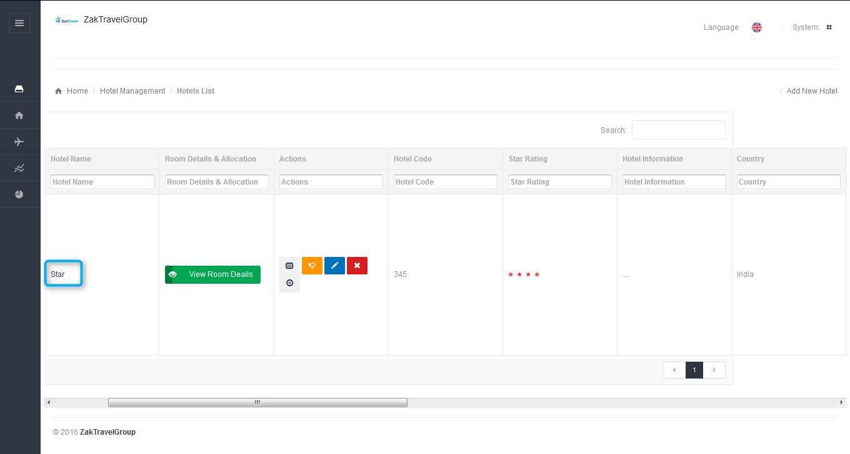

**6.4.6. Add room type:** For hotel need to add the room type and it contain Room code, adult and child capacity, image etc. so it will display in room detail while booking for hotel.

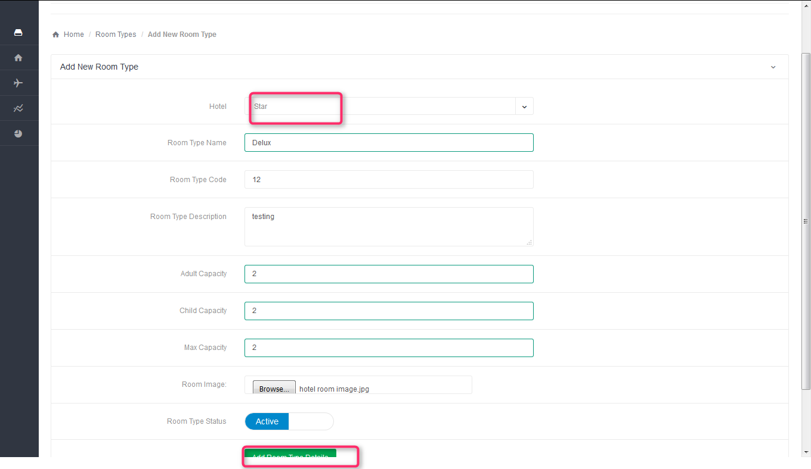

**6.4.7. After adding room type in supplier panel:** The added room type will display in the list.

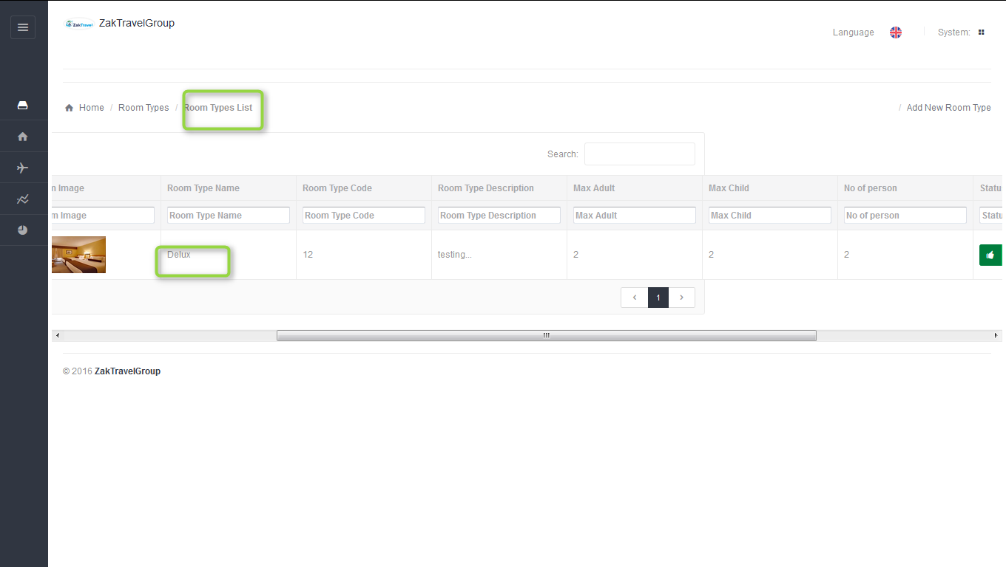

**7. View room detail (Add room):** Now go to the hotel list and allocation and click on view room detailand need to add the new rooms and management.

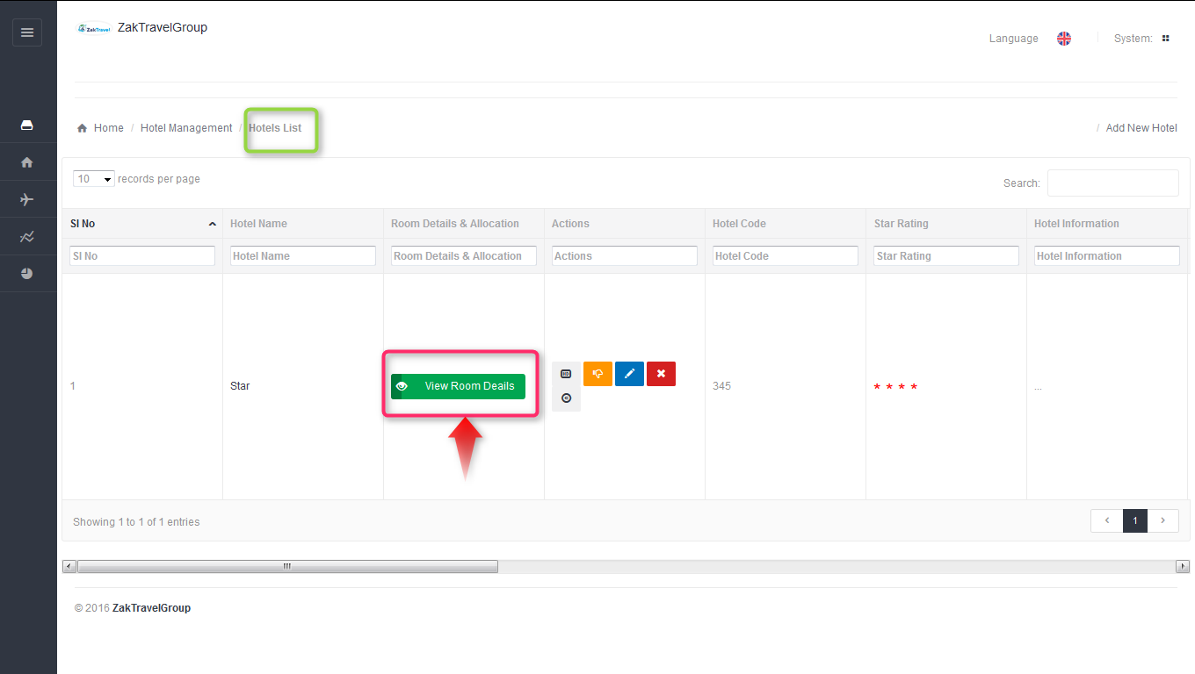

**7.1. Add new room:** Supplier has to add the rooms, Click on add new room and enter the room information and click on save.

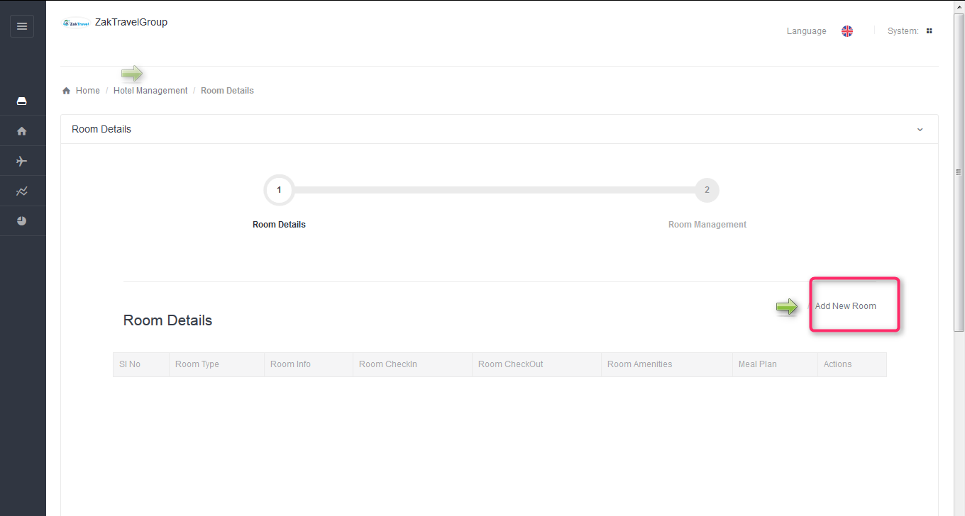

**7.2. Steps to add the room information:**

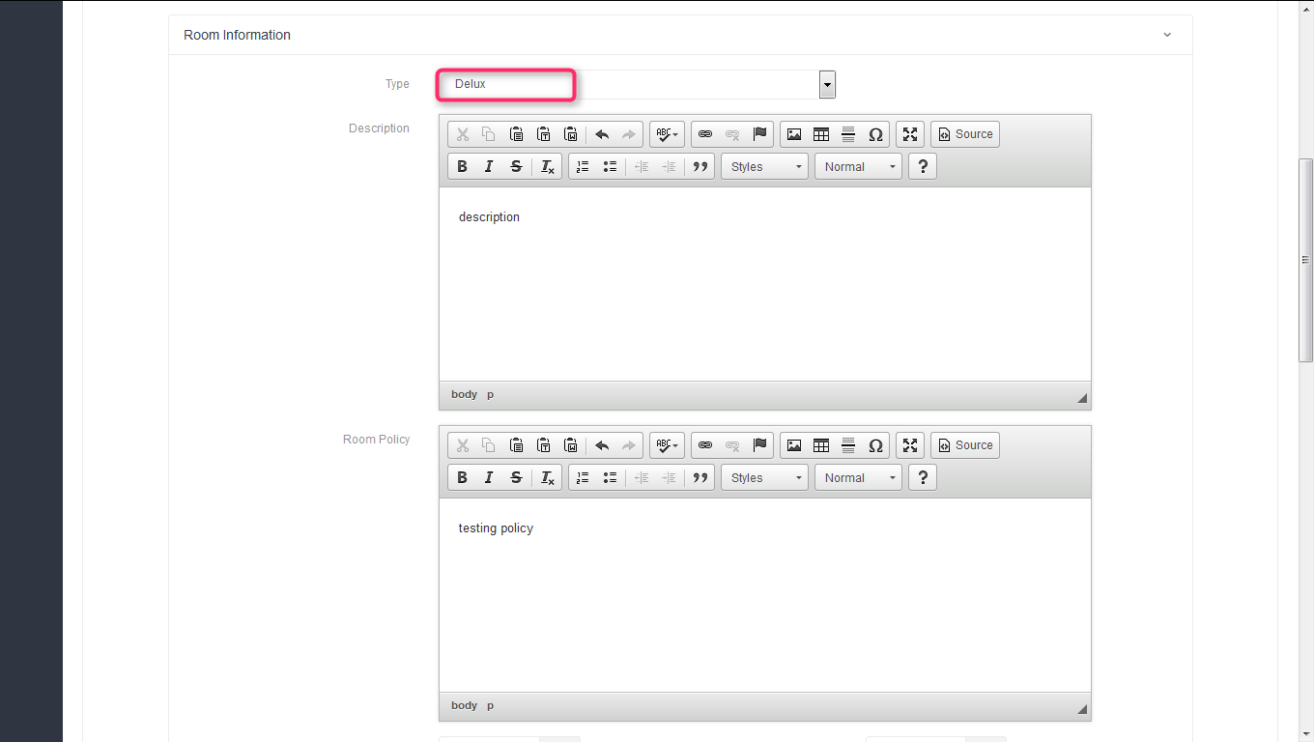

Added information is displayed in room details and now clicks on room management.

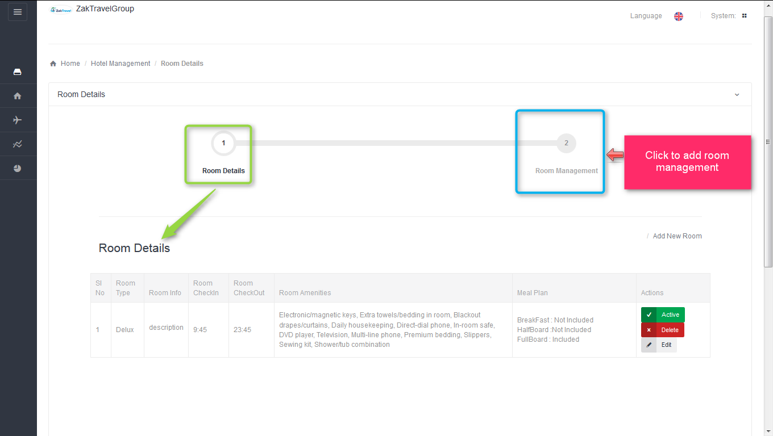

**7.3. Steps to add Room Management:** In the room management room are pre populated, select Allotment Date Range and number of rooms and click on save.

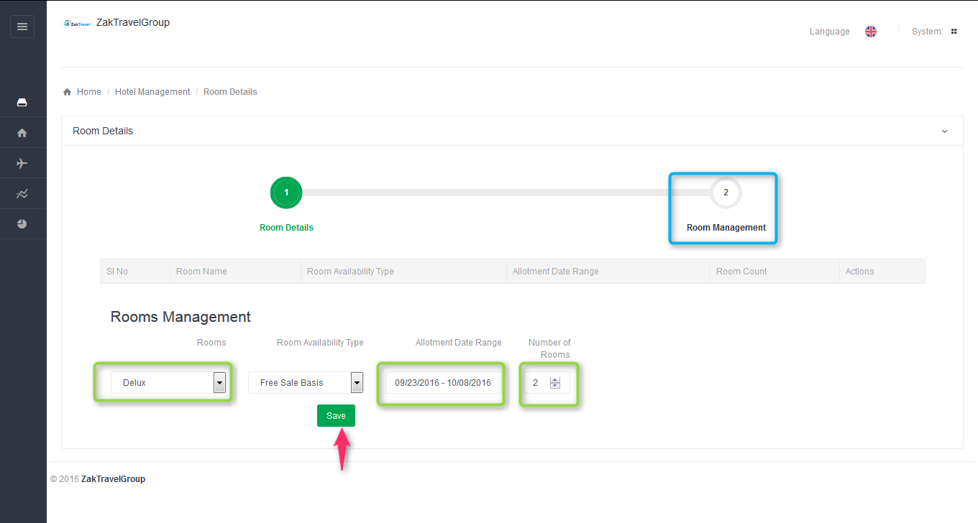

**7.4. After adding the room management:** After adding change the status as active.

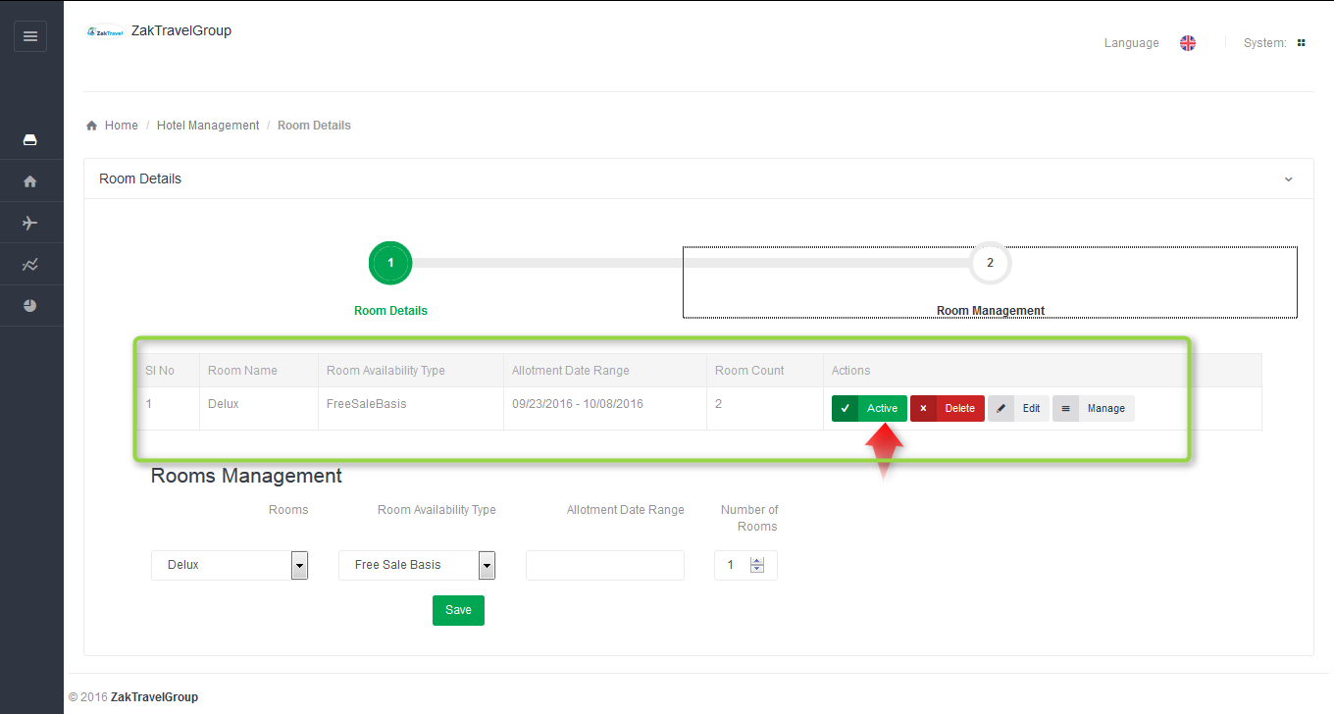

**7.5. Hotel detail:** Supplier has to add hotel basic information and contact information.

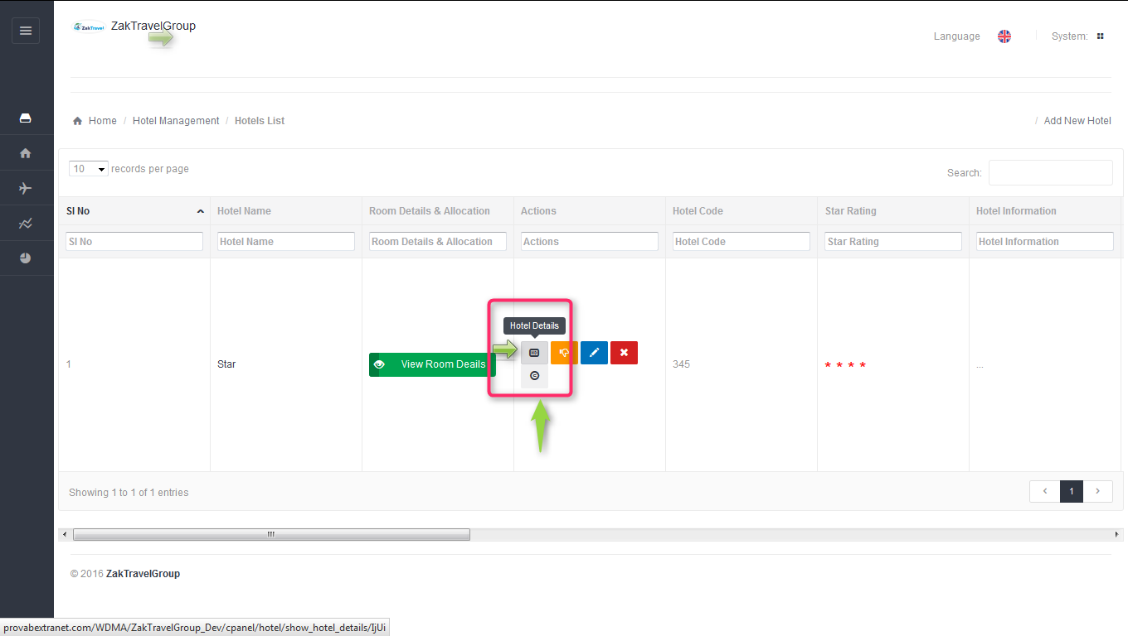

**7.5.1. Hotel basic information:** Basic information is already added.

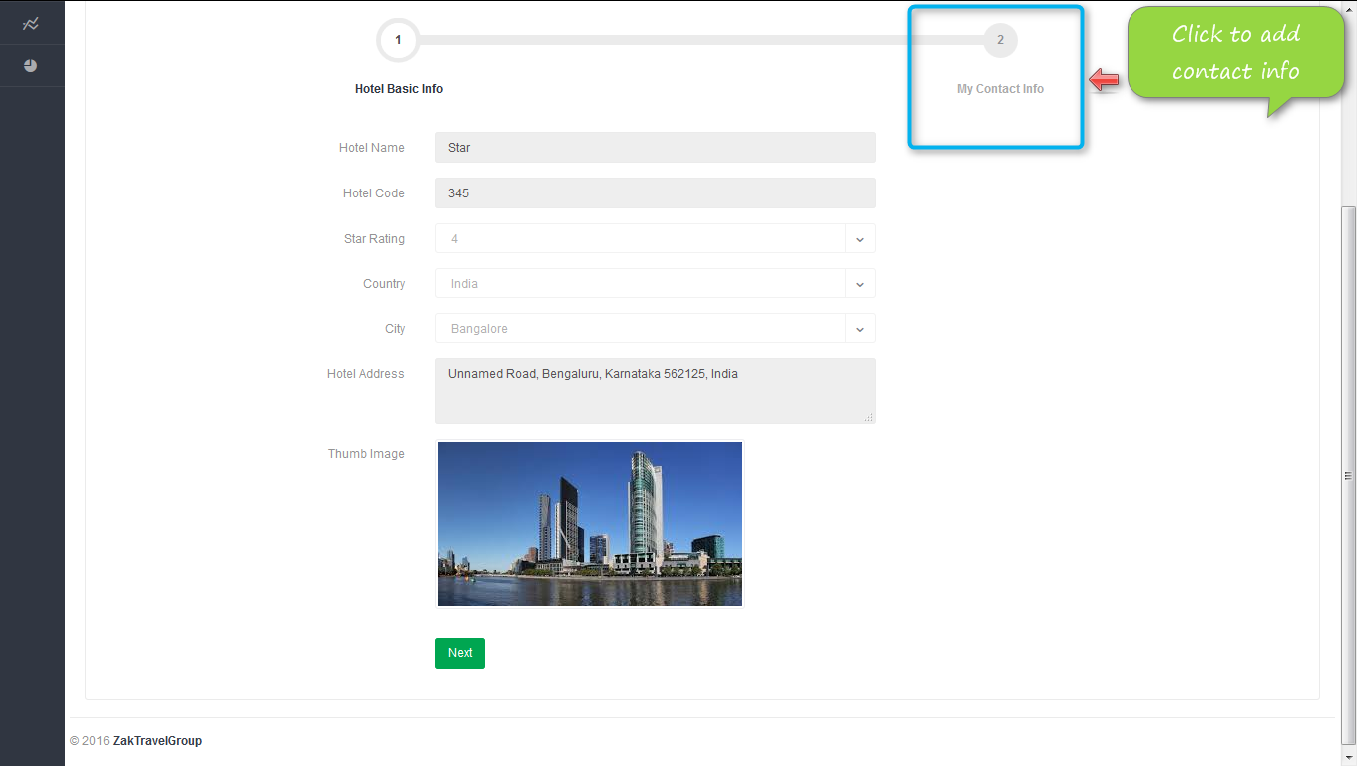

**7.5.2. Add contact information:**

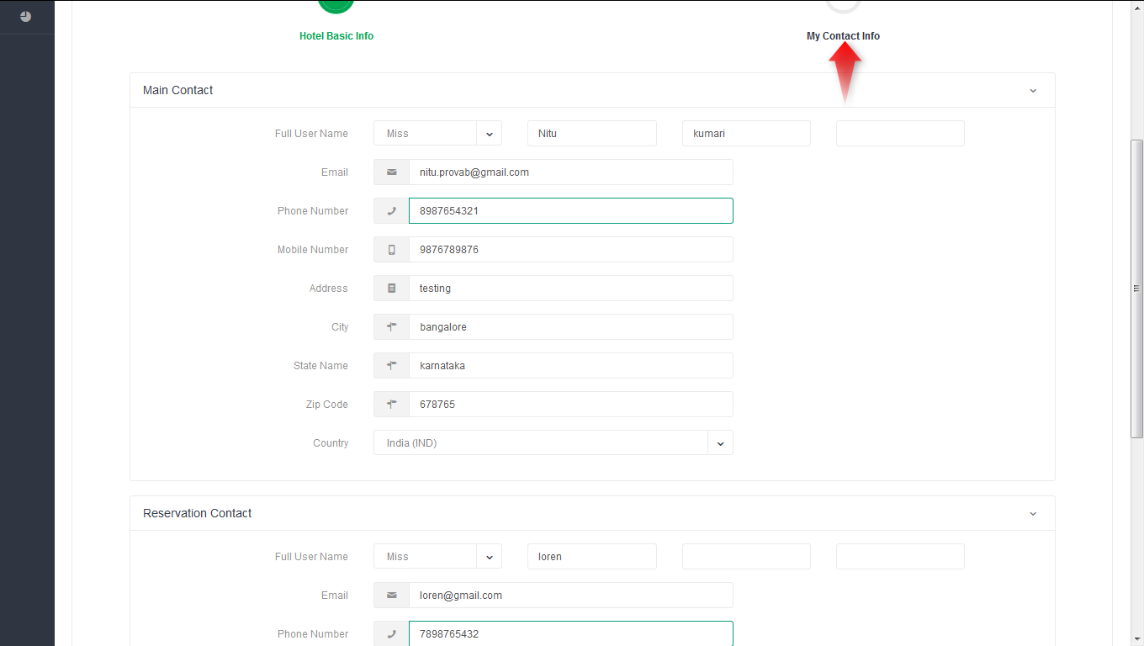

**8. Add room rate:** Click on room rate and select the hotel and room which is created previously and after selecting room, Date rage will display automatically in the date field.

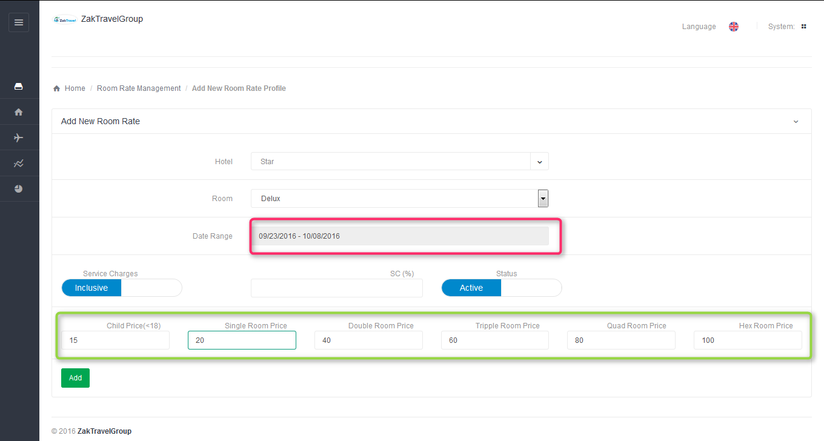

After adding room rate it display in the list.

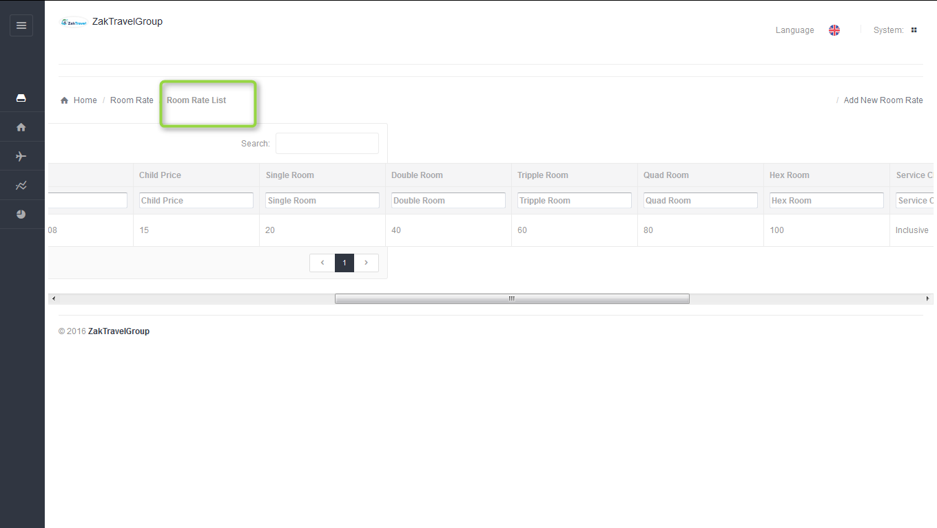

**9. Cancellation Policy:**

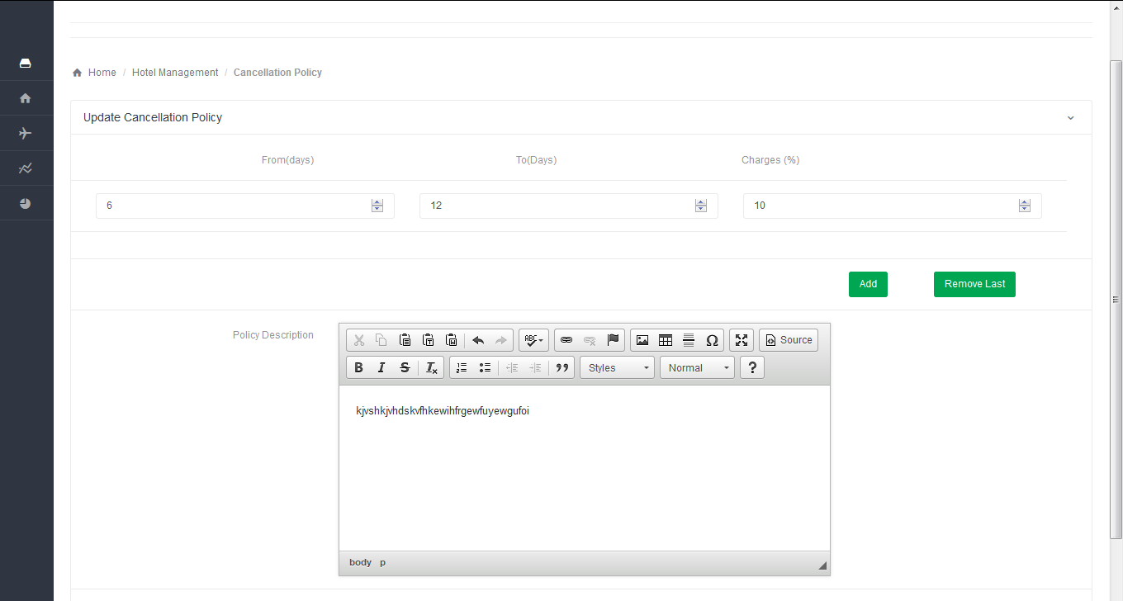

**10. Hotel displayed on front end:** After adding the details of hotel from supplier panel the hotel will be displayed on the front end and from where user can book.

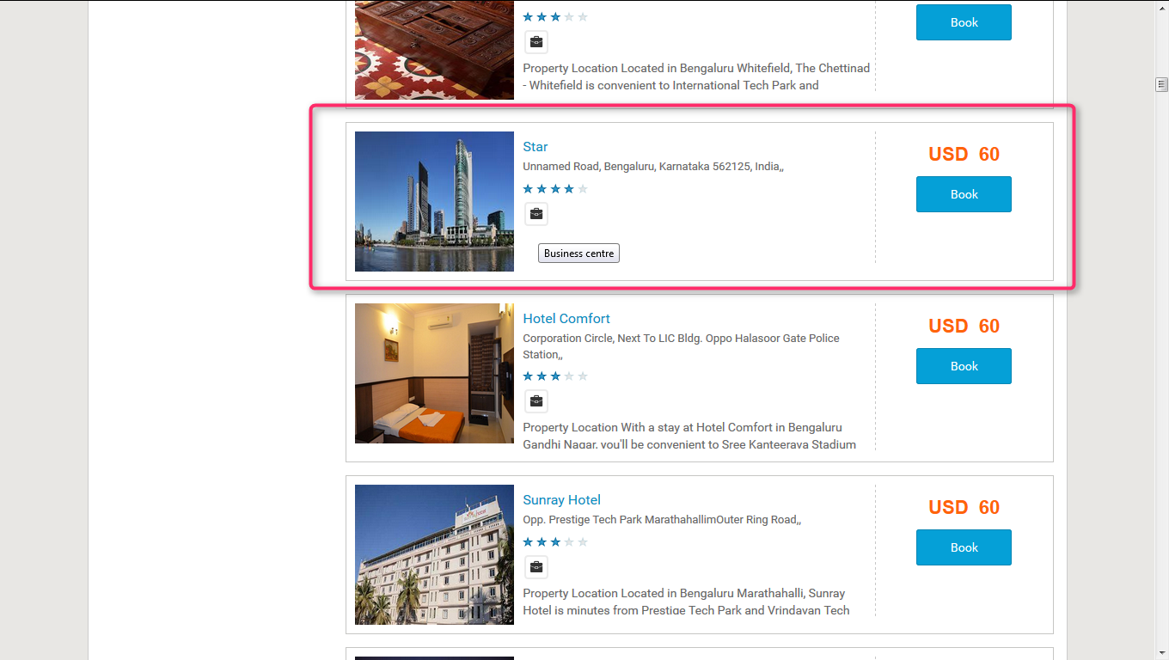

**11. MARKUP for Hotel (B2B, B2C)**: Markup is added by the Admin, after adding the markup from admin panel the markup will be added with total fare and display on front end.

**Markup for B2B:**

**11.1. Before adding the Markup for Hotel Admin panel (B2B):** Markup will not display in the list before adding.

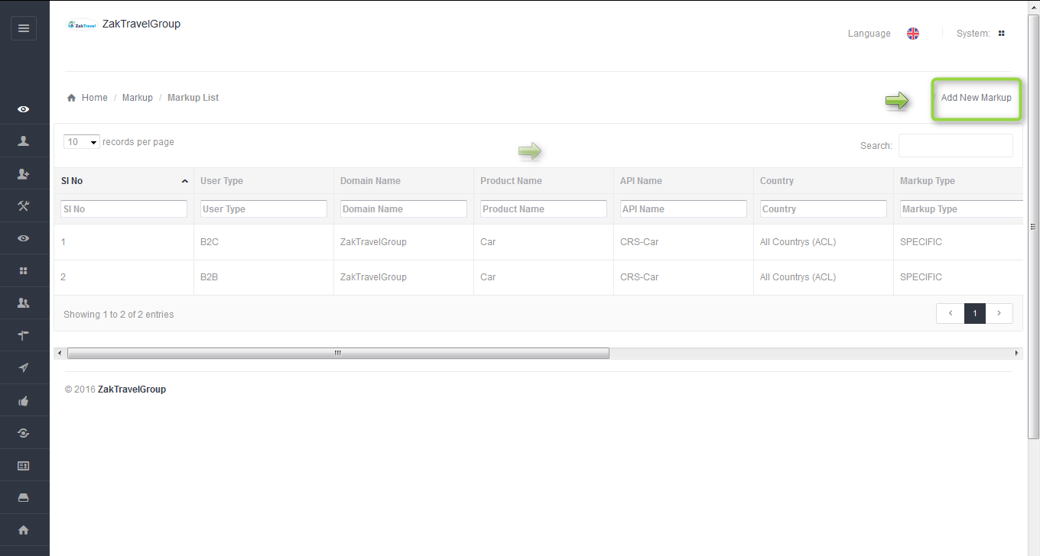

**11.2. Front End Without adding markup (B2B):** For a particular agentthe markup is not added with total fare so whatever the amount is added at the time of transfer creation that amount will be display only and total fare will display without markup.

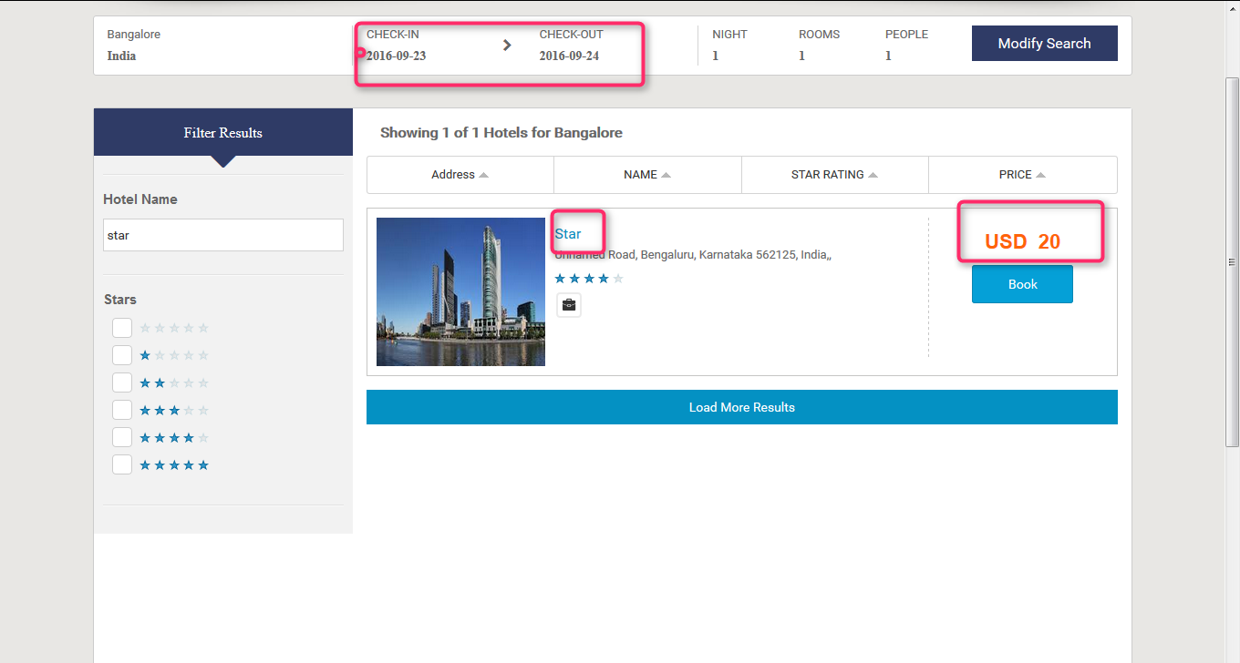

**11.3. Steps to add markup for hotel (Admin panel):** After click on add markup one form will be displayed and enter all the required information like user type, product, API, and markup value type, etc.

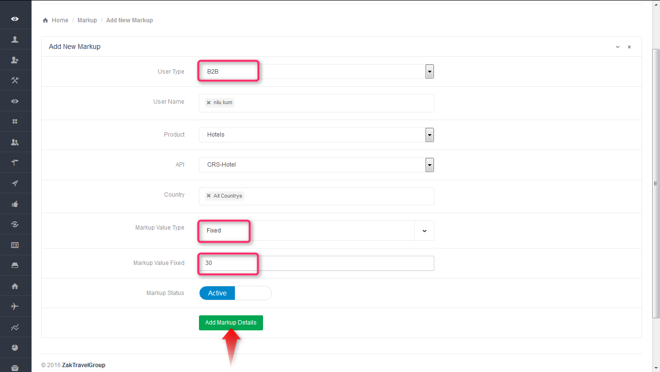

**11.4.Markup list admin panel for B2B**: Here admin add the markup for particular agent , select the user type as B2B , user name means for which agent admin add the markup, product as a Hotel , API CRS Hotel , country and markup type. After adding the markup will display in the list.

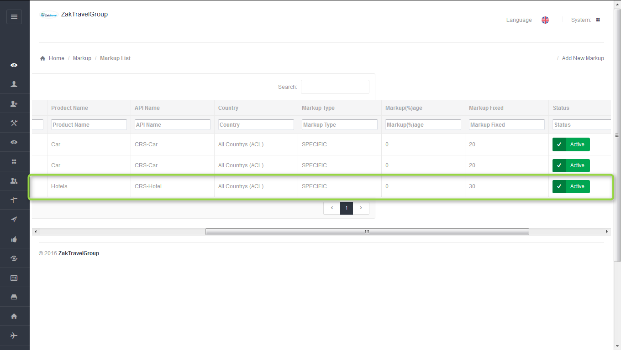

**11.5**. **Front end with Markup (B2B):** Now the added markup will be display with the total fare, for one day the markup added is 30 rupees now and markup will be added according to number of days.

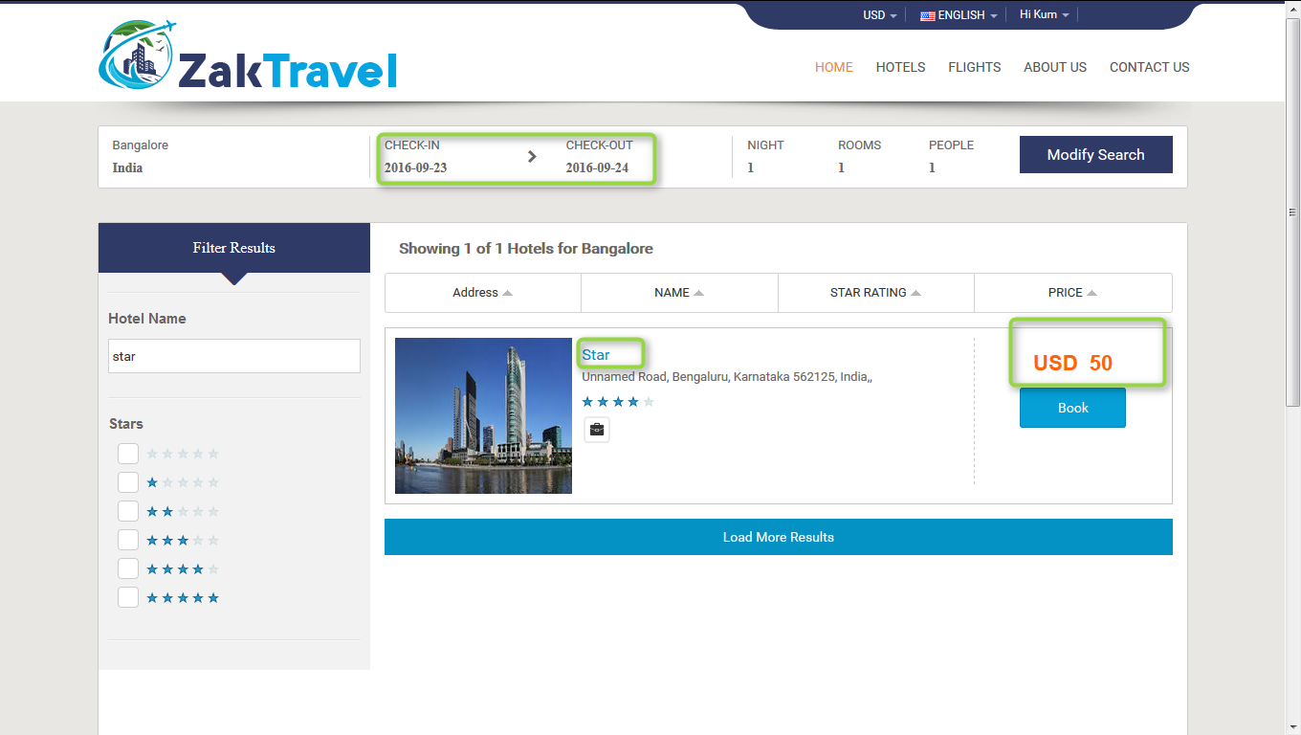

**11.6. Activation and Inactivation for markup:** After click on inactive the markup will not add with the total fare for adding the markup the status should be in active state.

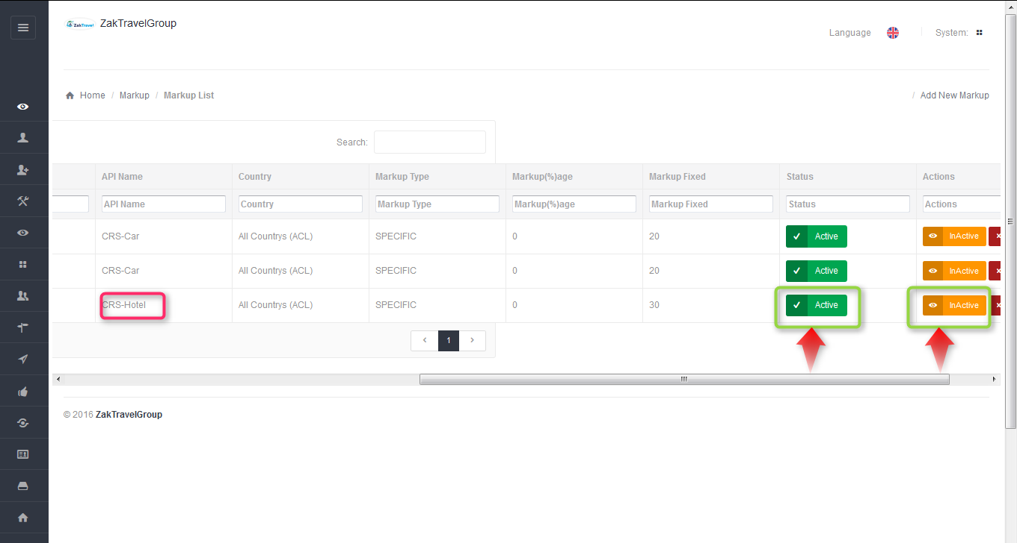

Active Inactive

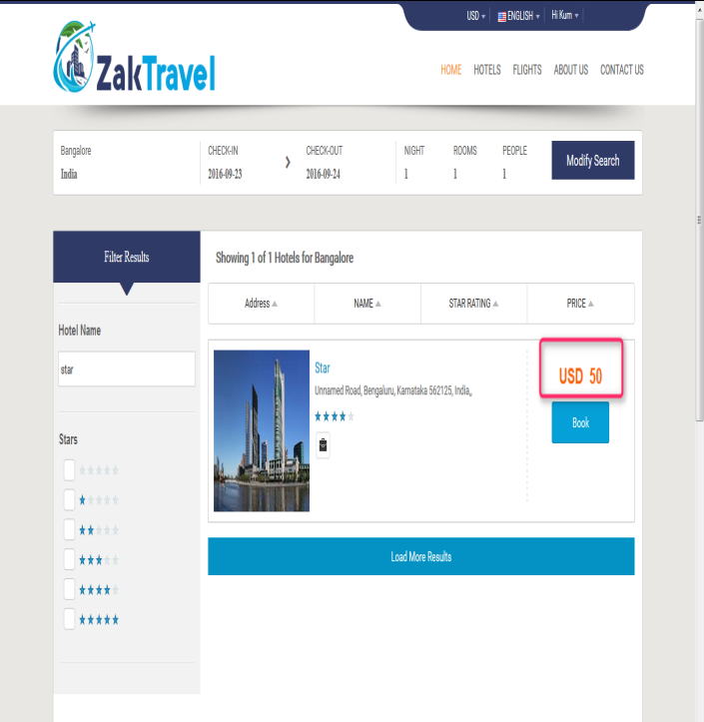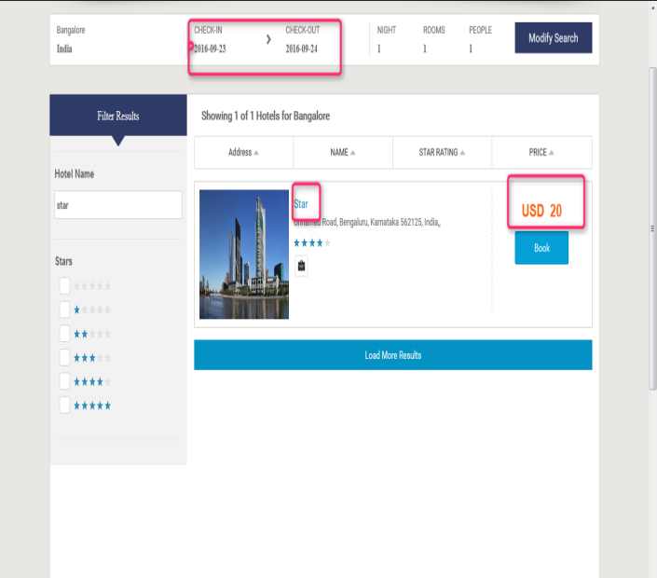

**11.7. Booking for Hotel (B2B):**

Users can book the particular hotel by providing their personal details. And they will get confirmation letter. Now click on hotel tab and provide all the valid detail and search for the hotel.

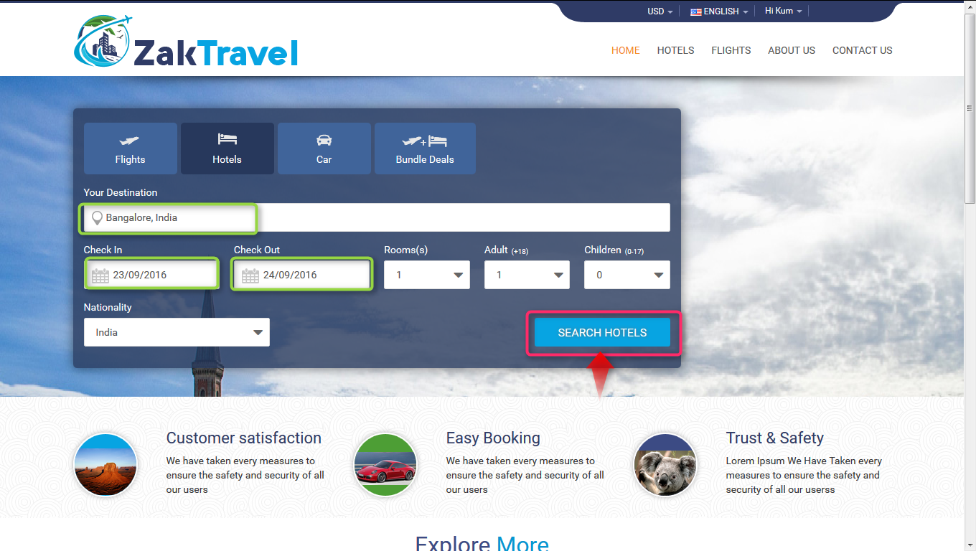

After click on search, the hotel search result will displayed. So click on Book button for booking the Hotel.

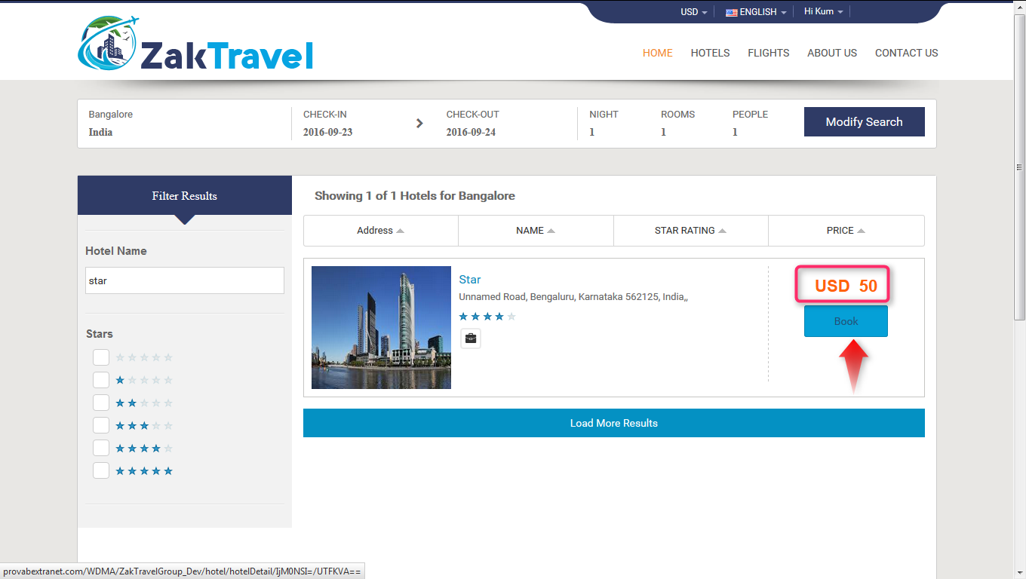

Now after click on book button it will open review, travelers and payment information and click on continue tab it will open the form to enter the personal information.

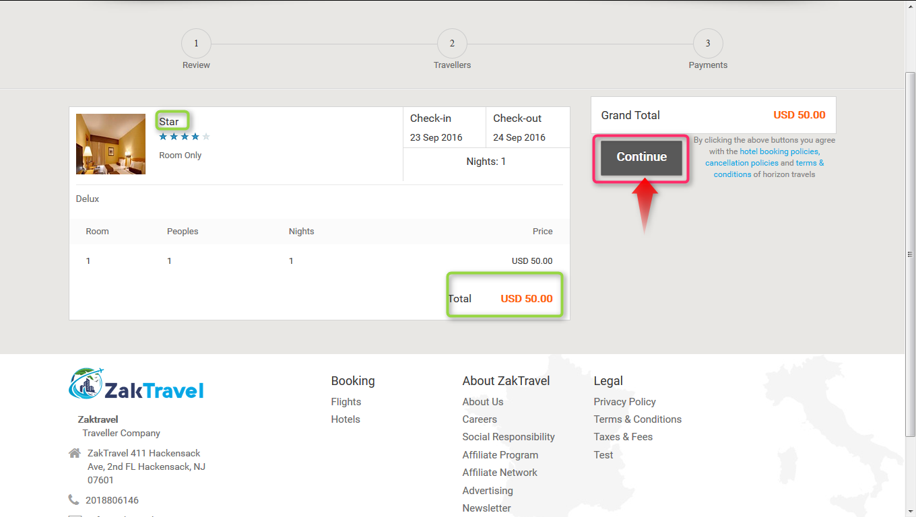

Provide all the valid information and click on continue button and check the check box for terms and conditions.

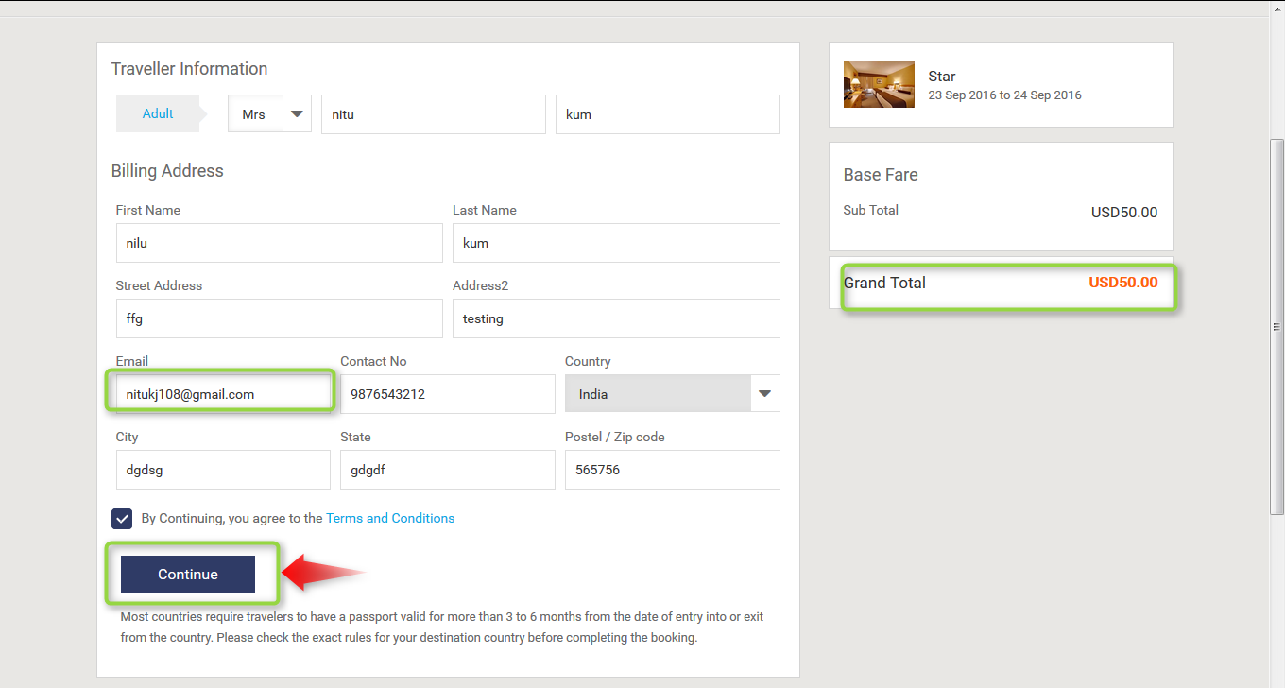

**11.8. Voucher page for Hotel (B2B)**: Voucher page display after providing all the information and click on continue button and everything will be present on the voucher page like booking status, reservation number, Traveler, date, amount etc.

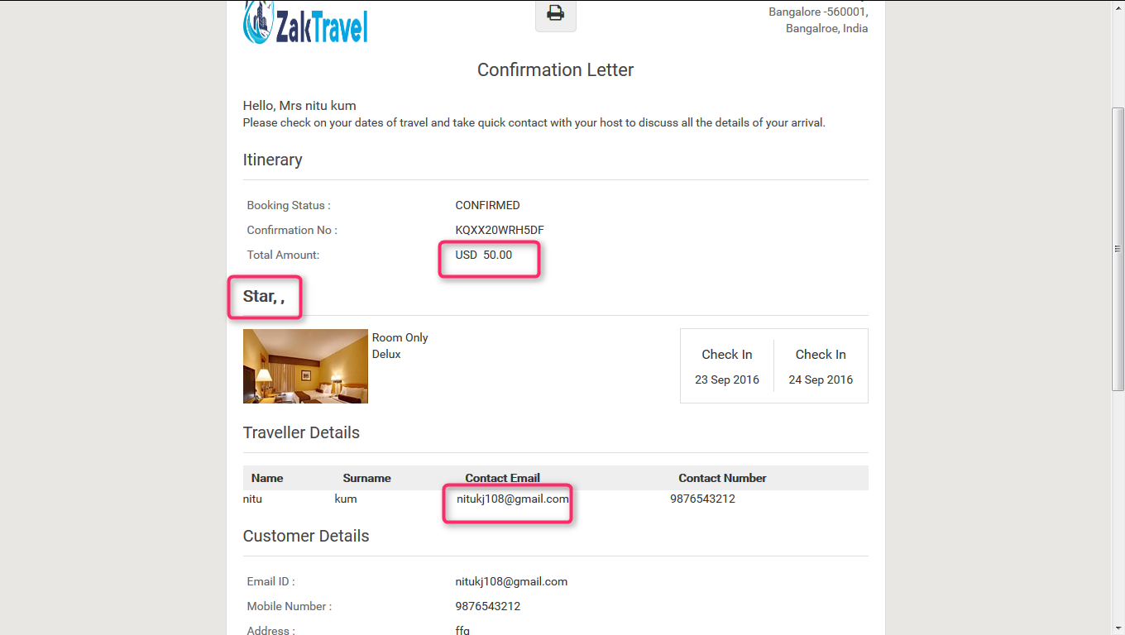

**12. (B2C) Markup:**

**12.1. Before adding the Markup for Hotel Admin panel (B2C):** Markup will not display in the list before adding.

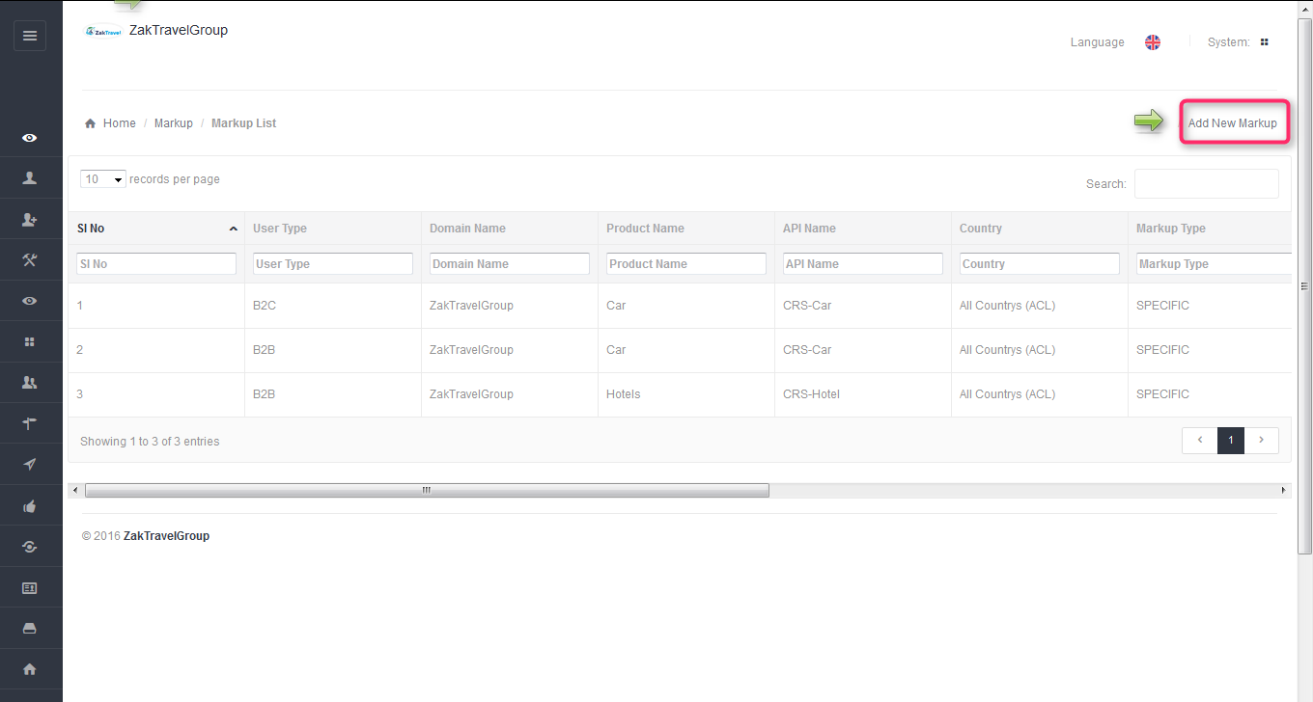

**12.2. Front End Without adding markup (B2C):** For a particular agentthe markup is not added with total fare so whatever the amount is added at the time of transfer creation that amount will be display only and total fare will display without markup.



**12.3. Steps to add markup for hotel (Admin panel B2C):** After click on add markup one form will be displayed and enter all the required information like user type, product, API, and markup value type, etc.

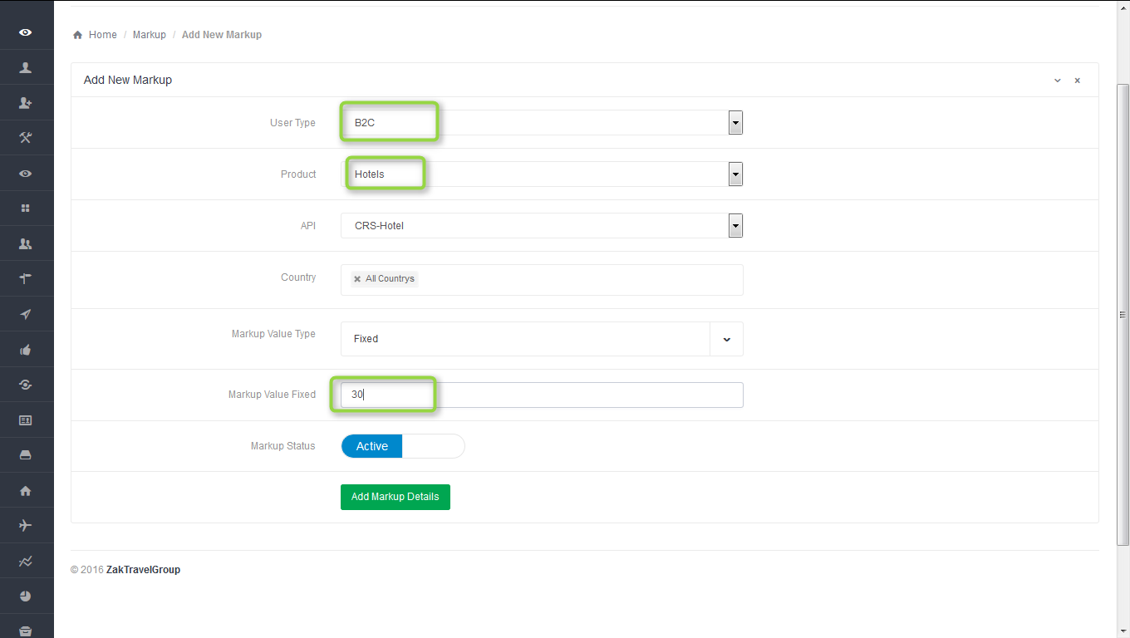

**12.4.Markup list admin panel for B2C**: Here admin add the markup for particular agent , select the user type as B2C , user name means for which agent admin add the markup, product as a Hotel , API CRS Hotel , country and markup type. After adding the markup will display in the list.

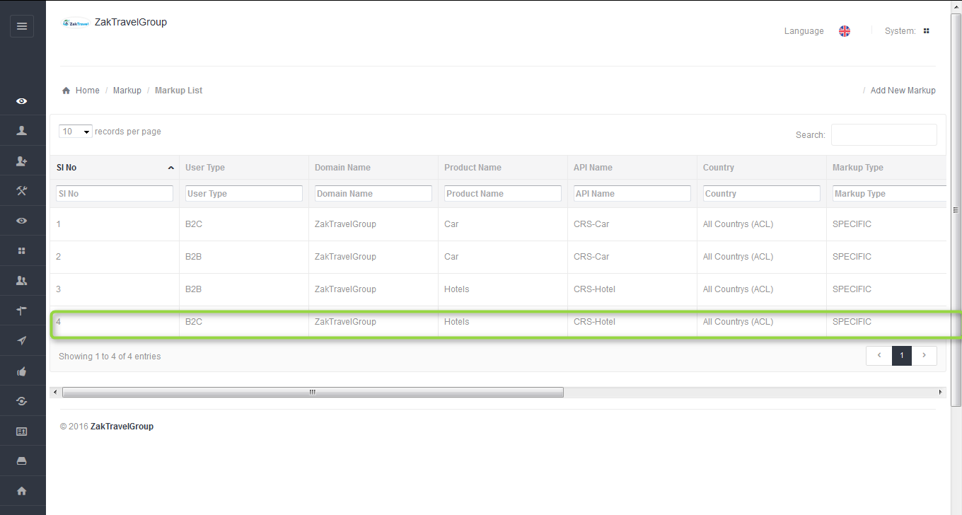

**12.5**. **Front end with Markup (B2C):** Now the added markup will be display with the total fare, for one day the markup added is 30 rupees now and markup will be added according to number of days.



**12.6. Activation and Inactivation for markup:** After click on inactive the markup will not add with the total fare for adding the markup the status should be in active state.

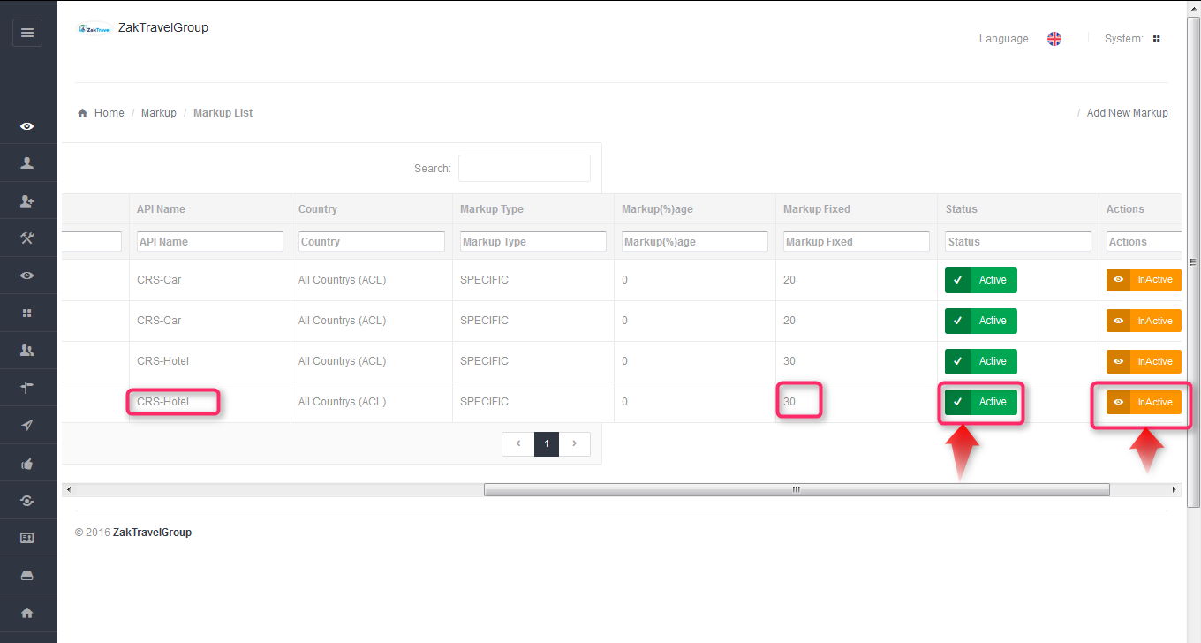

Active Inactive

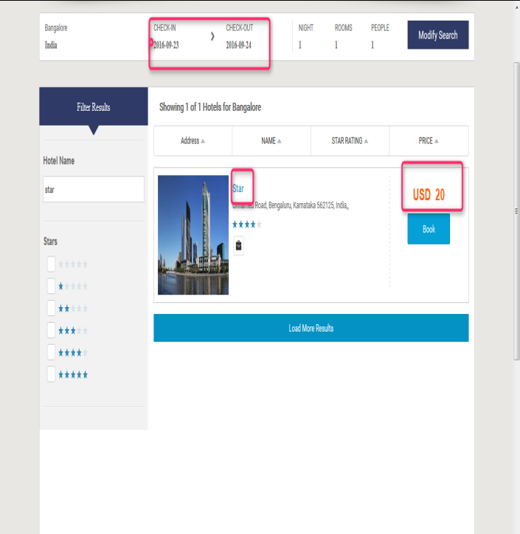

**12.7. Booking for Hotel (B2C):**

Users can book the particular hotel by providing their personal details. And they will get confirmation letter. Now click on hotel tab and provide all the valid detail and search for the hotel.



After click on search, the hotel search result will displayed. So click on Book button for booking the Hotel.



Now after click on book button it will open review, travelers and payment information and click on continue tab it will open the form to enter the personal information.



Provide all the valid information and click on continue button and check the check box for terms and conditions.

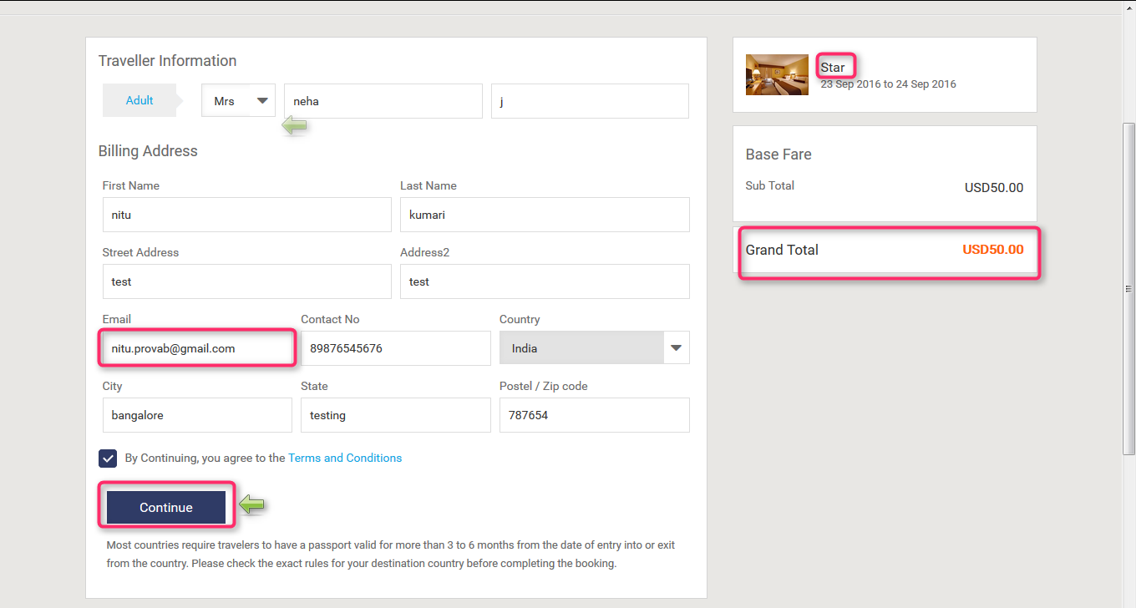

**12.8. Voucher page for Hotel (B2C)**: Voucher page display after providing all the information and click on continue button and everything will be present on the voucher page like booking status, reservation number, Traveler, date, amount etc.

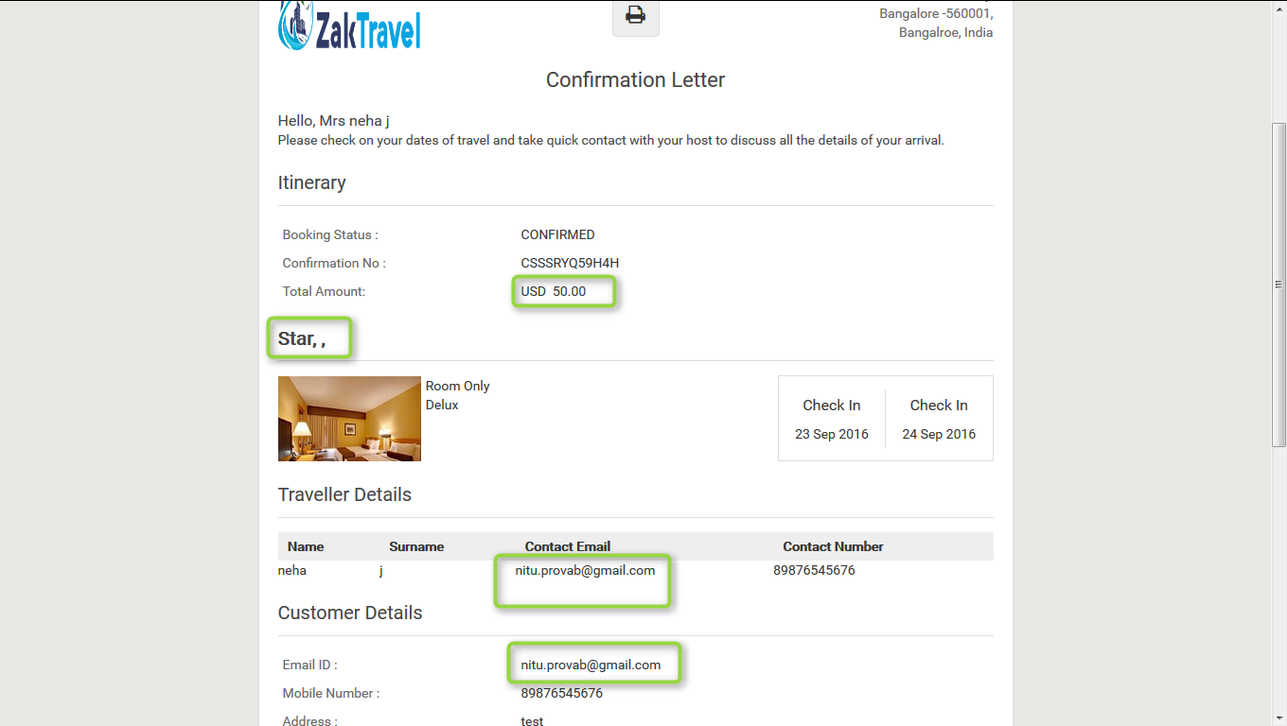

**13. FLIGHT:**

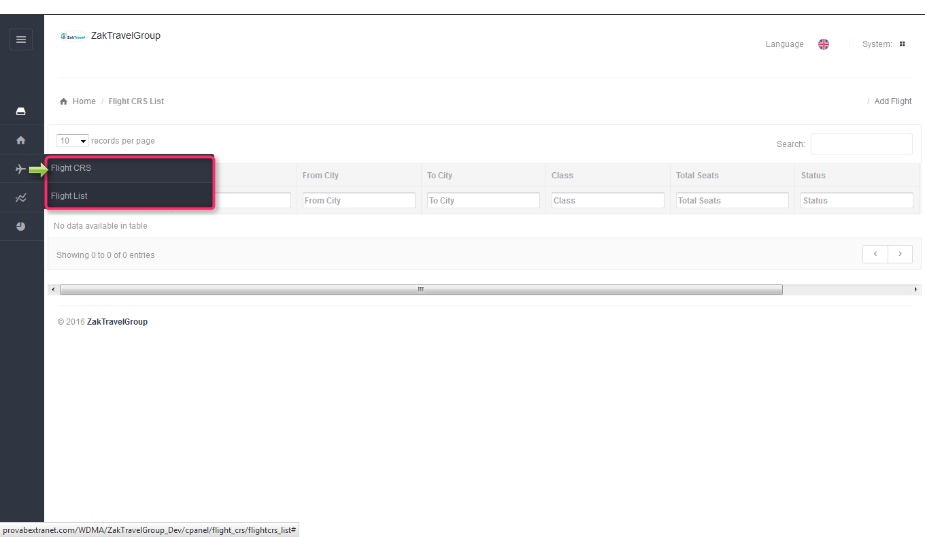

**13.1. Before adding the flight:** Supplier needs to add the flight and can edit and delete also.

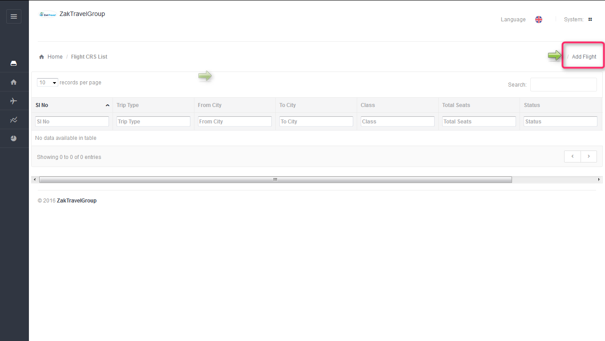

**13.2. Steps to add the flight:** Click on add flight, select flight trip, from, to, departure, number of seats etc and click on add flight details.

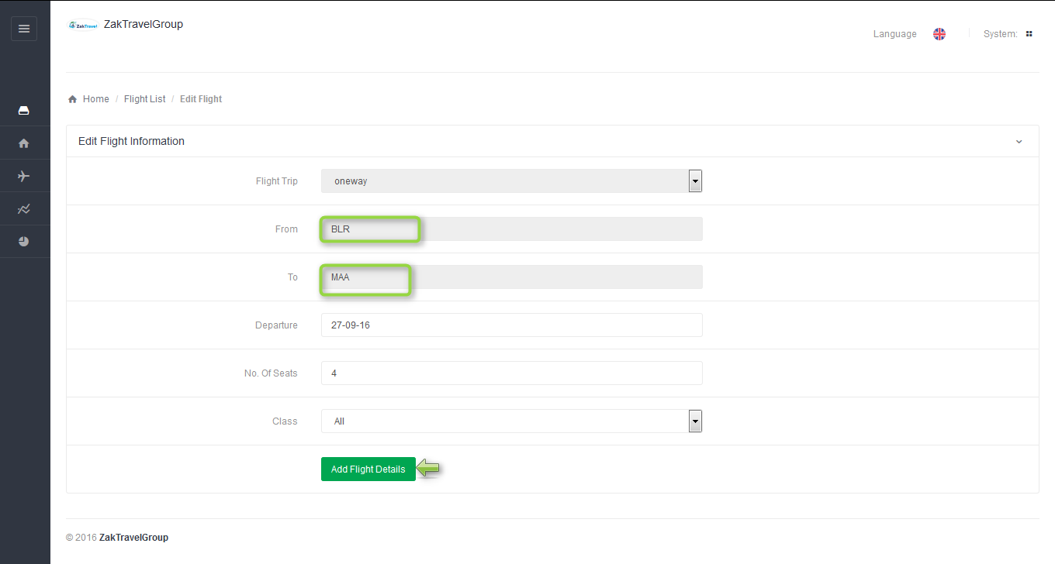

**13.3. After adding the flight:** After adding the flight it will display in the flight list in supplier panel and change the status as active.

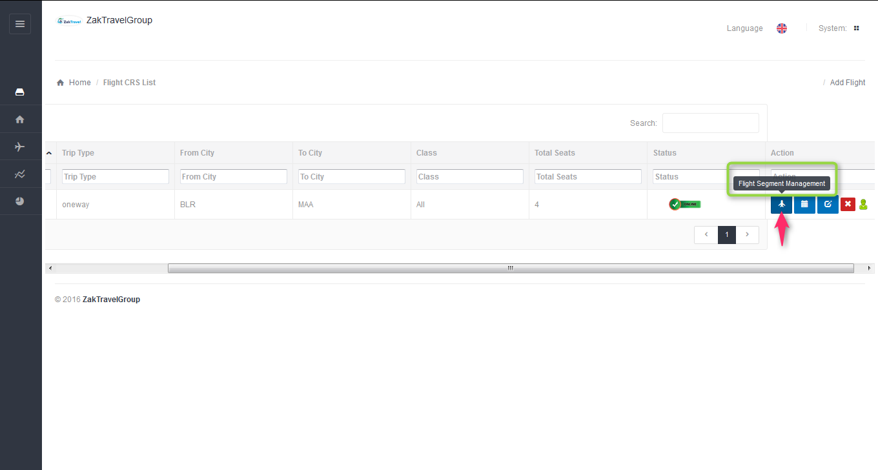

**13.4. Add Flight segment management:** Here need to add the flight segment.

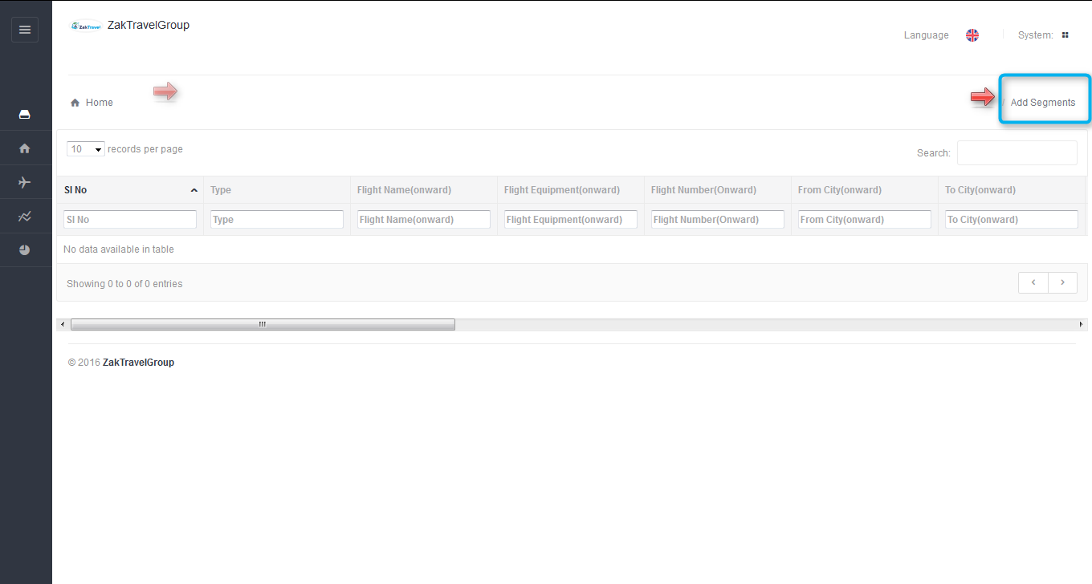

**13.5. Steps to add the Flight segment :** Click on add flight segment now flight segment page will open and enter the flight name, Flight Equipment , number, Origin, destination , Departure and arrival Time, arrival at . And click on add flight segment.

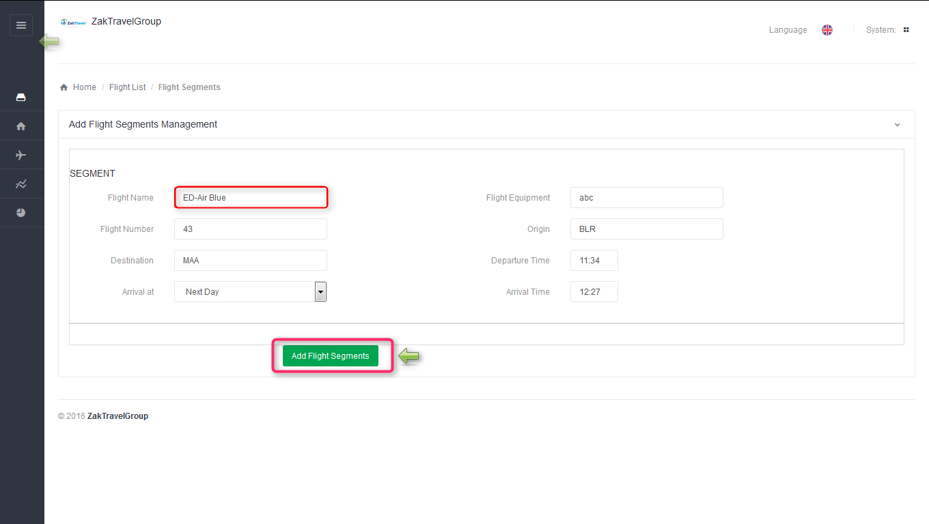

**13.6. After adding the flight segment:** Flight segment will display in the list now.

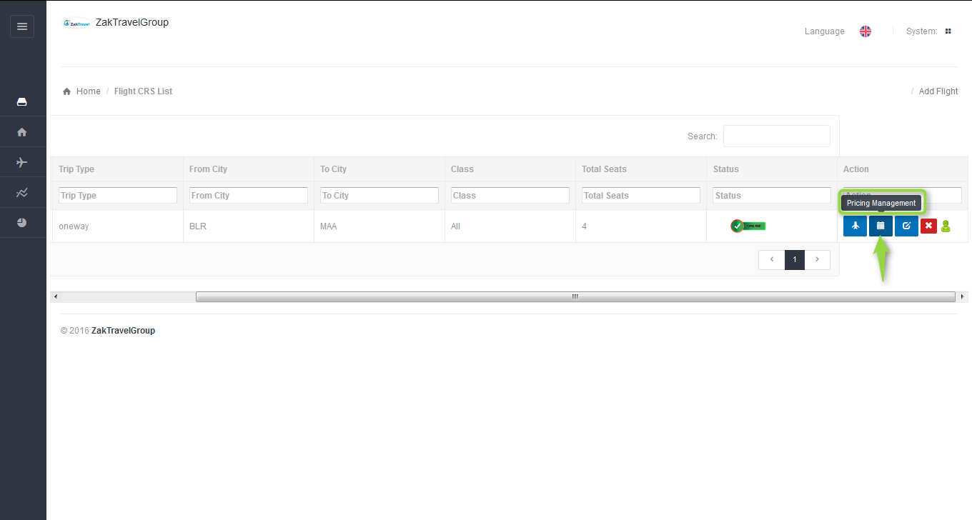

**13.7. Price Management for flight:** Here need to add the price for flight.

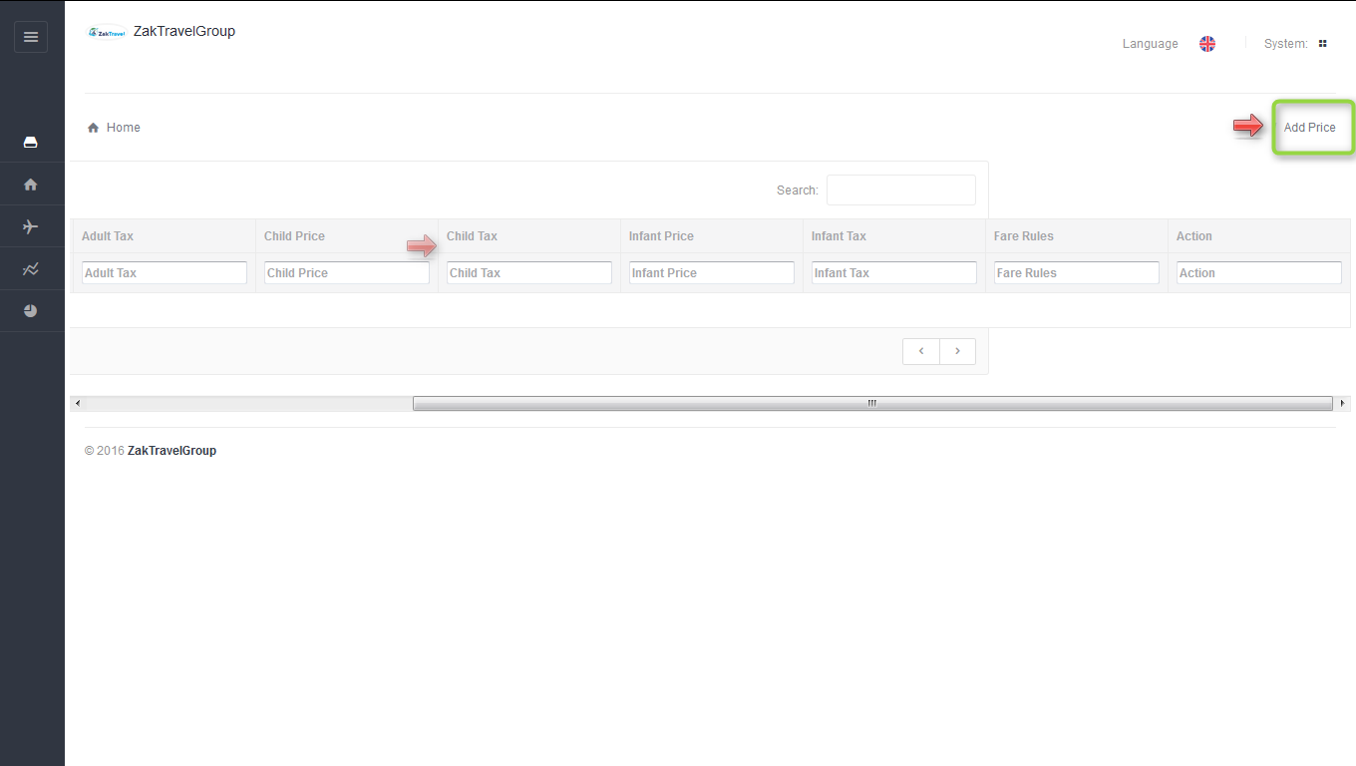

**13.8. Steps to add the price for flight:** Click on add price and select adult, child, infant price and tax, and click on add now flight pricing is added.

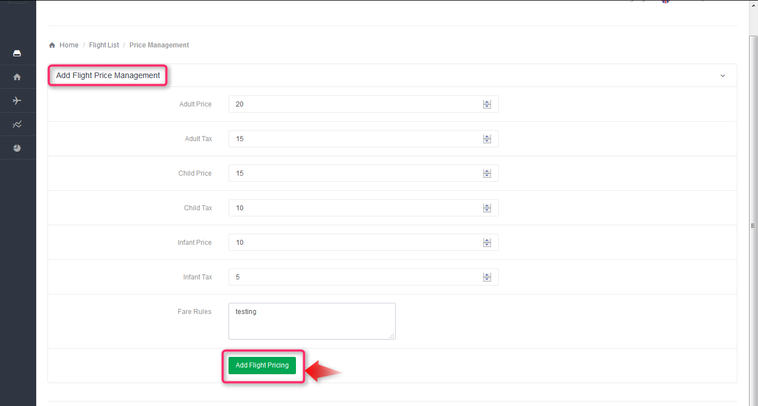

**14. Flight displayed on Front End:** After adding the flight and details from supplier panel the Flight will be displayed on the front end and from where user can book the flight.

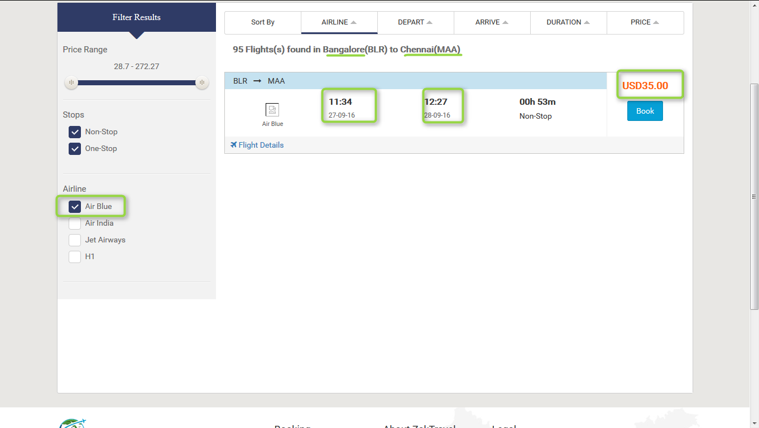

**14.1. Active and Inactive for Flight:** After change the status as inactive from the supplier or admin panel where Flight is added, the flight will not be display on the front end for displaying need to change the status as active.

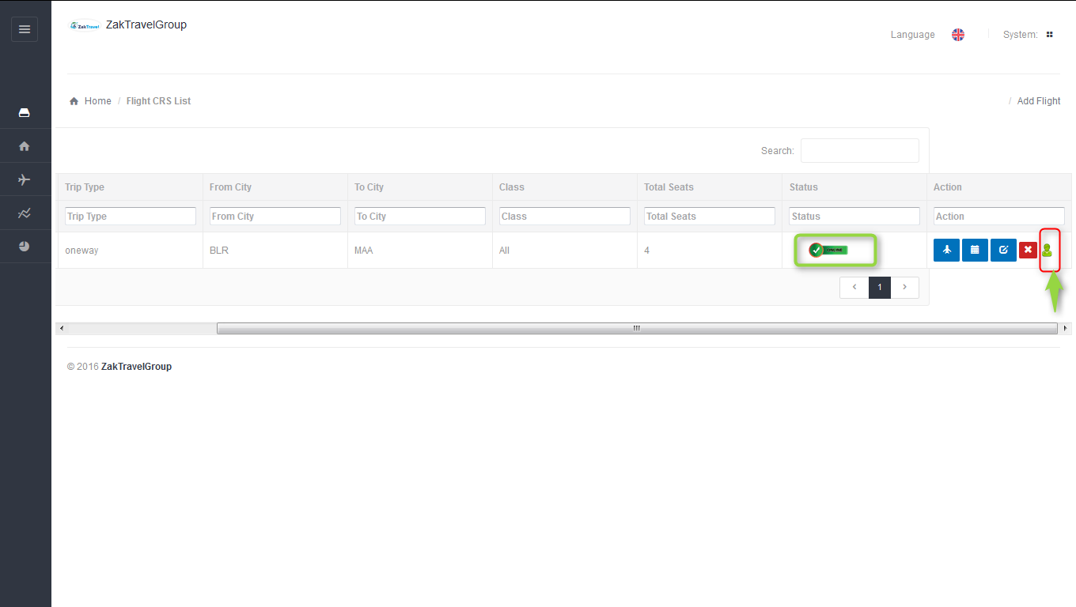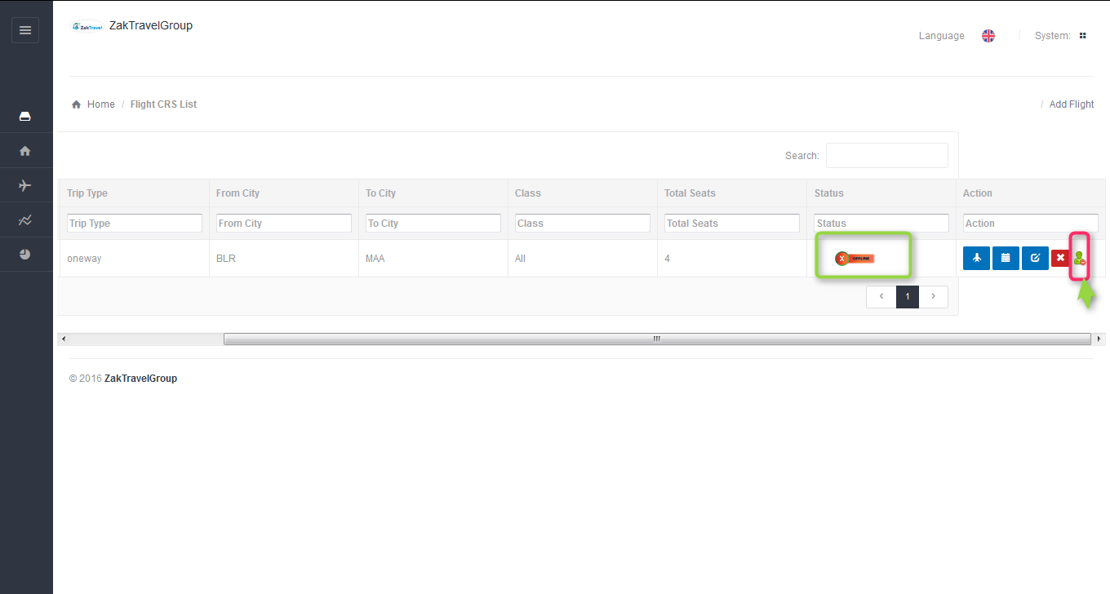

Active Inactive

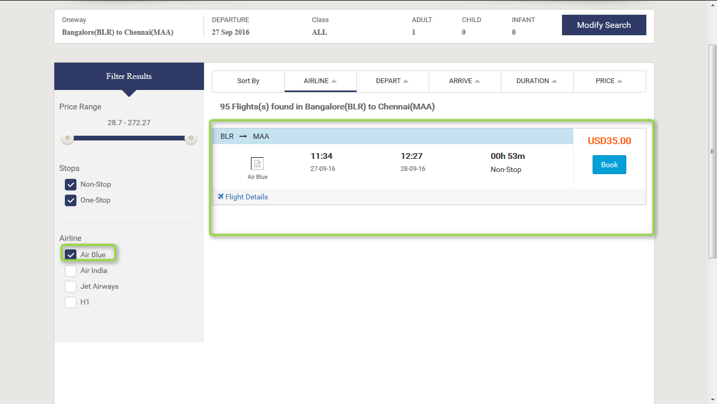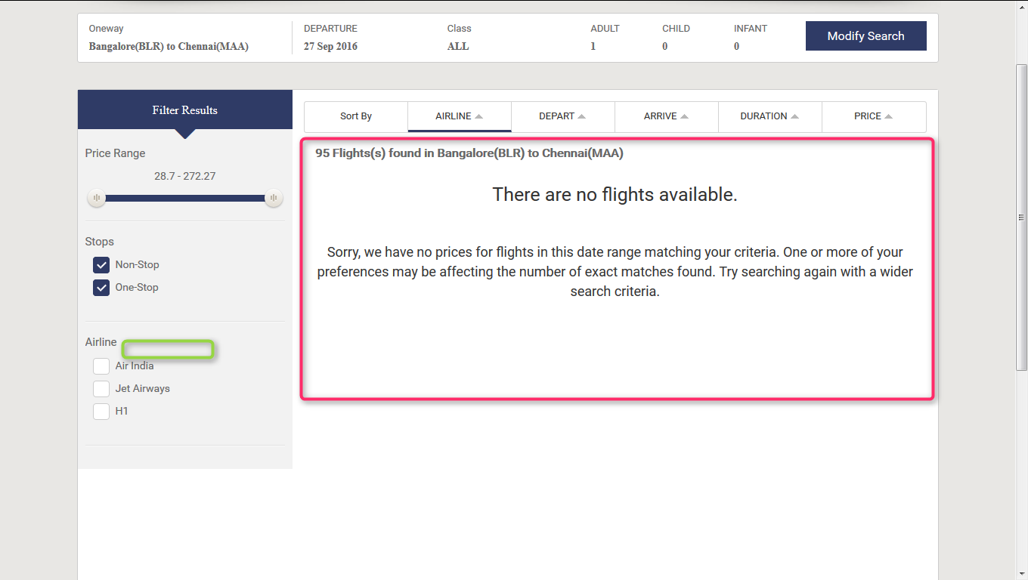

**15. MARKUP for Flight (B2B, B2C)**: Markup is added by the Admin, after adding the markup from admin panel the markup will be added with total fare and display on front end.

**15.1. Markup for B2B Flight:**

**15.2. Before adding the Markup for flight Admin panel (B2B):** Markup will not display in the list before adding.

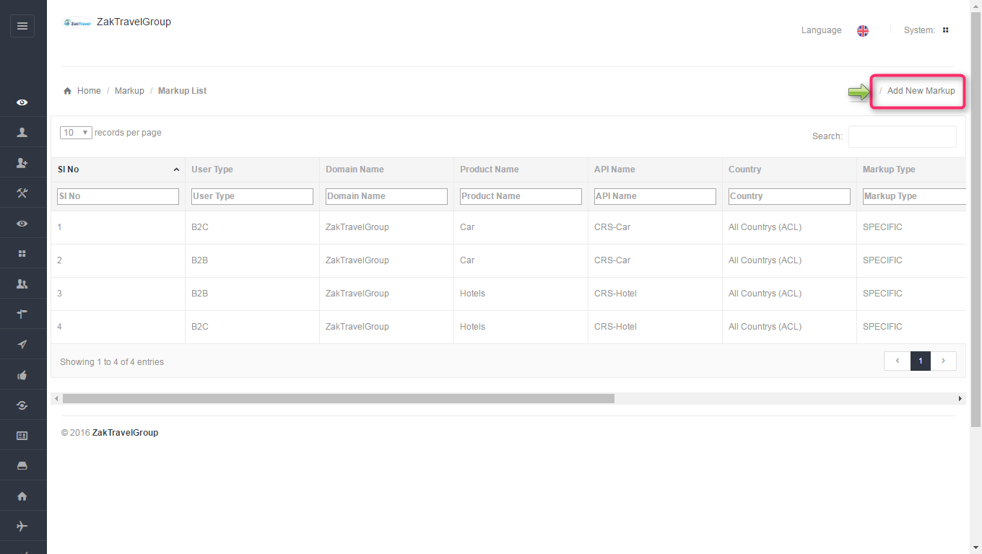

**15.3. Front End Without adding markup (B2B):** For a particular agentthe markup is not added with total fare so whatever the amount is added at the time of rate management that amount will be display only and total fare will display without markup.

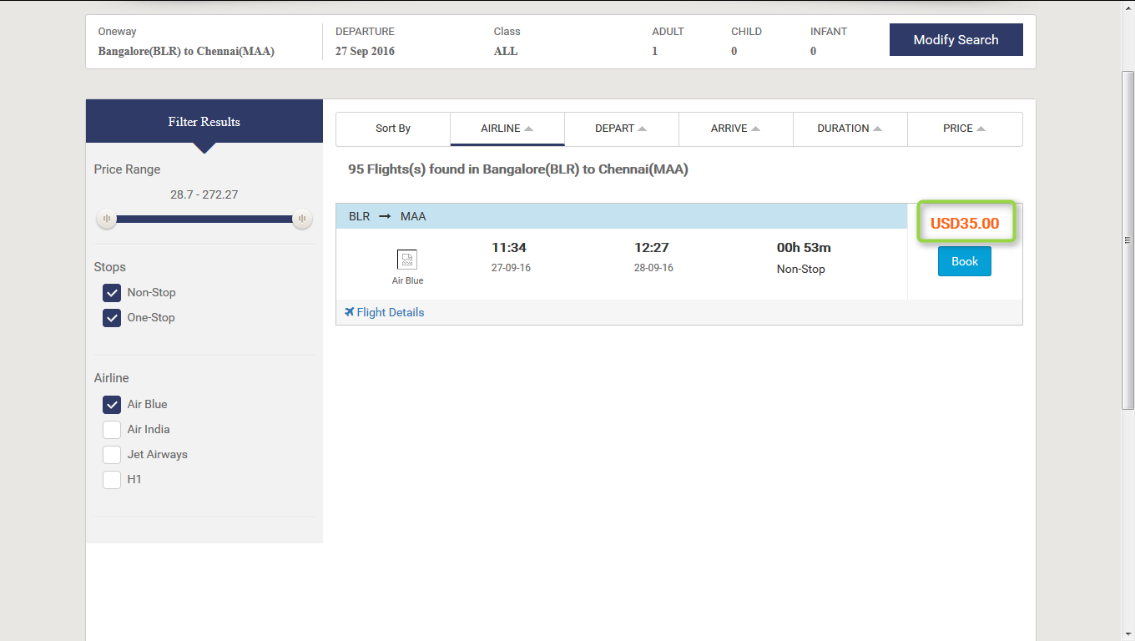

**15.4. Steps to add markup for Flight (B2B) Admin panel:** After click on add markup one form will be displayed and enter all the required information like user type, product, API, and markup value type, etc.

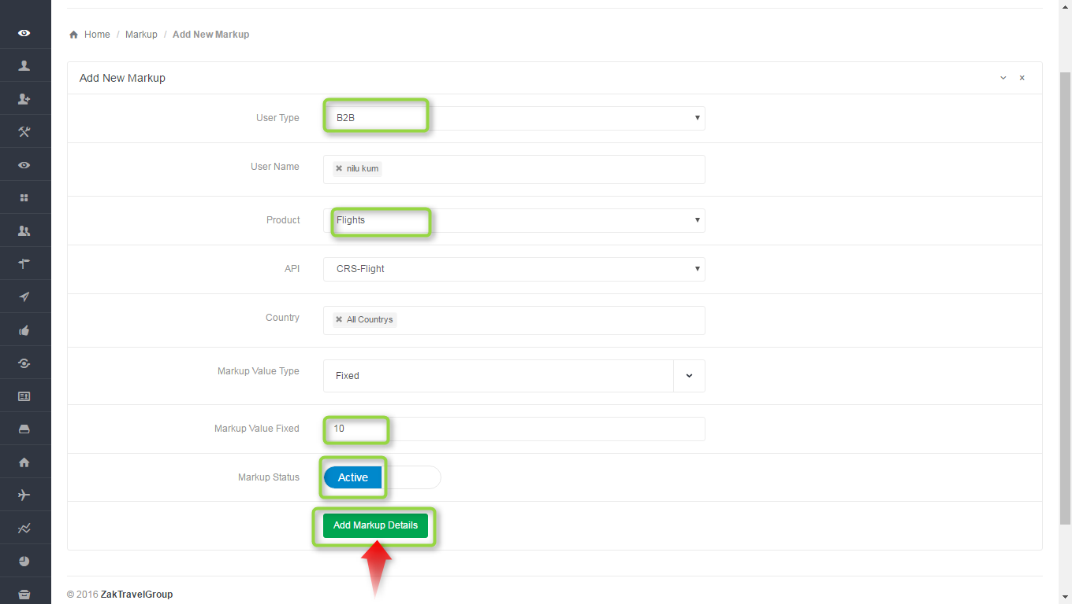

**15.5.Markup list admin panel for B2B**: Here admin add the markup for particular agent , select the user type as B2B , user name means for which agent admin add the markup, product as a Flight, API CRS Flight, country and markup type. After adding the markup will display in the list.

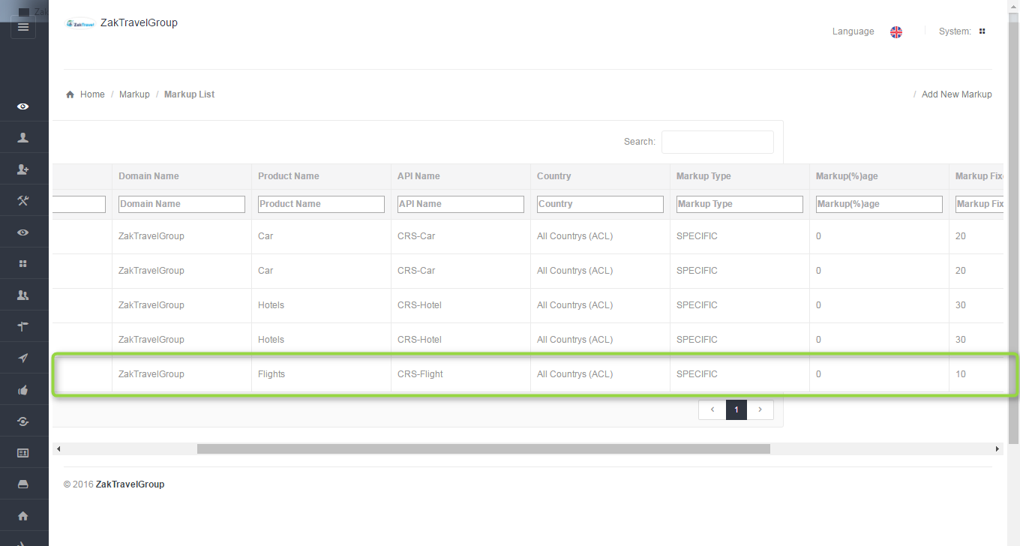

**15.6**. **Front end with Markup (B2B):** Now the added markup will be display with the total fare, for one day the markup added is 10 rupees now and markup will be added according to number of days.

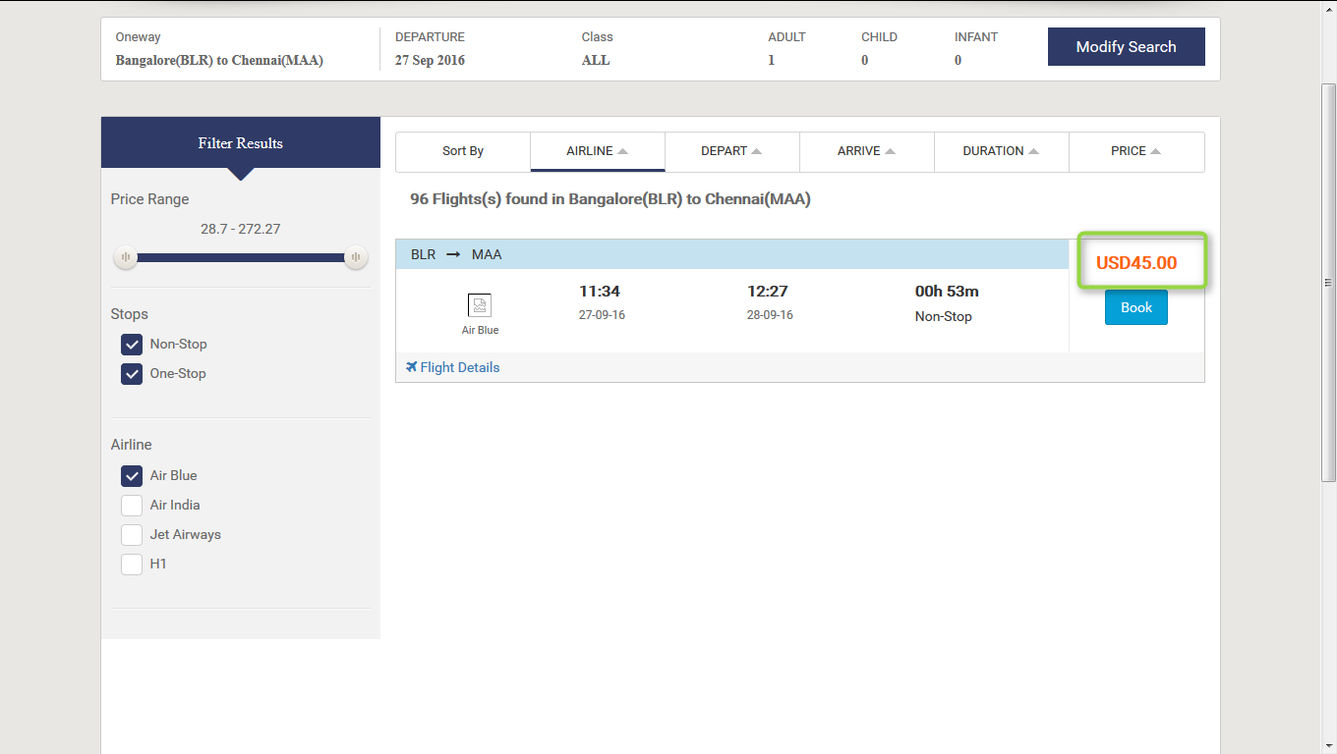

**15.7. Activation and Inactivation for markup:** After click on inactive the markup will not add with the total fare for adding the markup the status should be in active state.

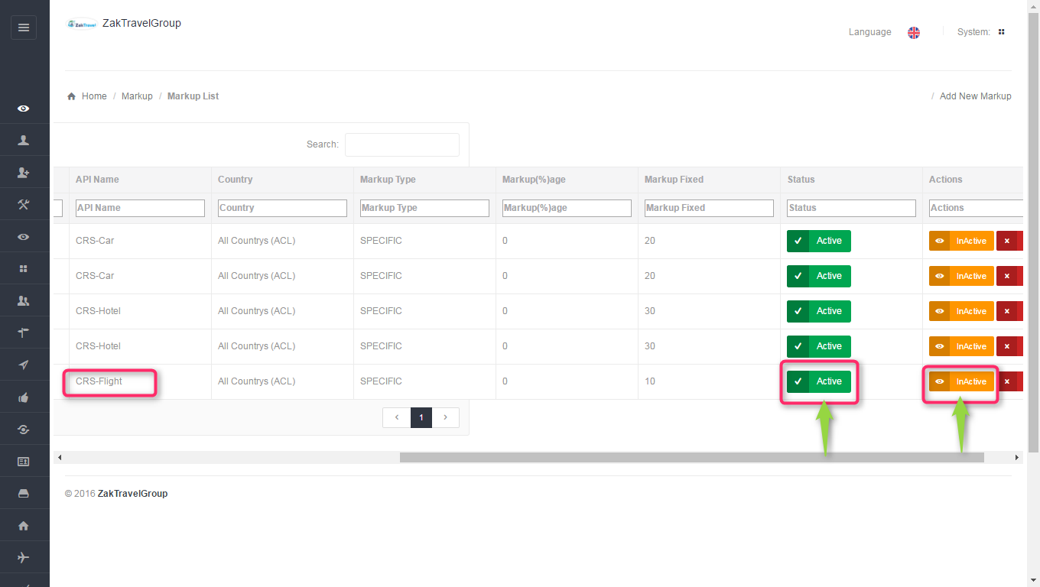

**Active Inactive**

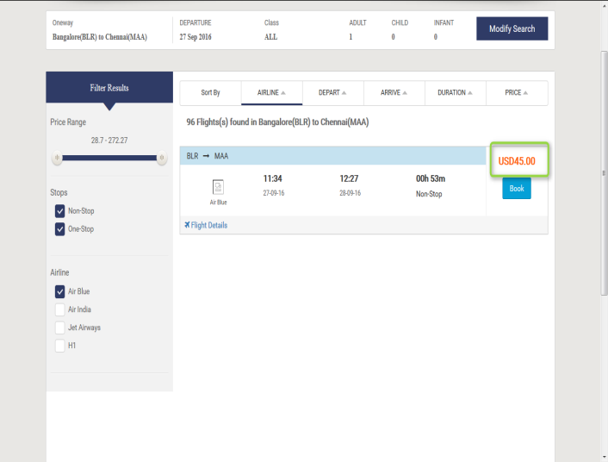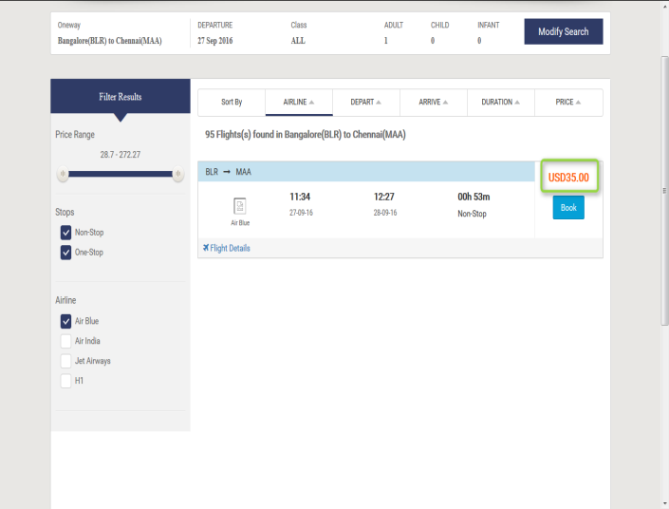

**15.8. Booking for Flight (B2B):**

Users can book the particular Flight by providing their personal details. And they will get confirmation letter. Now click on flight tab and provide all the valid detail and search for the Flight.

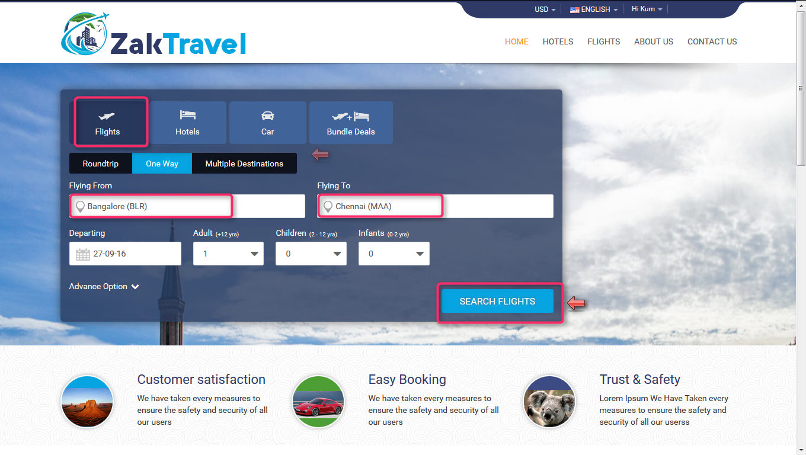

After click on search, the Flight search result will display. So click on Book button for booking the Flight.

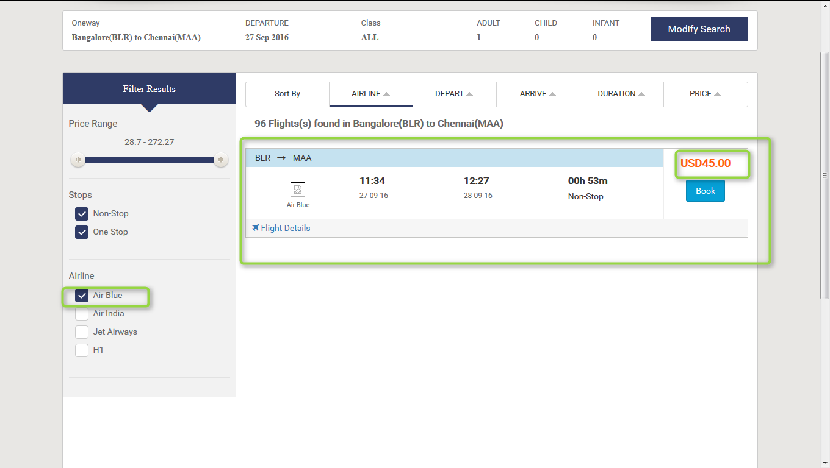

Now after click on book button it will open review, travelers and payment information and click on continue tab it will open the form to enter the personal information. Provide all the valid information and click on continue button and check the check box for terms and conditions.

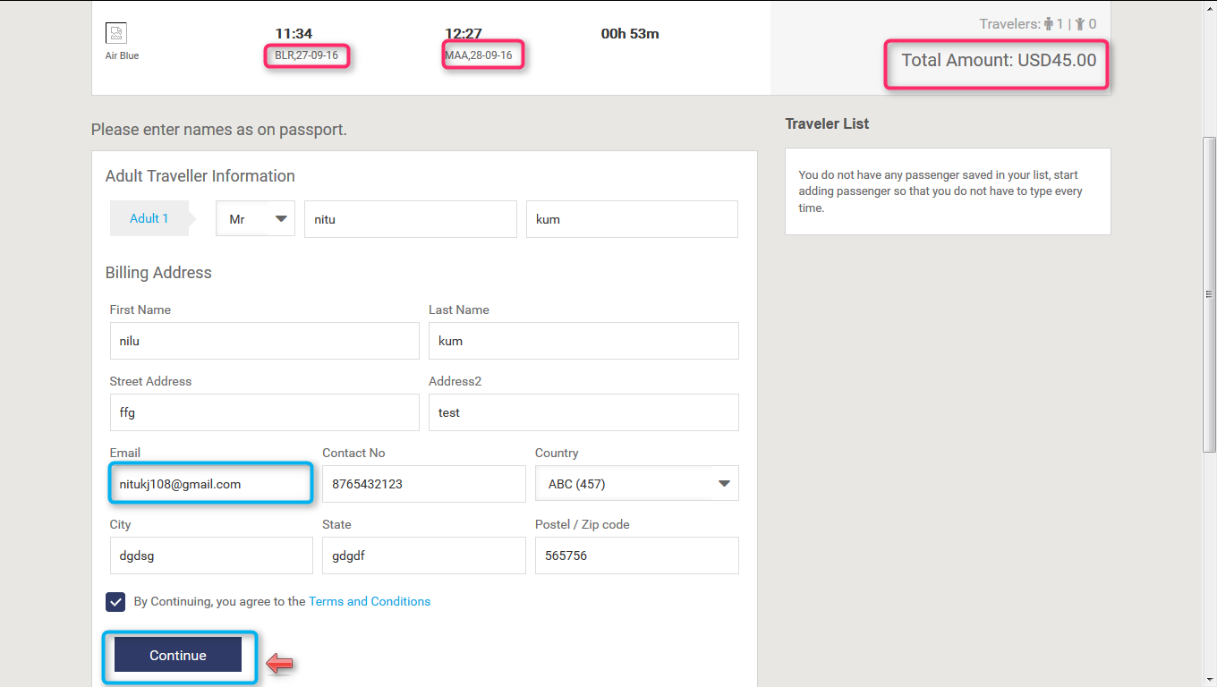

**15.9. Voucher page for Flight (B2B)**: Voucher page display after providing all the information and click on continue button and everything will be present on the voucher page like booking status, reservation number, Traveler, date, amount etc.

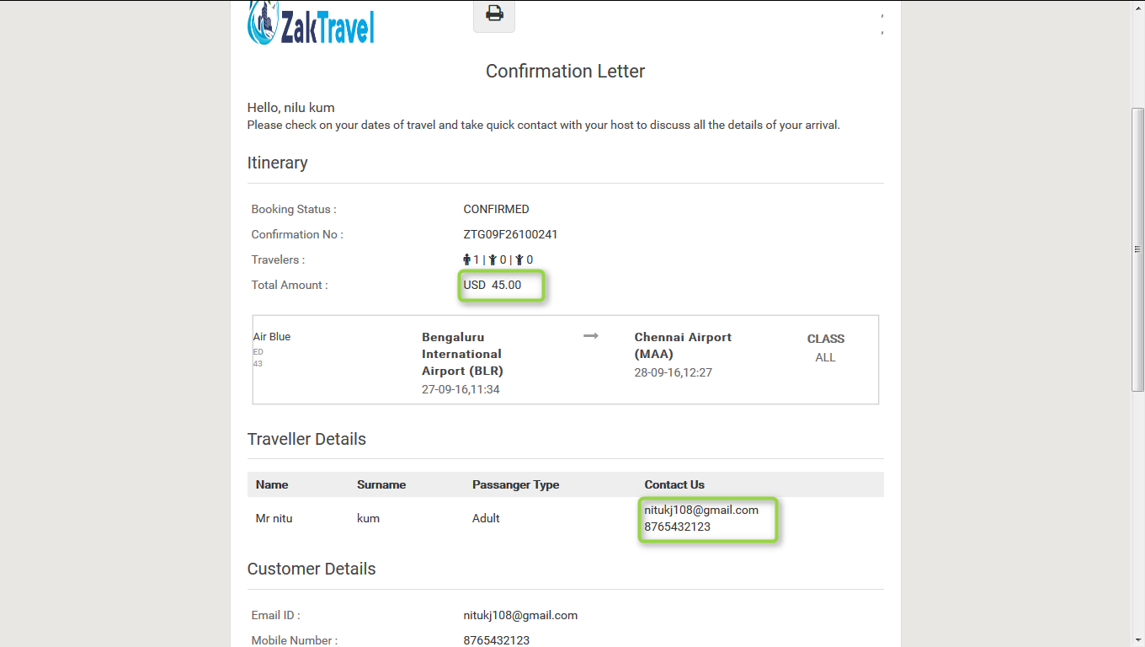

**16. Markup for B2C Flight:**

**16.1. Before adding the Markup for flight Admin panel (B2C):** Markup will not display in the list before adding.



**16.2. Front End Without adding markup (B2C):** Markup is not added with total fare so whatever the amount is added at the time of rate management that amount will be display only and total fare will display without markup.



**16.3. Steps to add markup for Flight (B2C) Admin panel:** After click on add markup one form will be displayed and enter all the required information like user type, product, API, and markup value type, etc.

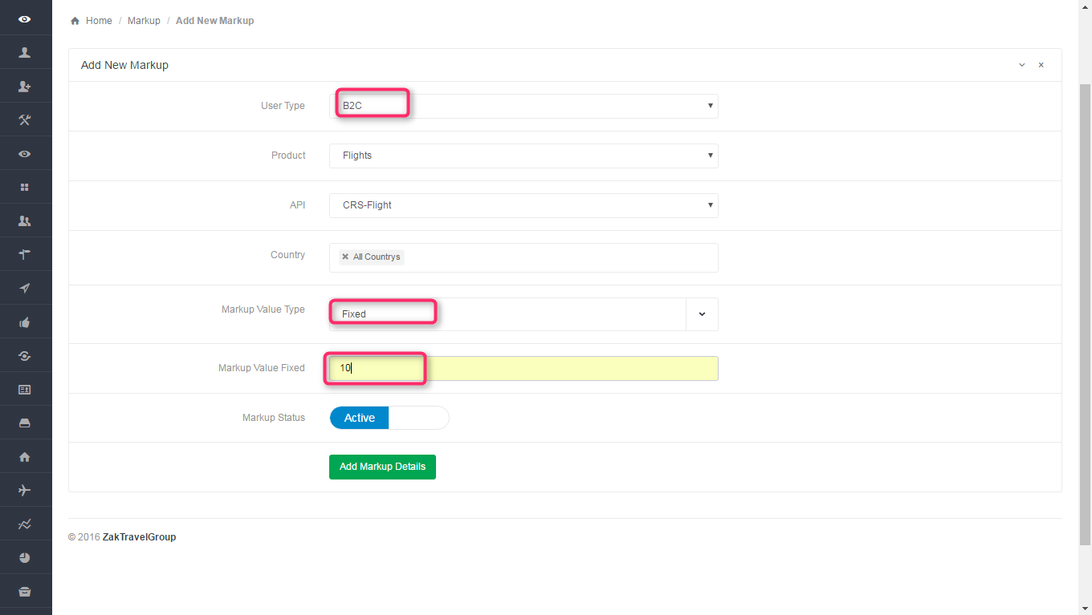

**16.4. Markup list admin panel for B2C**: select the user type as B2C, product as a Flight, API CRS Flight, country and markup type. After adding the markup will display in the list.

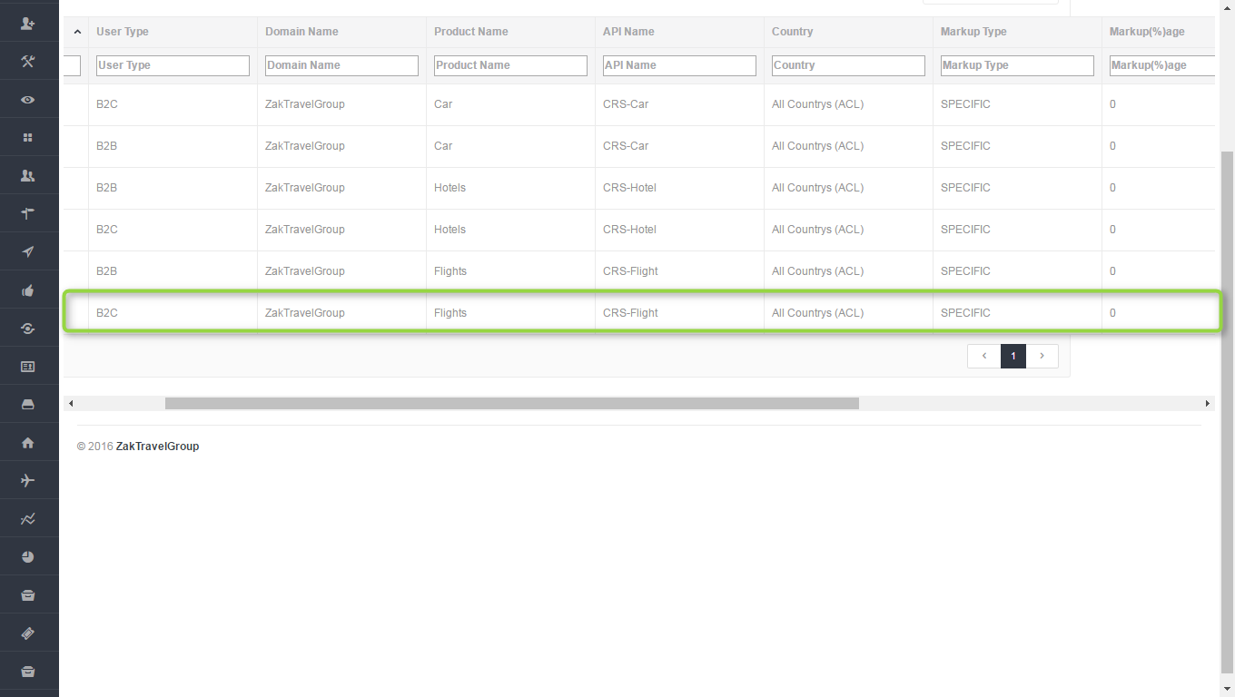

**16.5**. **Front end with Markup (B2C):** Now the added markup will be display with the total fare, for one day the markup added is 10 rupees now and markup will be added according to number of days.



**16.6. Activation and Inactivation for markup:** After click on inactive the markup will not add with the total fare for adding the markup the status should be in active state.

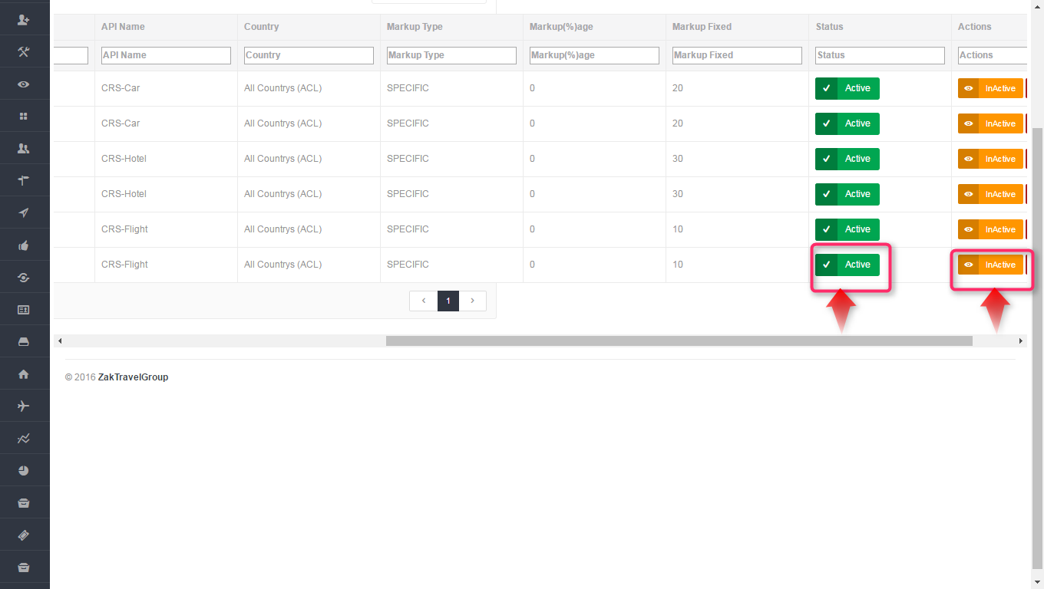

**Active Inactive**



**16.7. Booking for Flight (B2C):**

Users can book the particular Flight by providing their personal details. And they will get confirmation letter. Now click on Flight tab and provide all the valid detail and search for the Flight.

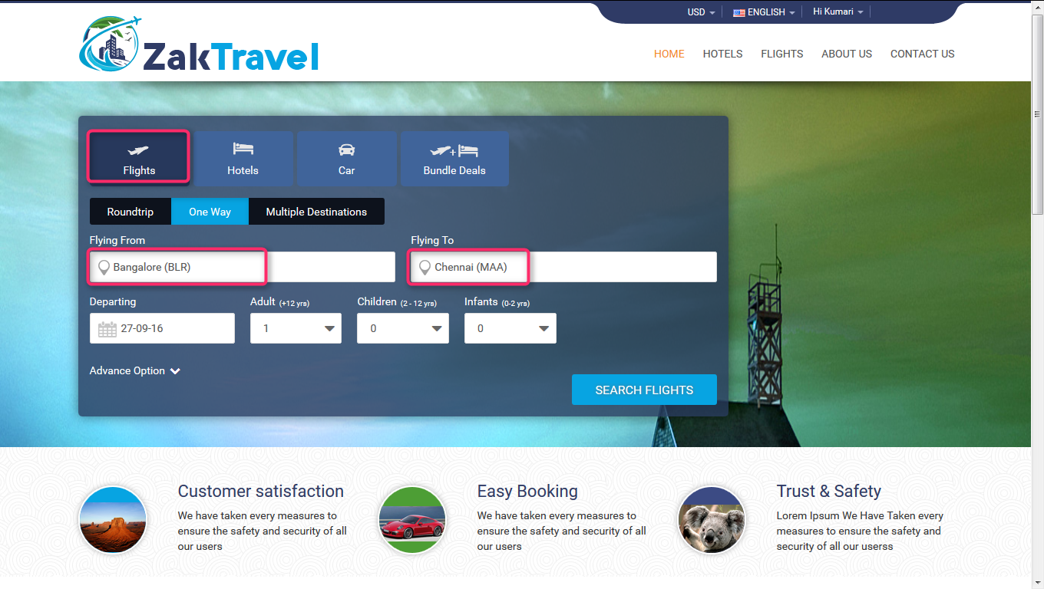

After click on search, the Flight search result will display. So click on Book button for booking the Flight.



Now after click on book button it will open review, travelers and payment information and click on continue tab it will open the form to enter the personal information. Provide all the valid information and click on continue button and check the check box for terms and conditions.

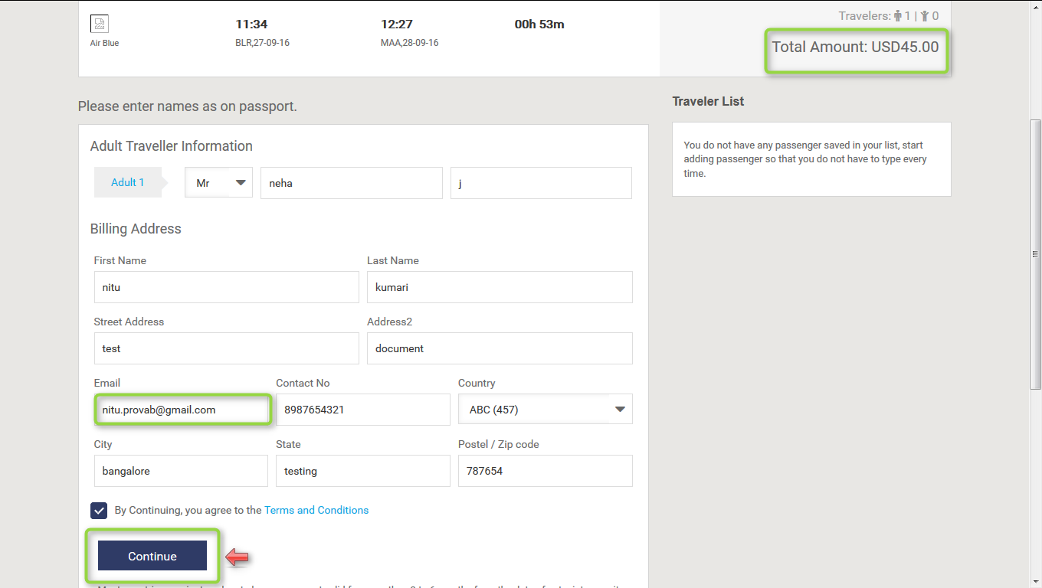

**16.8. Voucher page for Flight (B2C)**: Voucher page display after providing all the information and click on continue button and everything will be present on the voucher page like booking status, reservation number, Traveler, date, amount etc.

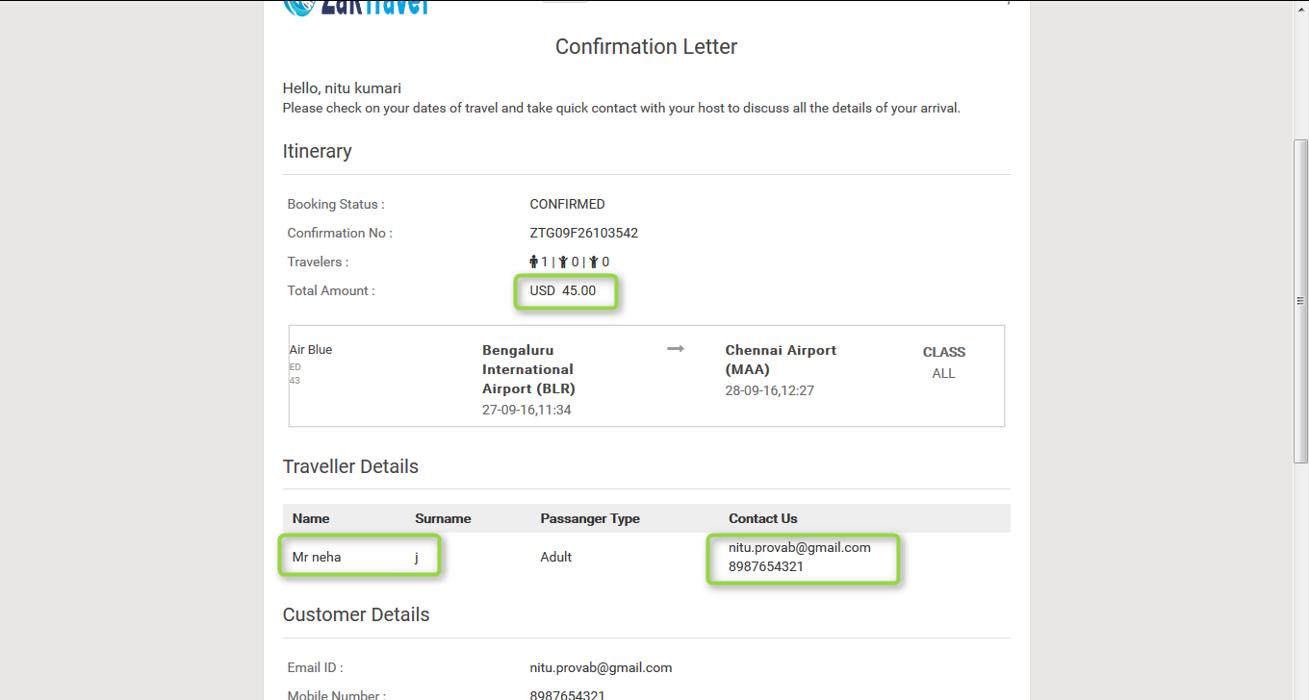

**17. BUNDLE DEALS:**

**17.1. Before adding bundle deals:** Supplier needs to add the Bundle and can edit and delete also.

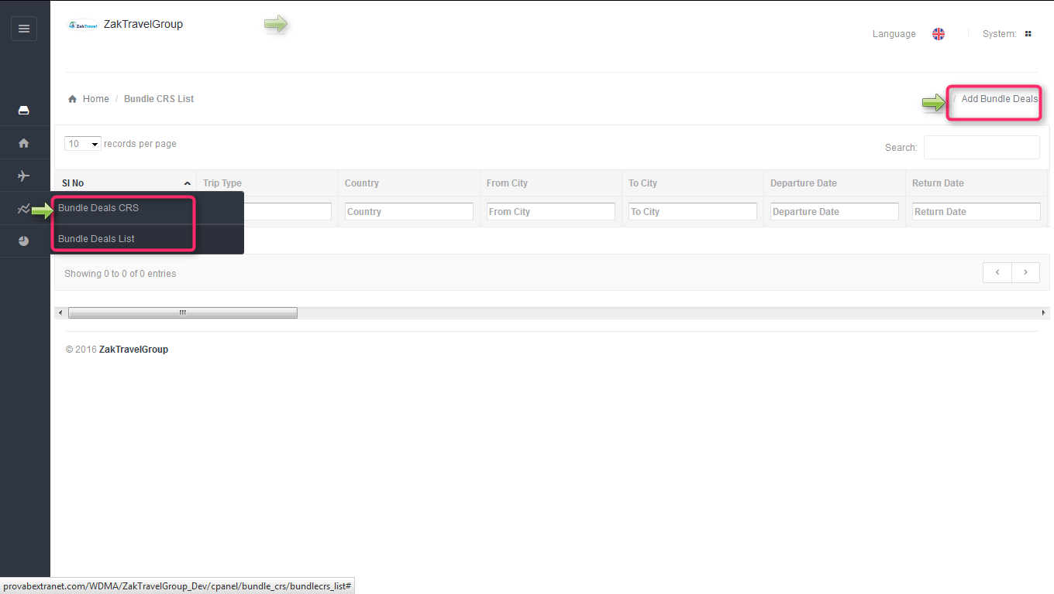

**17.2. Steps to add bundle deals (Flight+Hotel+Car):** Supplier orAdmin can  add bundles they need to provide all the information  like city name, departure and return date , trip type, and all the details about bundle (Car+Flight+Hotel) , need to Activate the bundle and the added bundles will display on front end. After deactivating the deals it will not be display on the front end.

, 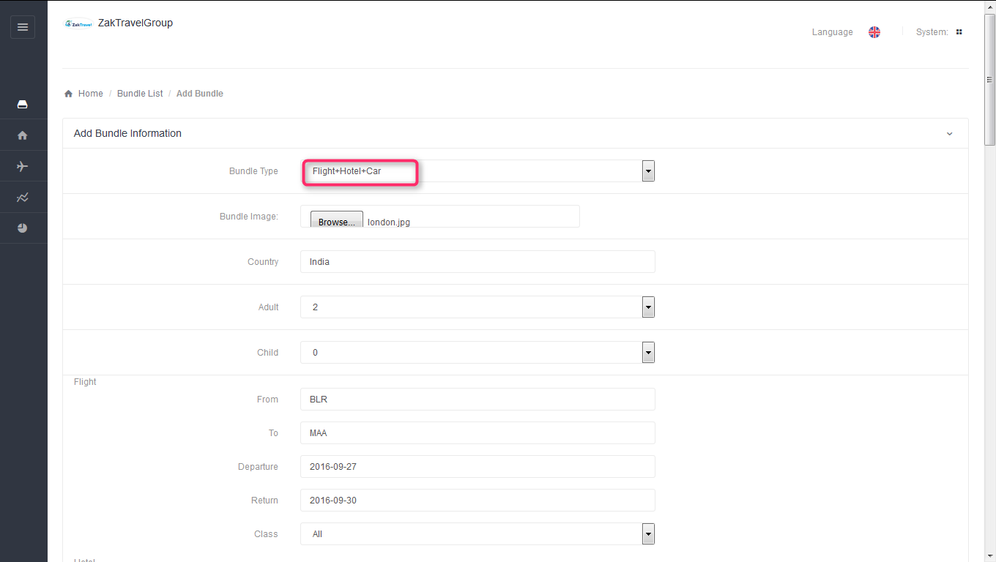

**17.3. Flight segment Management:**

**17.4. Before adding segment:** Supplier needs to add the flight segment.

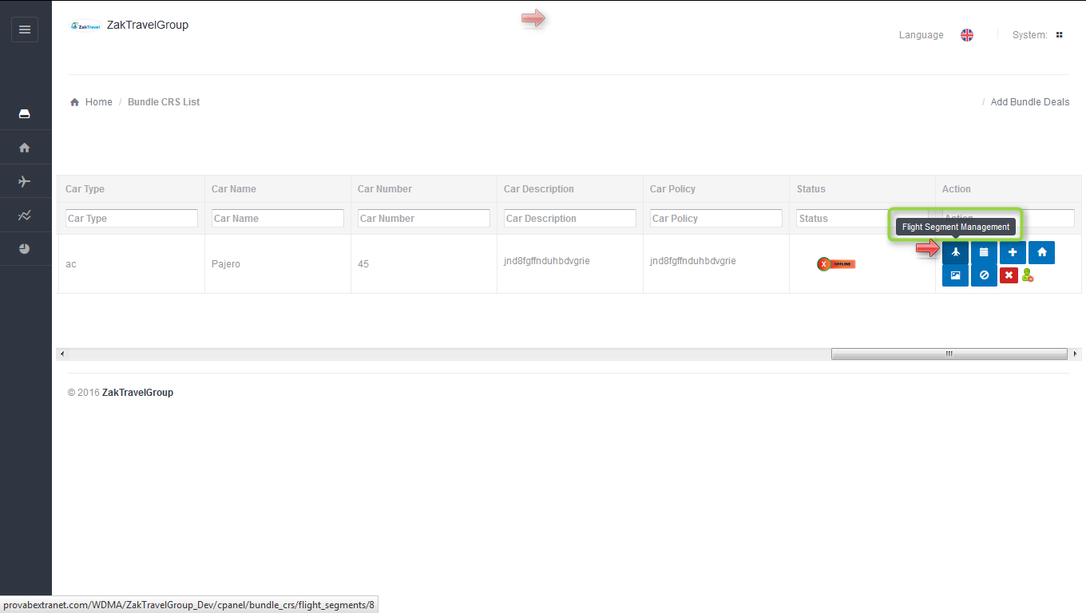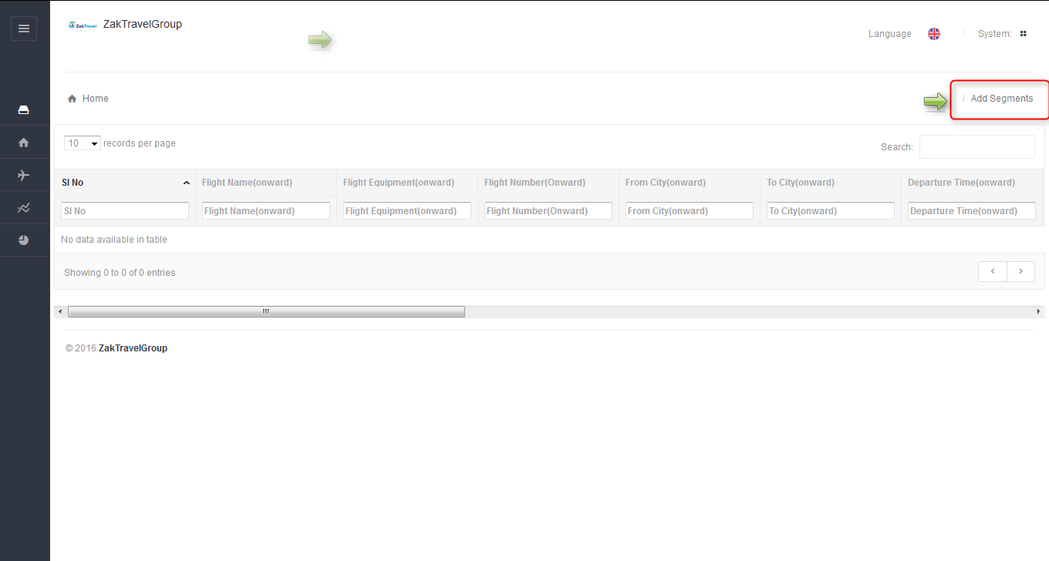

**17.5. Steps to add flight segment:** Click on flight segment symbol and click on add segment, Enter flight name, and Equipment, Departure and arrival time for both onward and return.

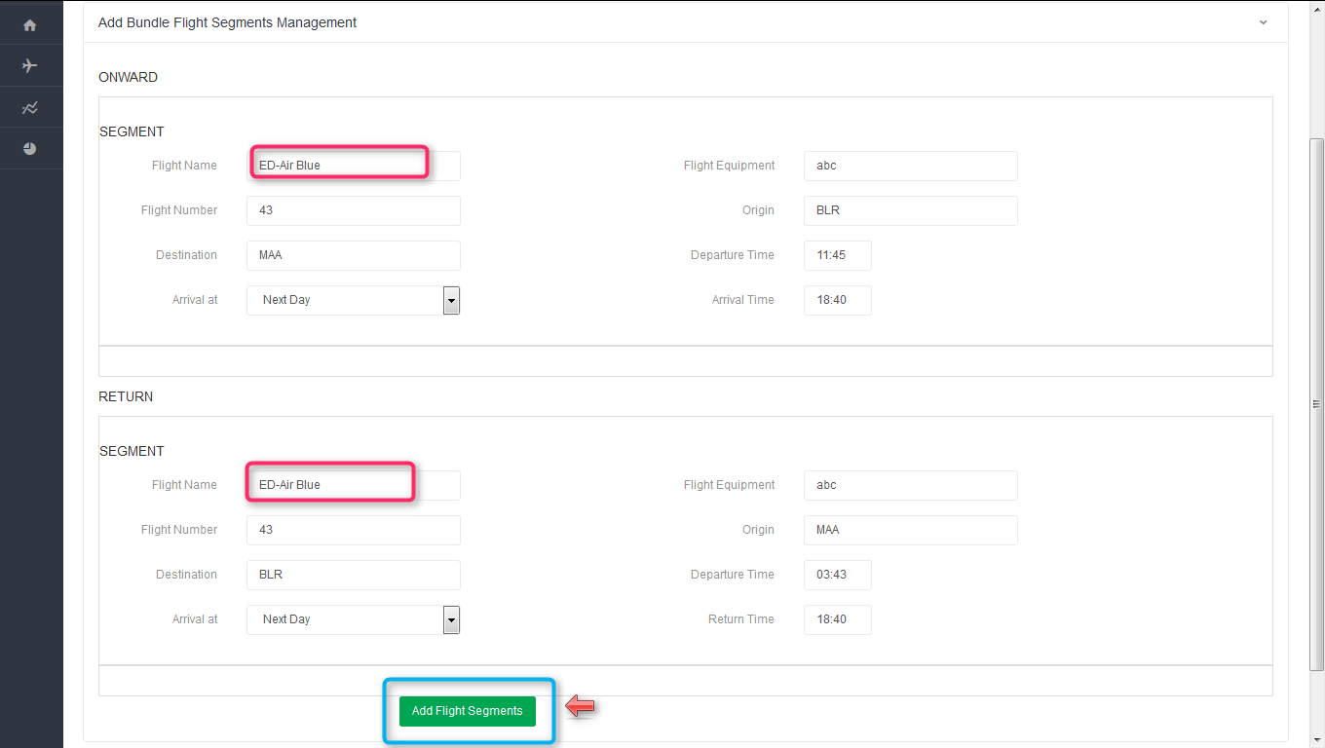

**17.6. After adding segment:** Added segment will be displayed in the list.

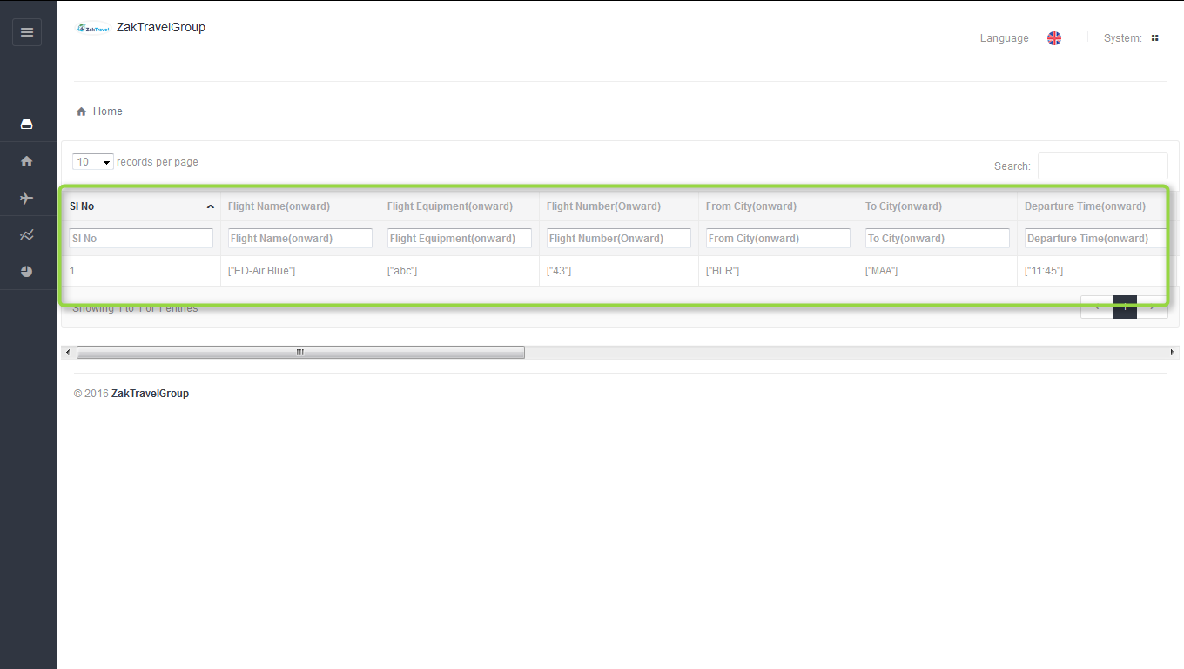

**17.7. Add Bundle Flight Pricing Management:** In price management need to add the price for adult, Child, infant with tax.

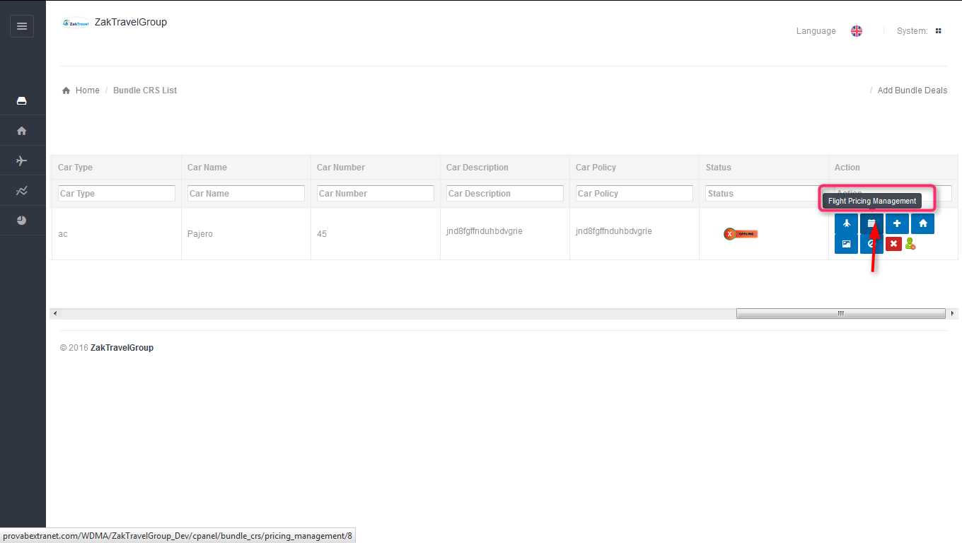

**17.8. Before adding the price:** Supplier needs to add the price of the flight.

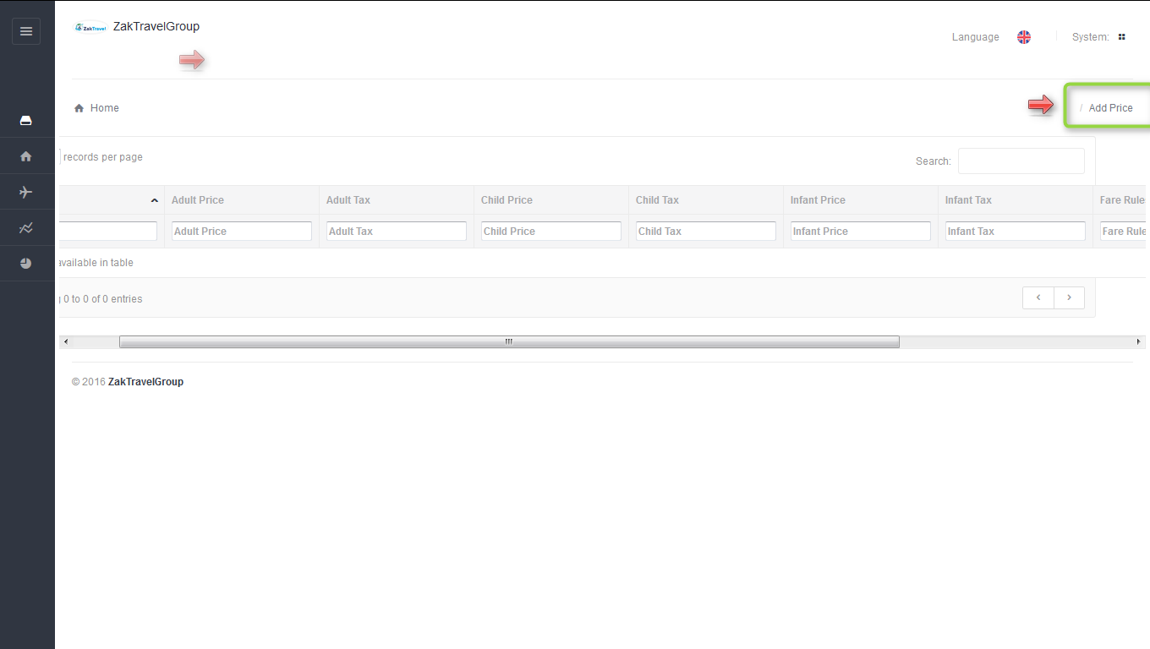

**17.9. Steps to add the price:** Click on add price Enter adult, child, infant price with tax and click on add.

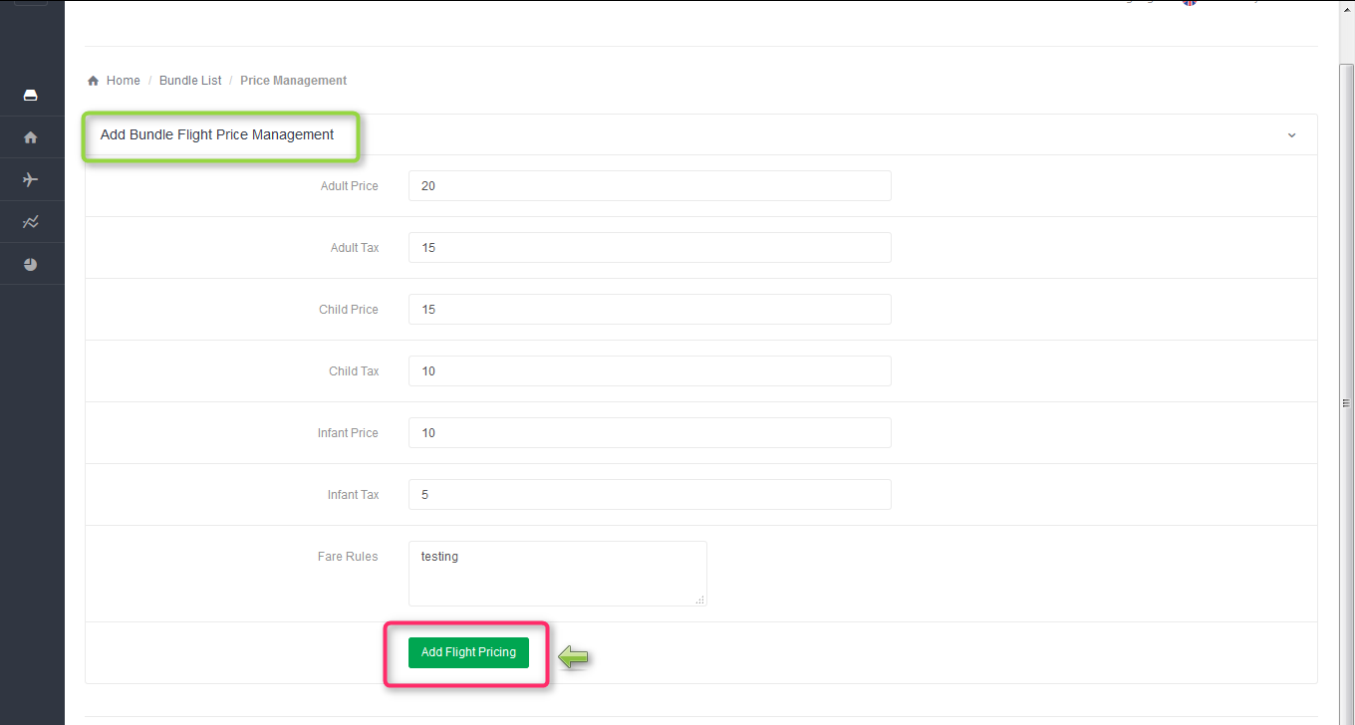

**17.9.1. Add/View Room type:** Need to add the room type and number of customers.

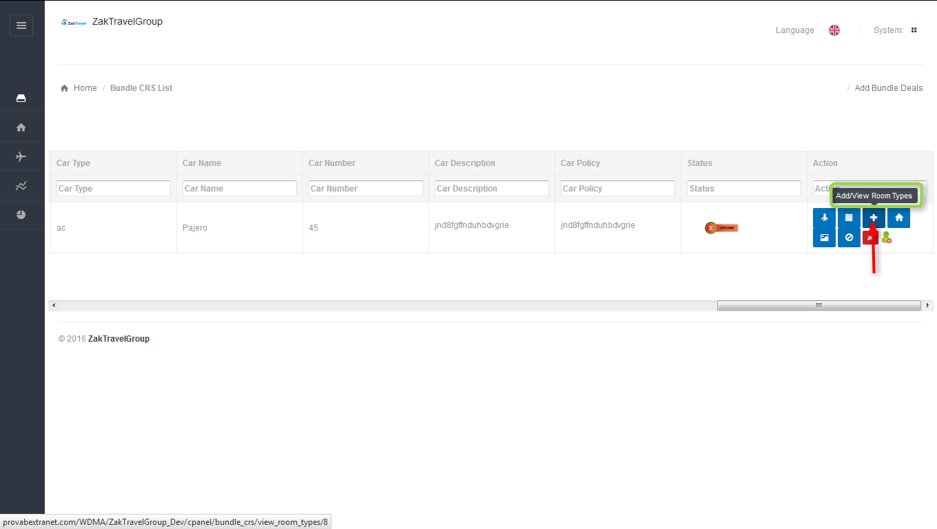

**17.9.2. Before adding room type :** Supplier needs to add the room type.

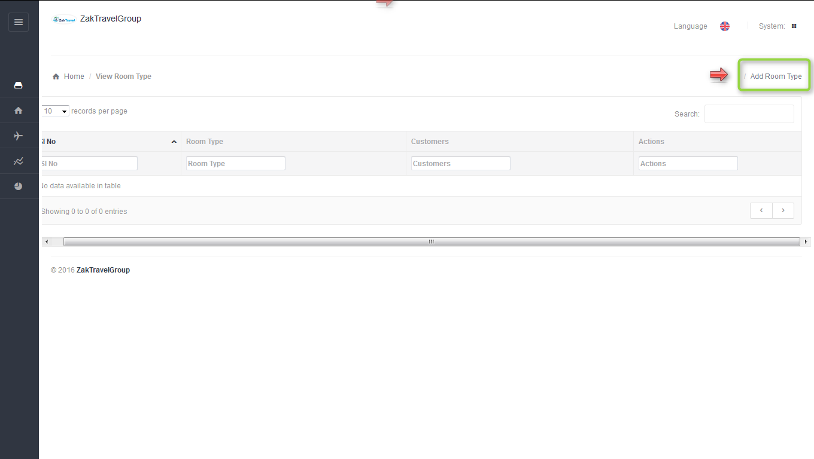

**17.9.3. Steps to add the room type:** Click on add room type and enter the type and select the customer.

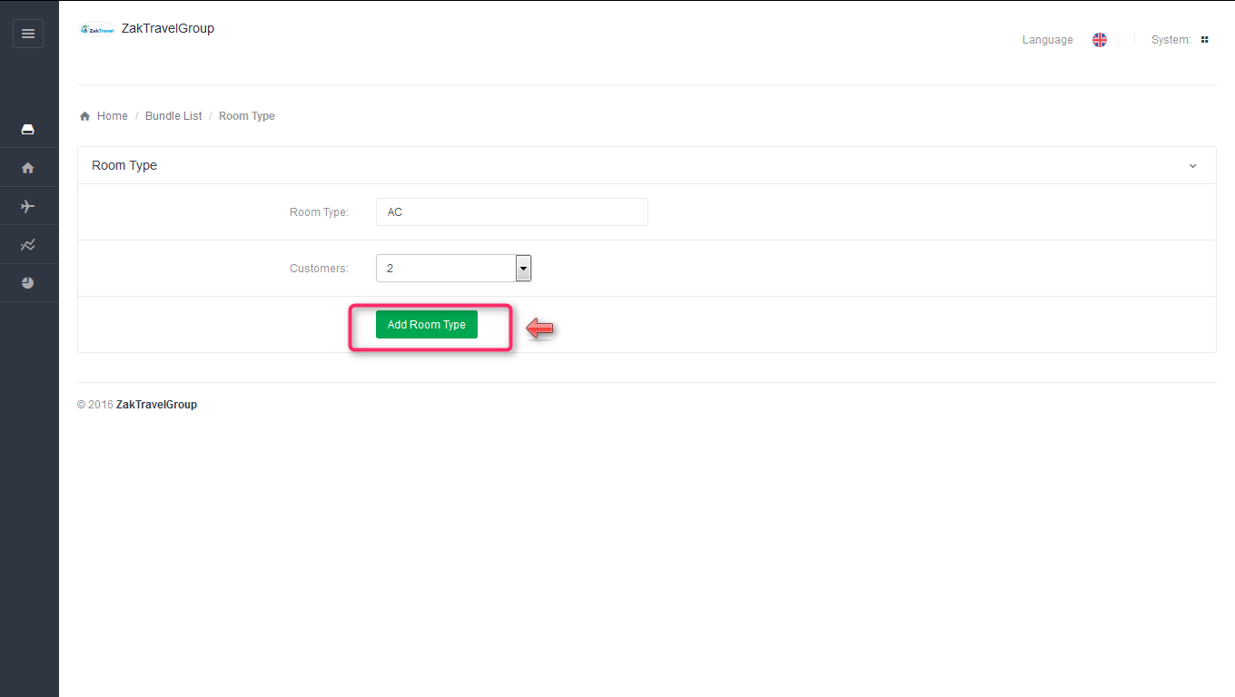

**17.9.4. After adding room type:** The added room type will display in the list.

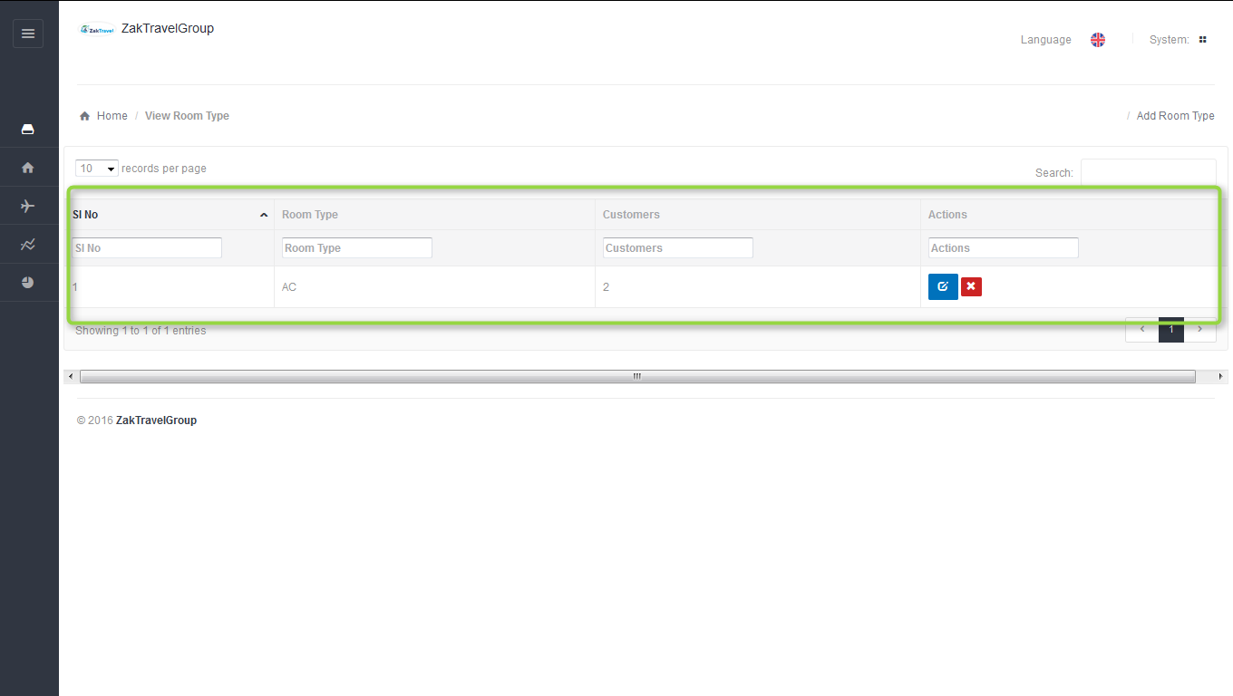

**17.9.5. Room Management (Add new room):** In room management add new rooms and hotel price and hotel name will be pre populated because the hotel name is already provided while adding bundle information.

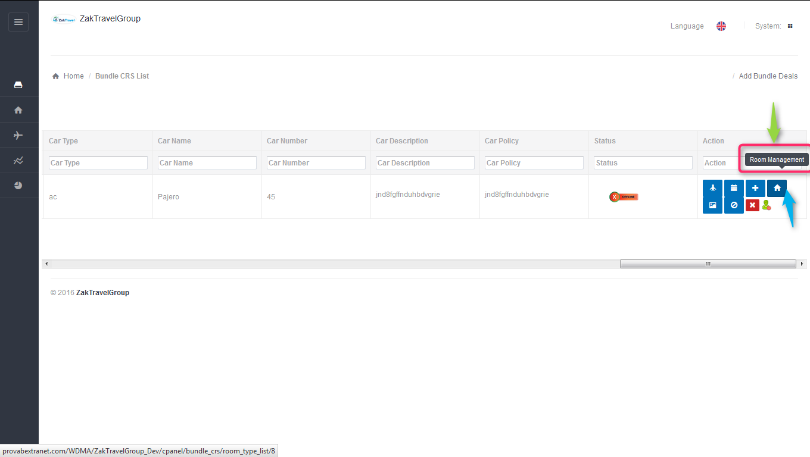

**17.9.6. Before adding room:** Supplier needs to add the room.

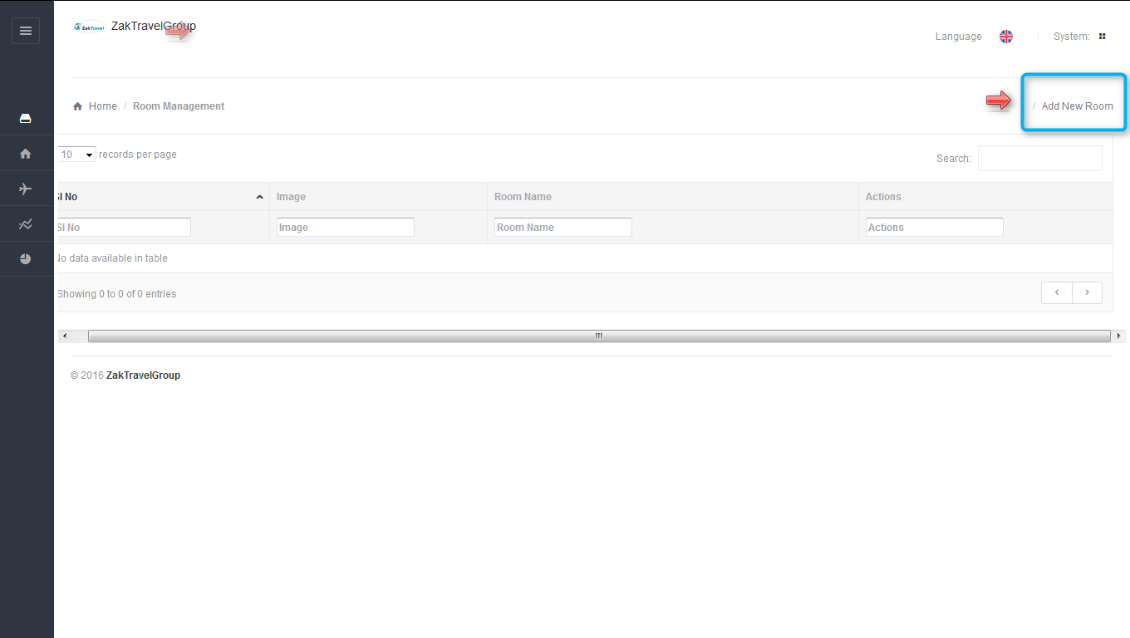

**17.9.7. Steps to add the new room:** Now Click on Add new room and hotel name would be pre selected and select the room name, hotel price, Cancellation Charges and click on add.

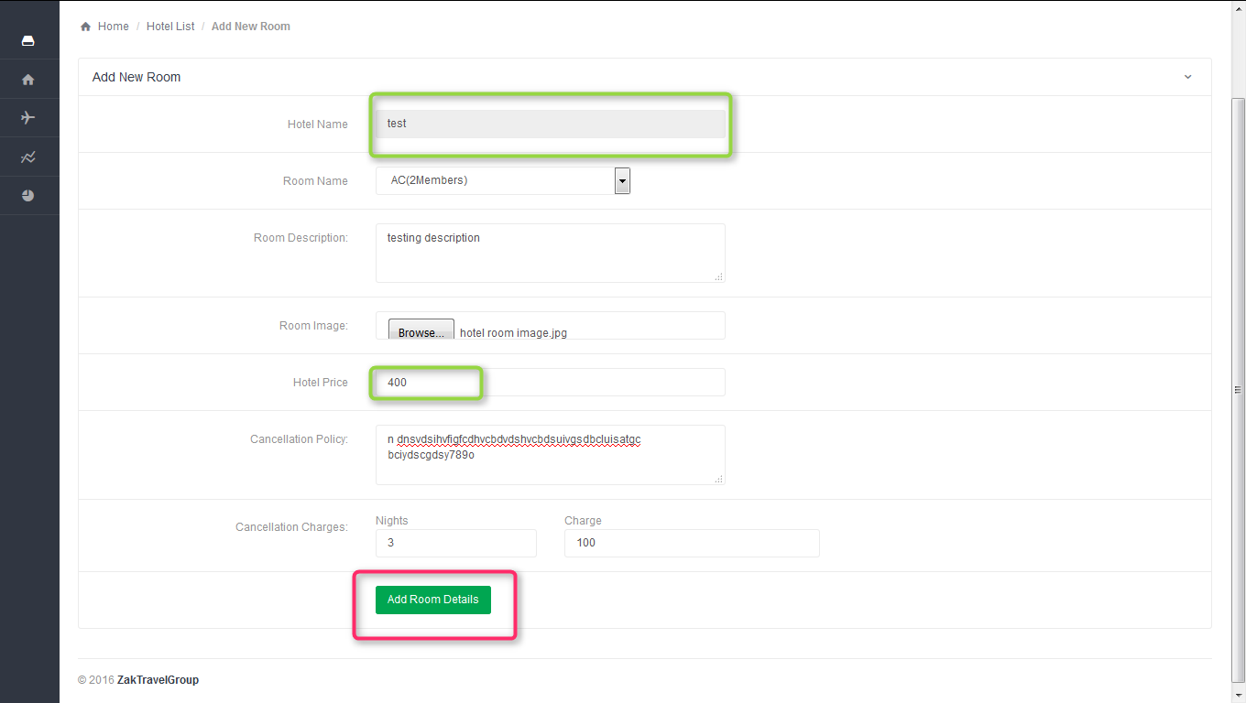

**17.9.8. After adding the new room:** The added room will display in the list.

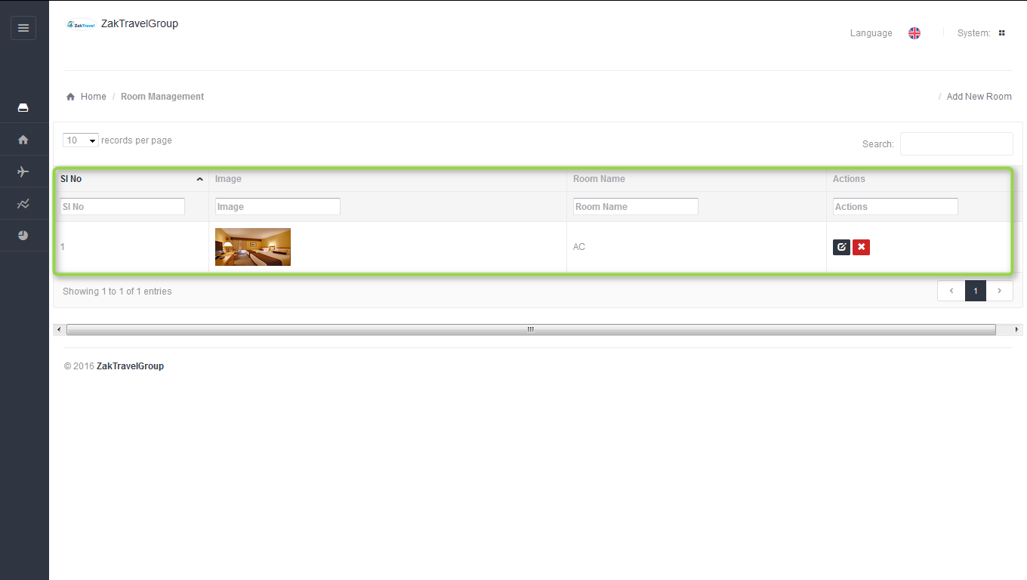

**18. Gallery management:** In the gallery management add hotel image and need to upload the same image.

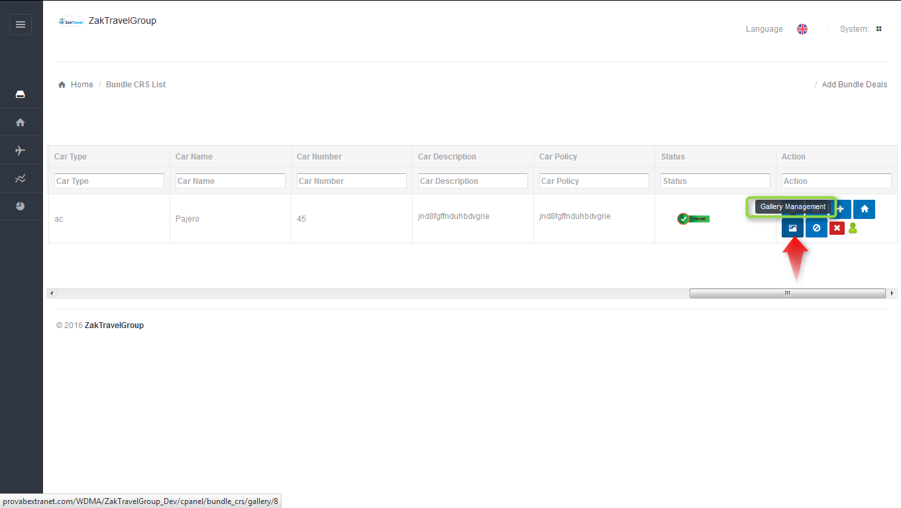

**18.1. Before adding gallery:** Supplier needs to add the gallery.

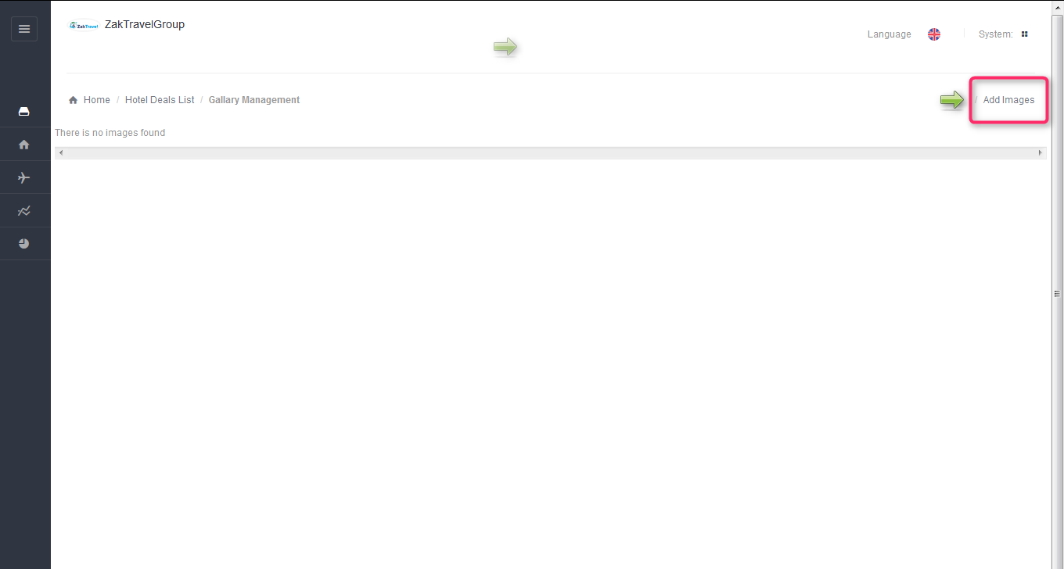

**18.2. Steps to add the gallery:** Click on add image and click on add file and select the image and click open start uploading and upload the image successfully.

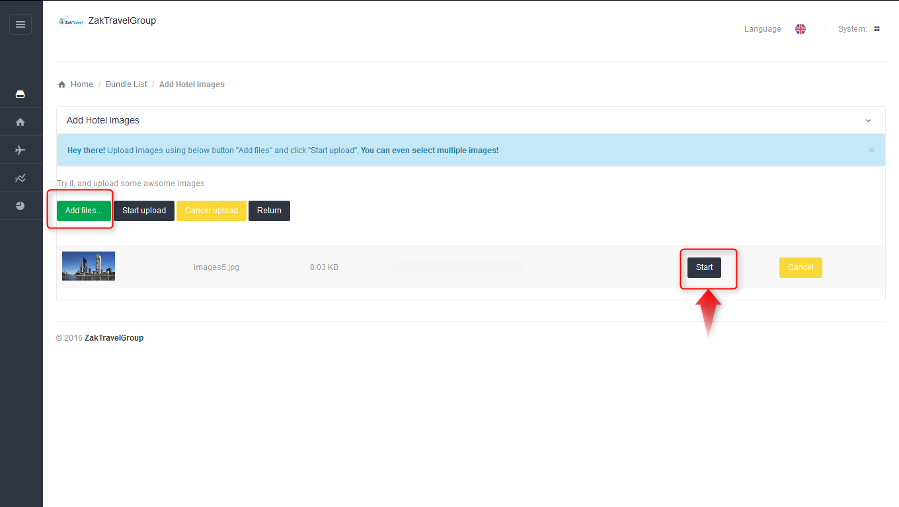

**18.3. After uploading:** After uploading the picture of hotel will display in the list.

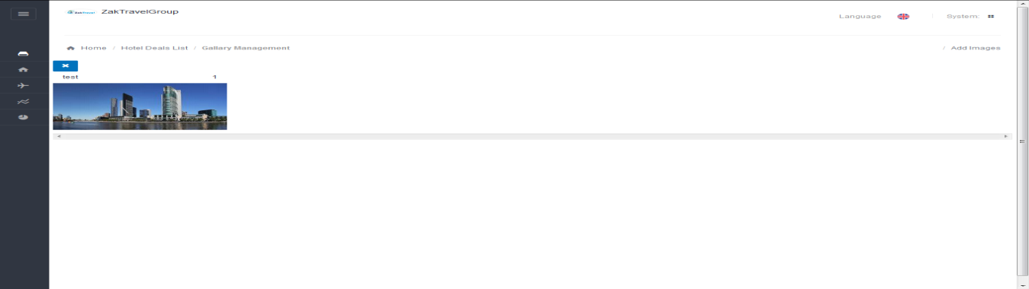

**18.4. Car Pricing:** Here need to add the adult price for the car with Baggage Allowance in kg and how many Suitcases should be carried.

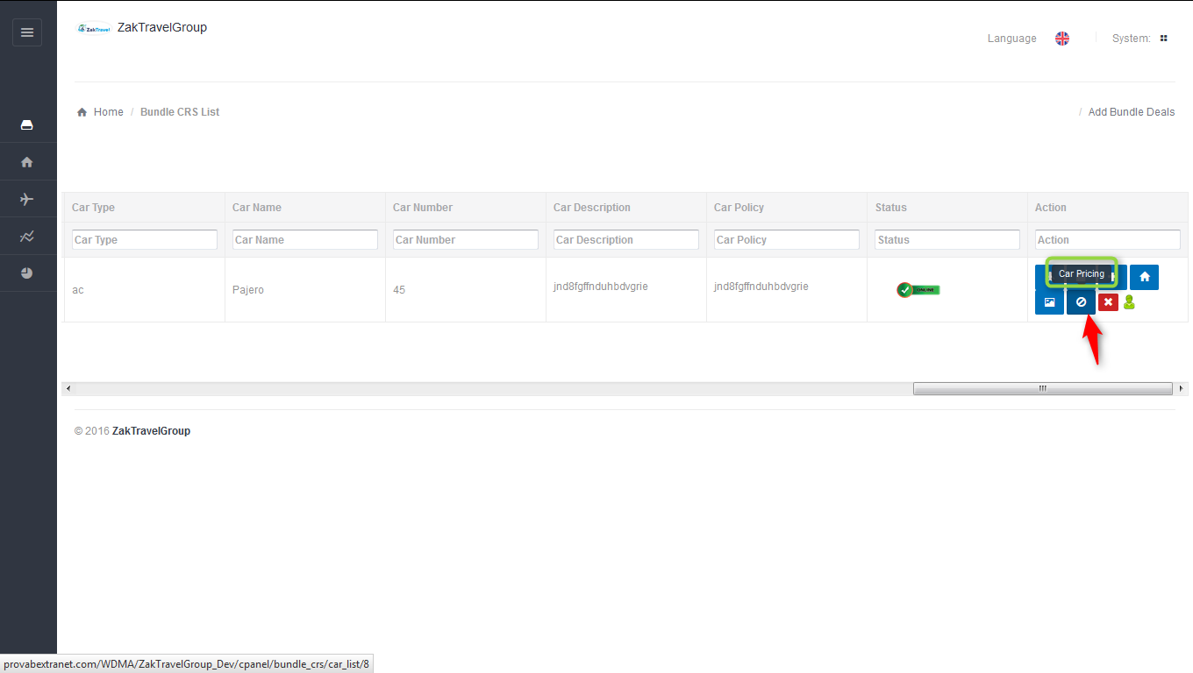

**18.5. Before adding car pricing:** Supplier needs to add the car price.

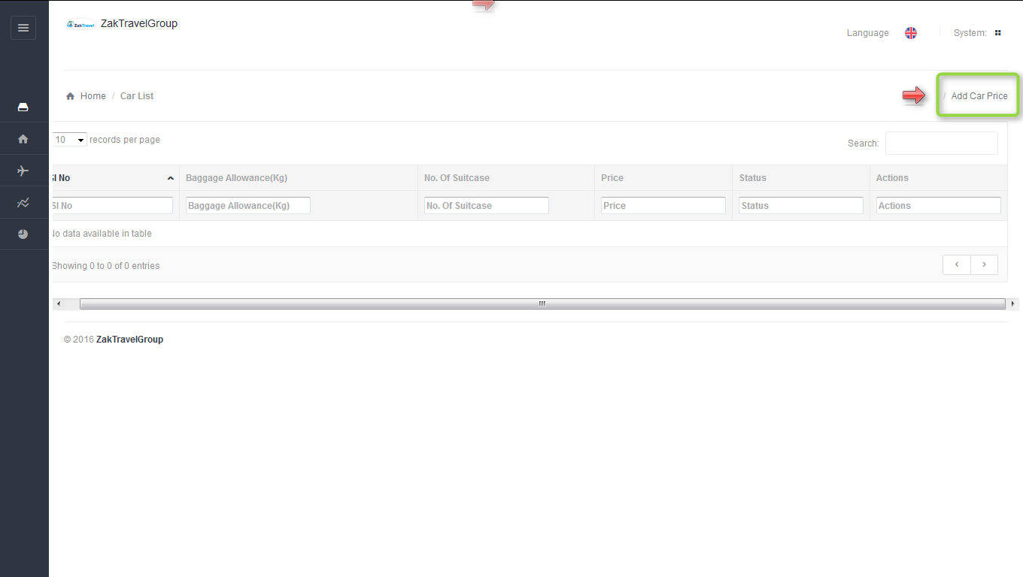

**18.6. Steps to add car price:** Click on car price and enter the adult price, number of suitcase to be carried out etc and click on add transfer detail.

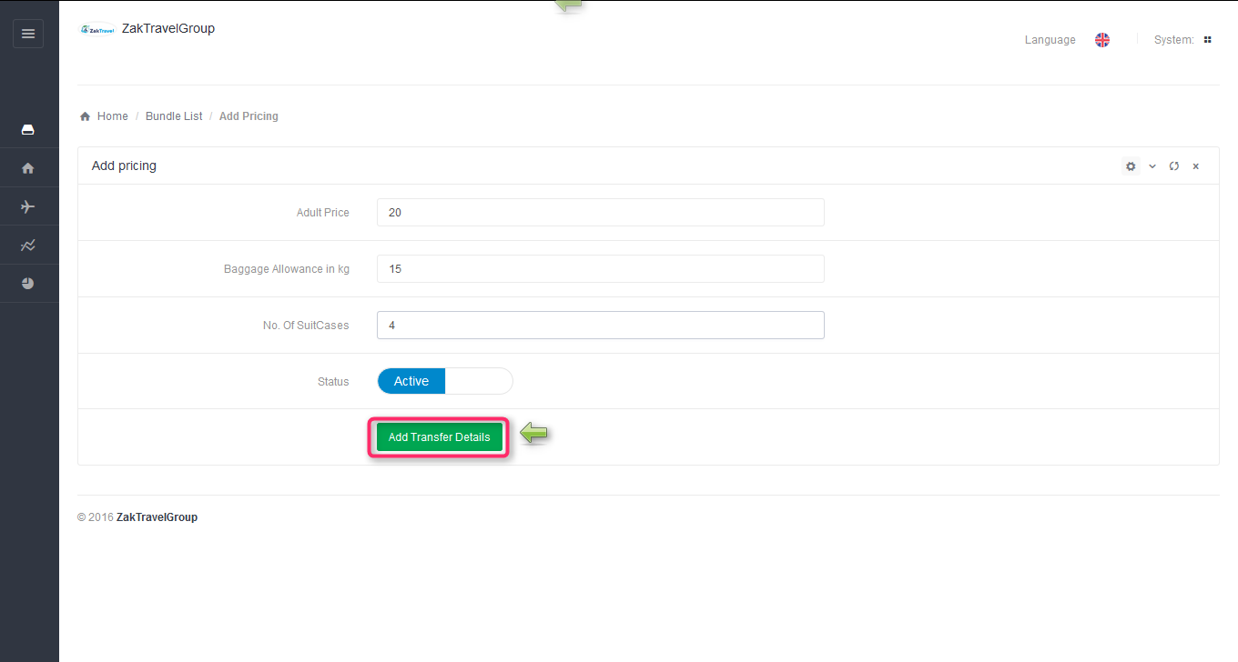

**18.7. Created bundle deal (B2B, B2C):** Now created bundle will display on the home page in best deals and click on bundle deals.

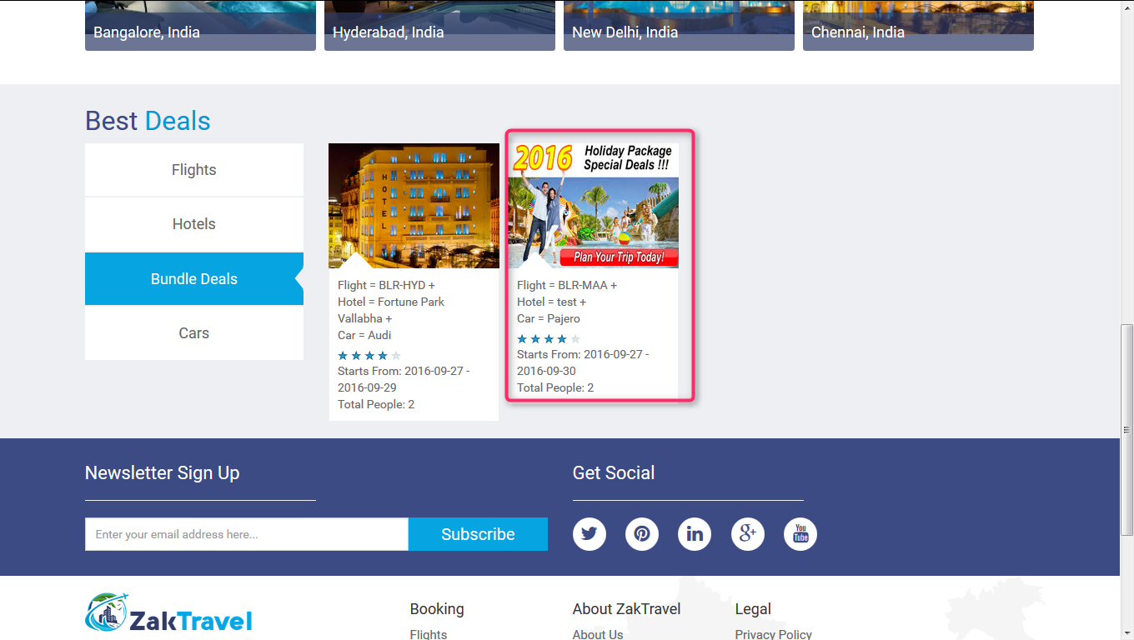

**18.8. Front End (B2B, B2C):** Created bundle will display on front end from where booking will be done.

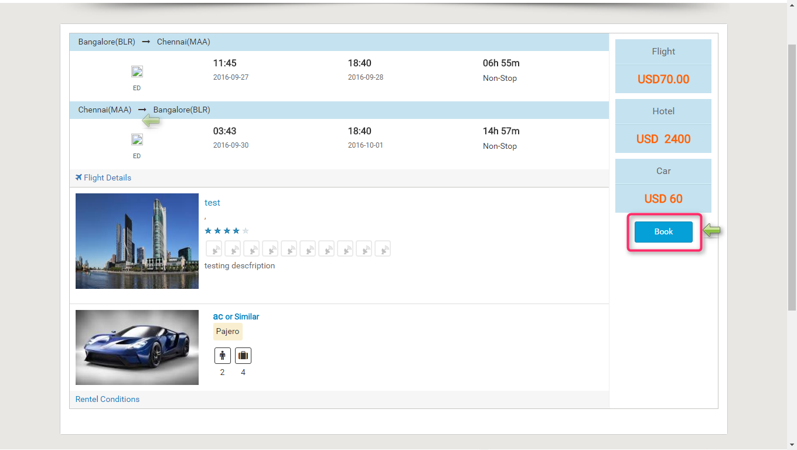

**18.9. Booking Page (B2B, B2C):** Click on bookand onthe booking page all the information which is given by the user and total amount will be present. Now click on continue voucher page will be displayed.

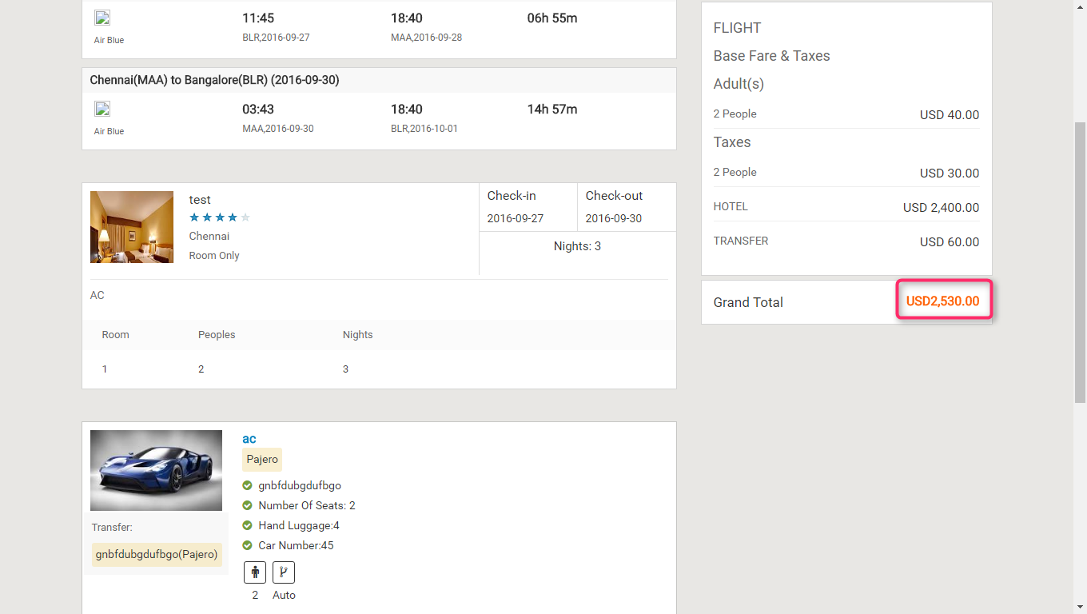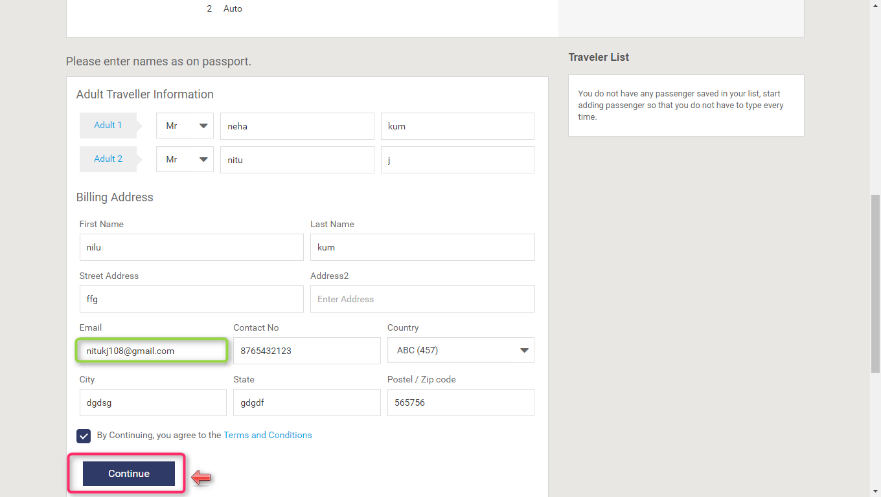

**18.9.1. Voucher Page (B2B):**After providing all the information and click on continue user will get confirmation letter.

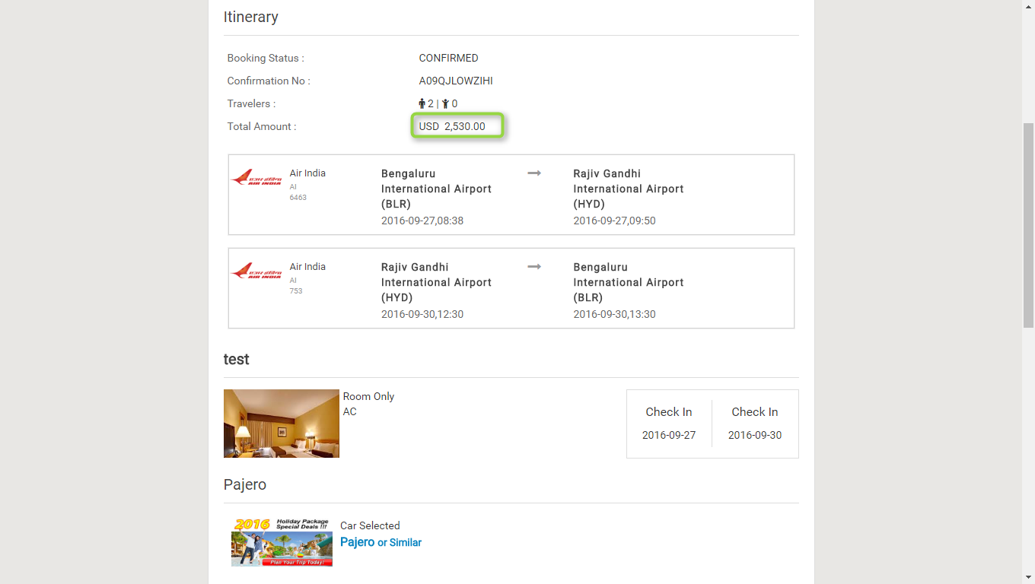

**18.9.2.** **Voucher Page (B2C):**After providing all the information and click on continue user will get confirmation letter.

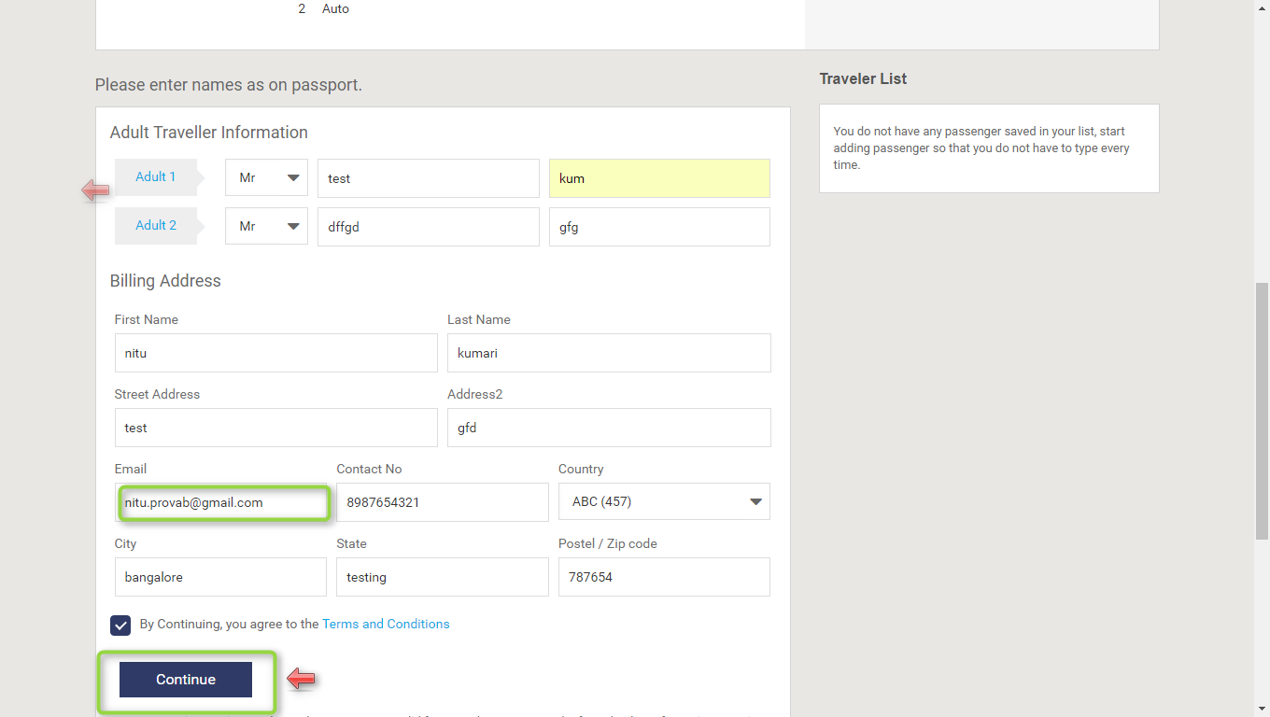

**18.9.2. MARKUP for Bundle deals (B2B, B2C)**: Markup is added by the Admin, after adding the markup from admin panel the markup will be added with total fare and display on front end.

**18.9.3. Markup for B2B Bundle deal:**

**18.9.4. Before adding the Markup for bundle Admin panel (B2B):** Markup will not display in the list before adding.

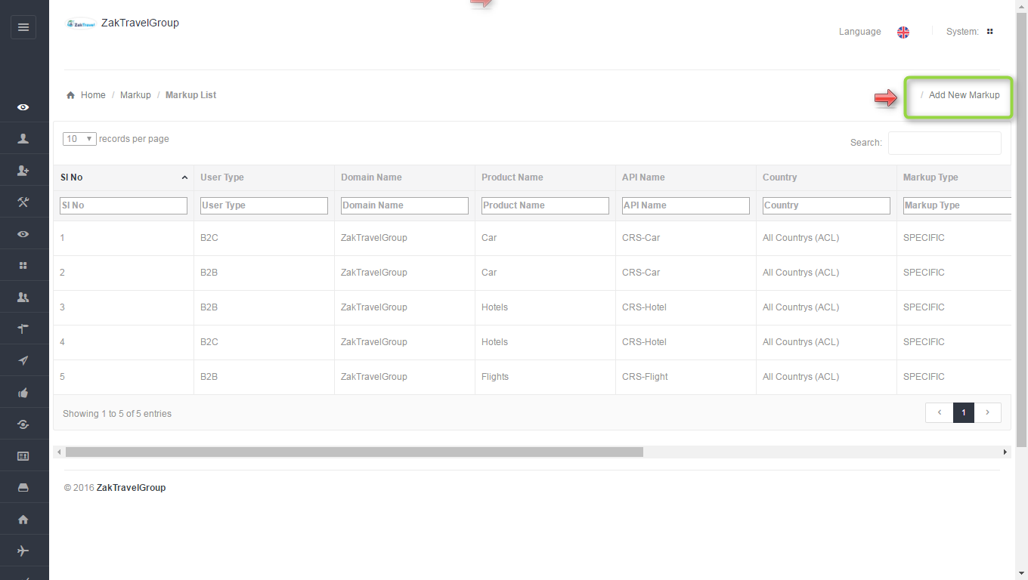

**18.9.5. Front End Without adding markup (B2B):** For a particular agentthe markup is not added with total fare so whatever the amount is added at the time of rate management that amount will be display only and total fare will display without markup.

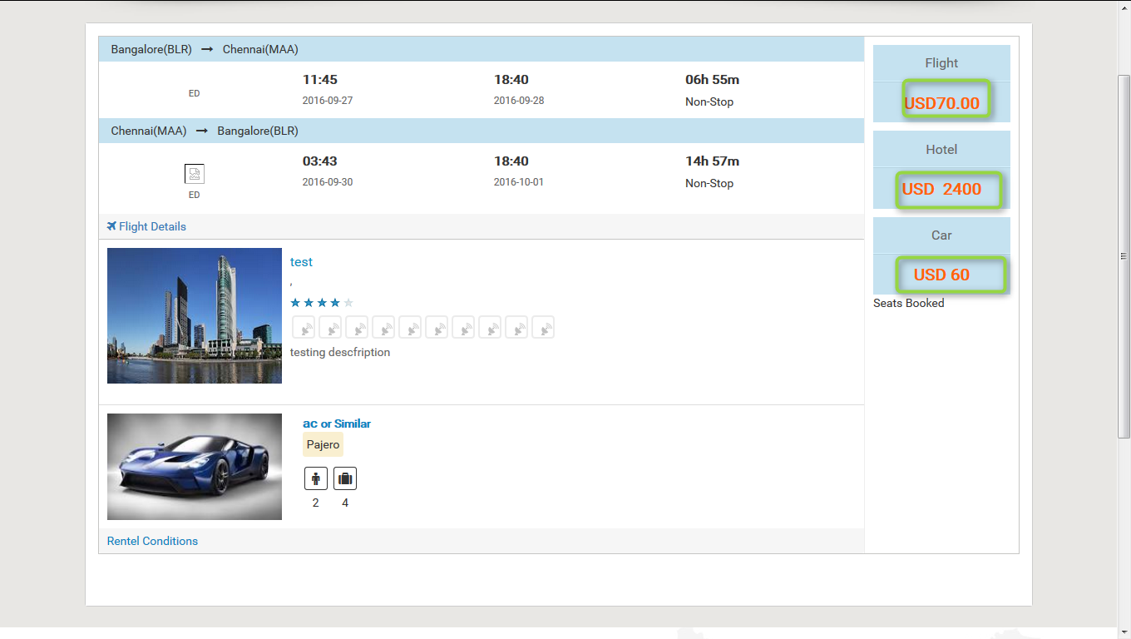

**18.9.6. Steps to add markup for bundle (B2B) Admin panel:** After click on add markup one form will be displayed and enter all the required information like user type, product, API, and markup value type, etc.

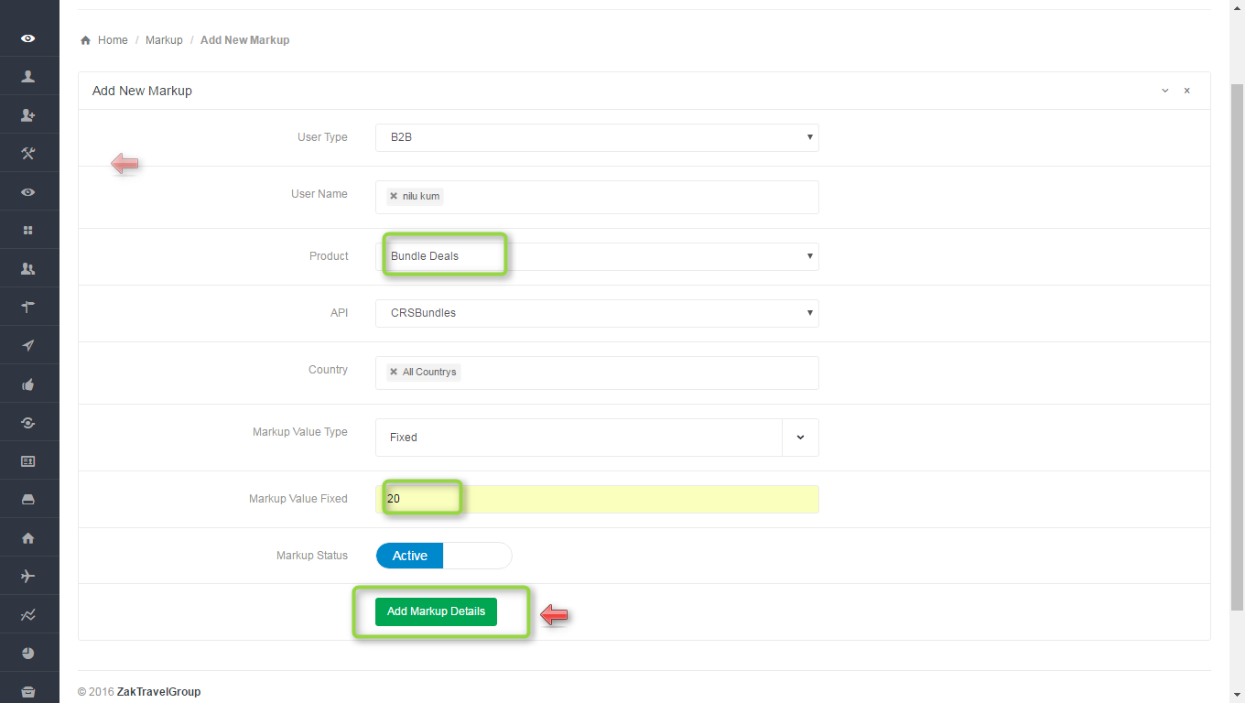

**18.9.7.Markup list admin panel for B2B**: Here admin add the markup for particular agent , select the user type as B2B , user name means for which agent admin add the markup, product as a bundle, API CRS Bundle, country and markup type. After adding the markup will display in the list.



**18.9.8**. **Front end with Markup (B2B):** Now the added markup will be display with the total fare, for one day the markup added is 20 rupees now and markup will be added according to number of days.

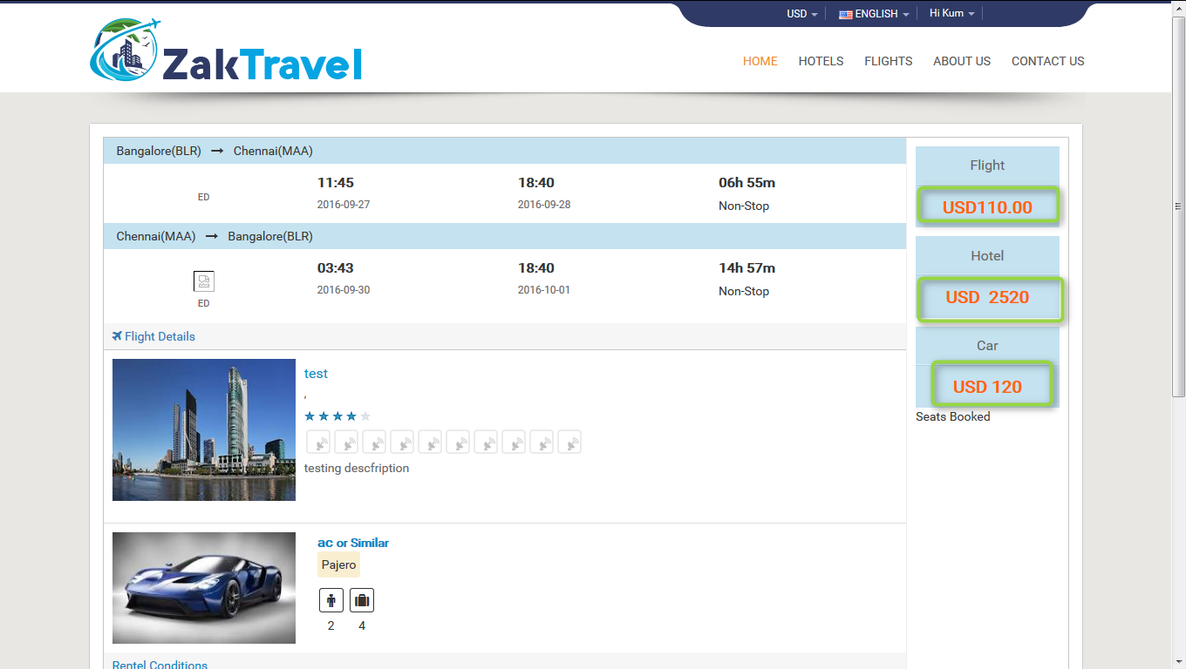

**18.9.9. Activation and Inactivation for markup (B2B):** After click on inactive the markup will not add with the total fare for adding the markup the status should be in active state.

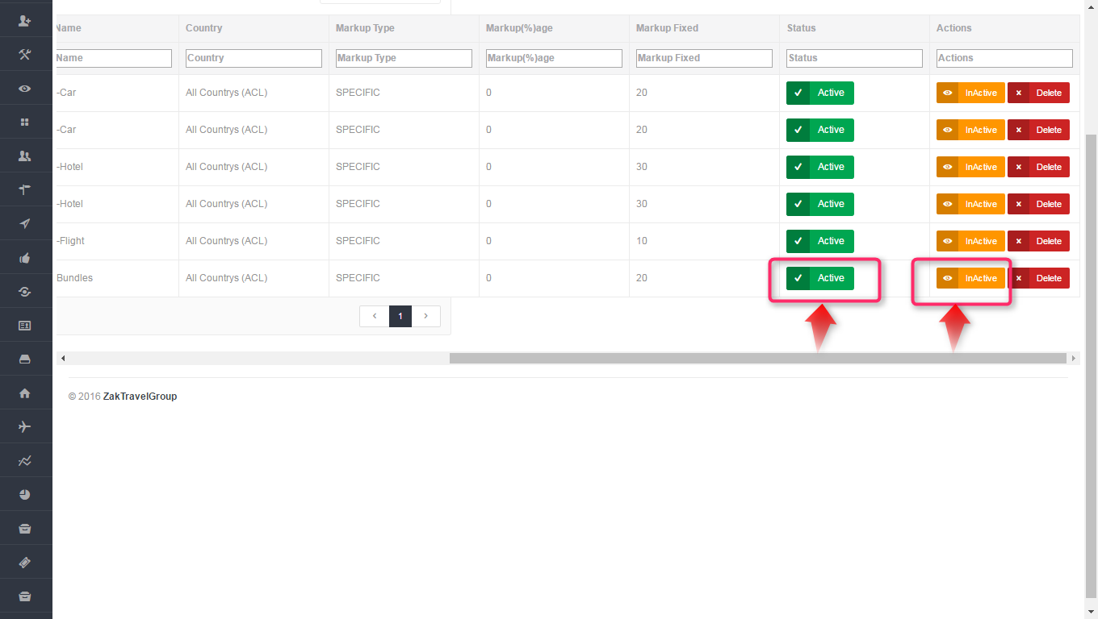

**Active Inactive**

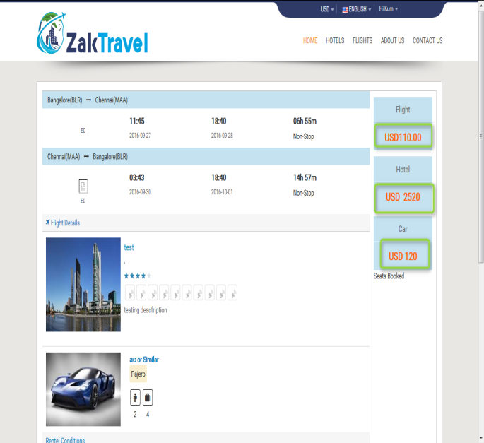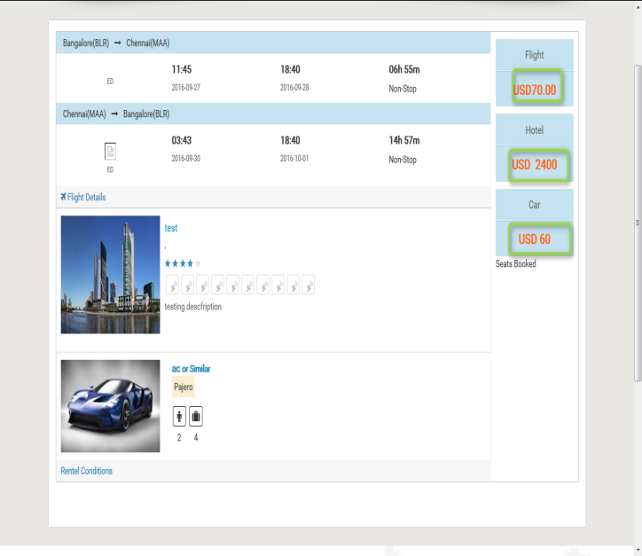

**19. Markup for B2C Bundle deal:**

**19.1. Before adding the Markup for bundle Admin panel (B2C):** Markup will not display in the list before adding.



**19.2. Front End Without adding markup (B2C):** Markup is not added with total fare so whatever the amount is added at the time of rate management that amount will be display only and total fare will display without markup.



**19.3. Steps to add markup for bundle (B2C) Admin panel:** After click on add markup one form will be displayed and enter all the required information like user type, product, API, and markup value type, etc.

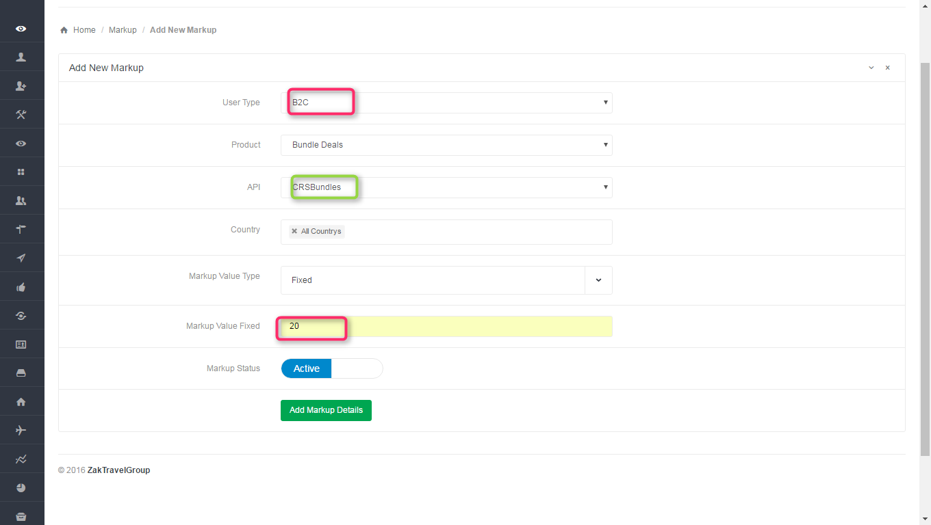

**19.4. Markup list admin panel for B2C**: Here admin add the markup for customer, select the user type as B2C, product as a bundle, API CRS Bundle, country and markup type. After adding the markup will display in the list.

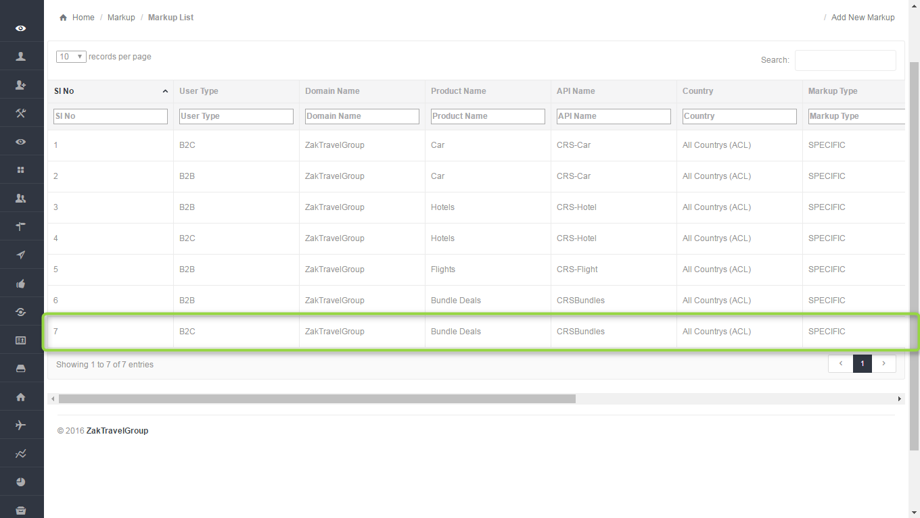

**19.5**. **Front end with Markup (B2C):** Now the added markup will be display with the total fare, for one day the markup added is 20 rupees now and markup will be added according to number of days.



**20.(Flight Hotel) :** Admin can  add bundles they need to provide all the information  like city name, departure and return date , trip type, and all the details about bundle (Flight Hotel) , need to Activate the bundle and the added bundles will display on front end. After deactivating the deals it will not be display on the front end.

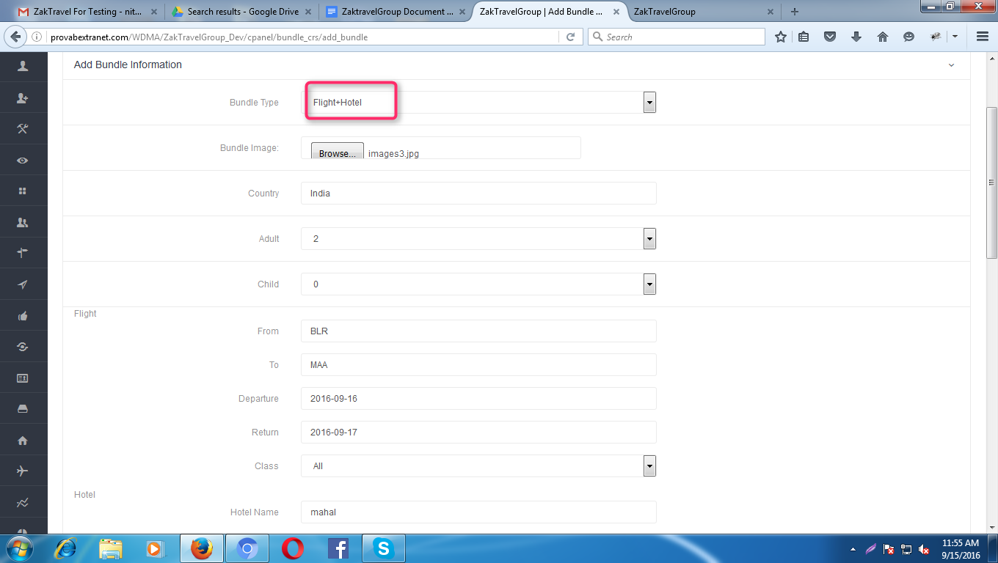

**20.1. Flight segment Management:**  Add the flight segment like flight name, city, and time etc for both onward and return.

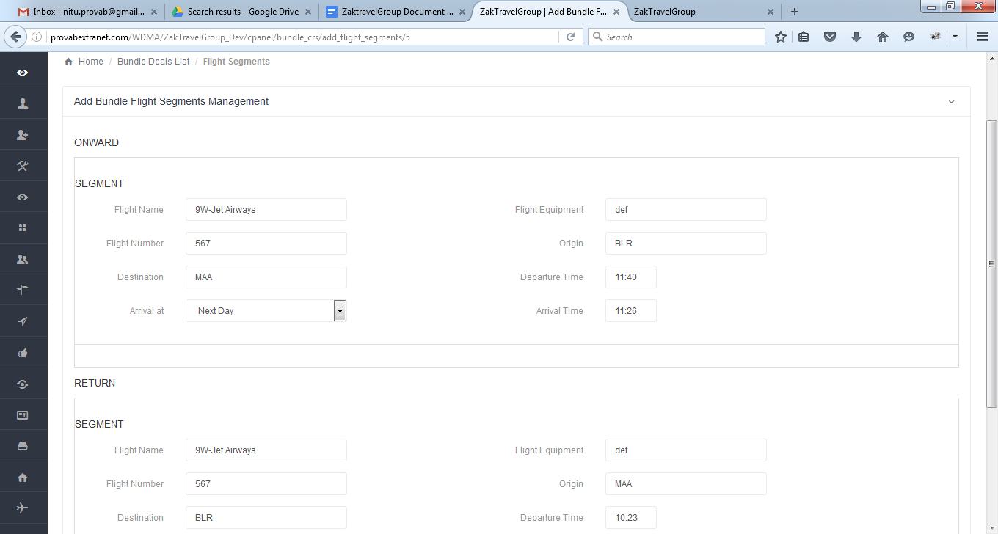

**20.2. Add Bundle Flight Price Management:** In price management need to add the price for adult, Child, infant with tax.

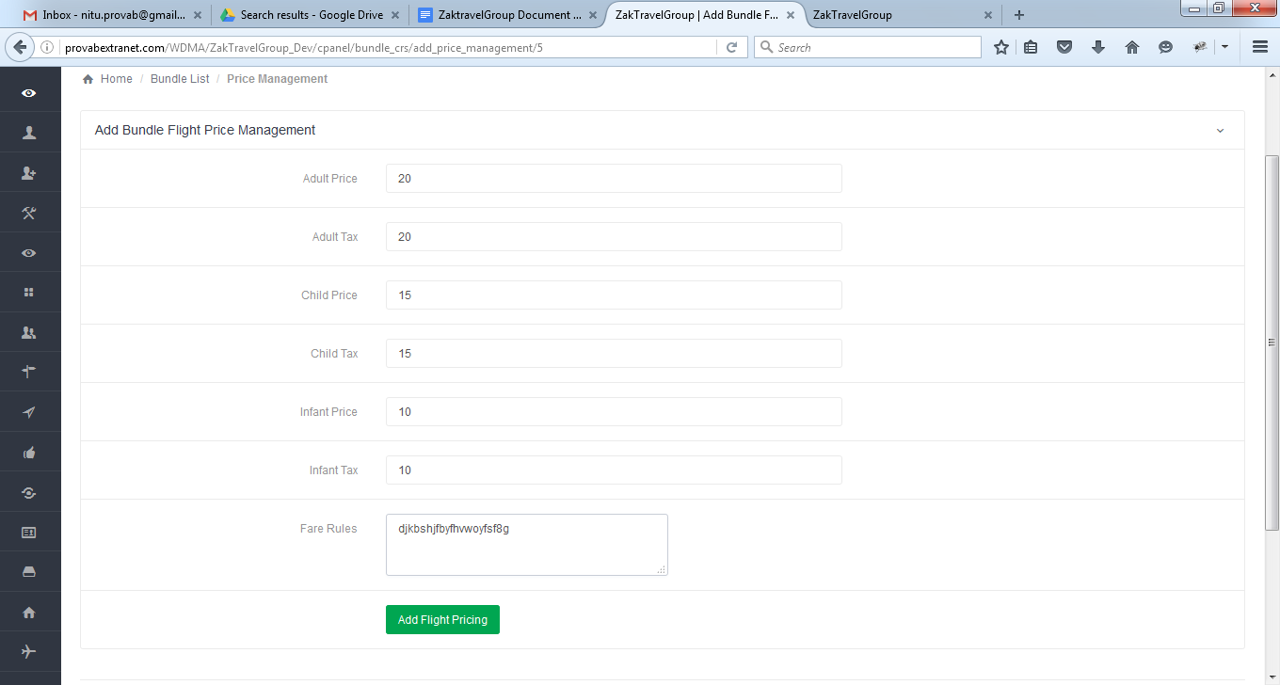

**20.3. Add/View Room type:** Need to add the room type and number of customers.

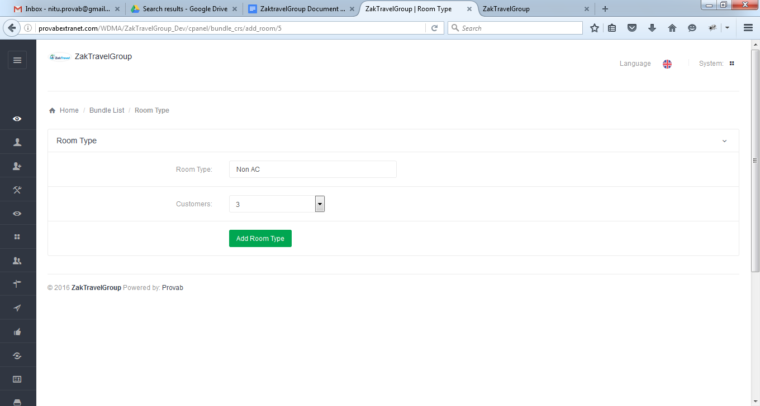

**20.4. Room Management (Add New Room):** In room management add new rooms and hotel price and hotel name will be pre populated because the hotel name is already provided while adding bundle information.

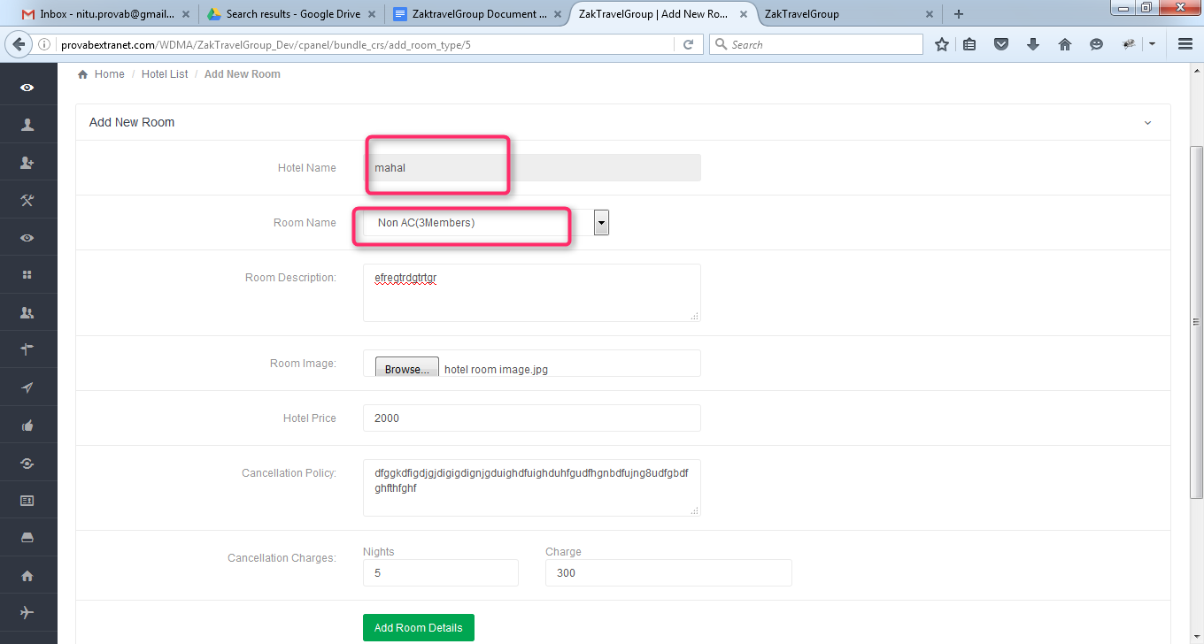

**20.5. Gallery management:** In the gallery management add hotel image and need to upload the same image.

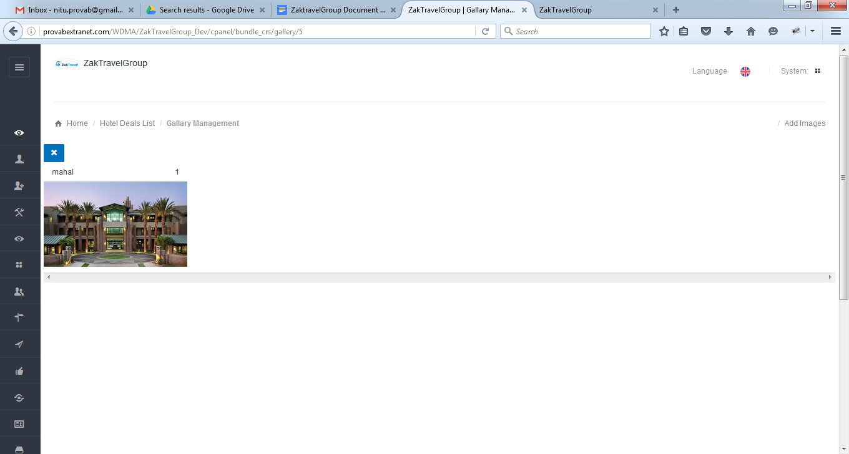

**20.6. Created bundle deals:**

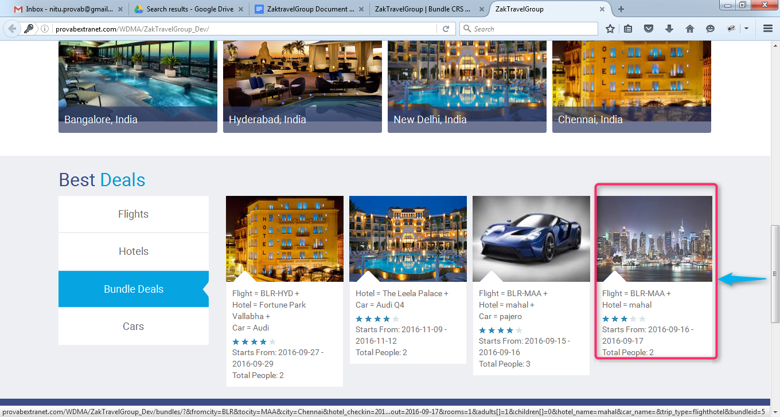

**20.7. Front End:** Created bundle will display on front end from where booking will be done.

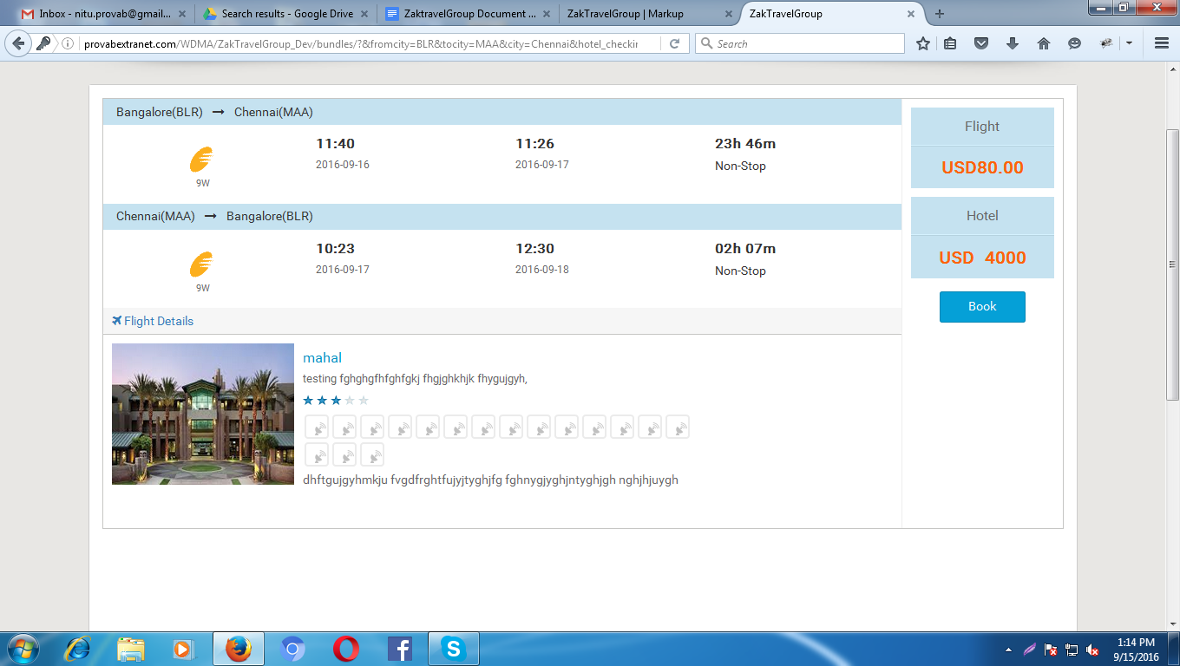

**20.8. Booking Page:** On the booking page all the information which is given by the user and total amount will be present.

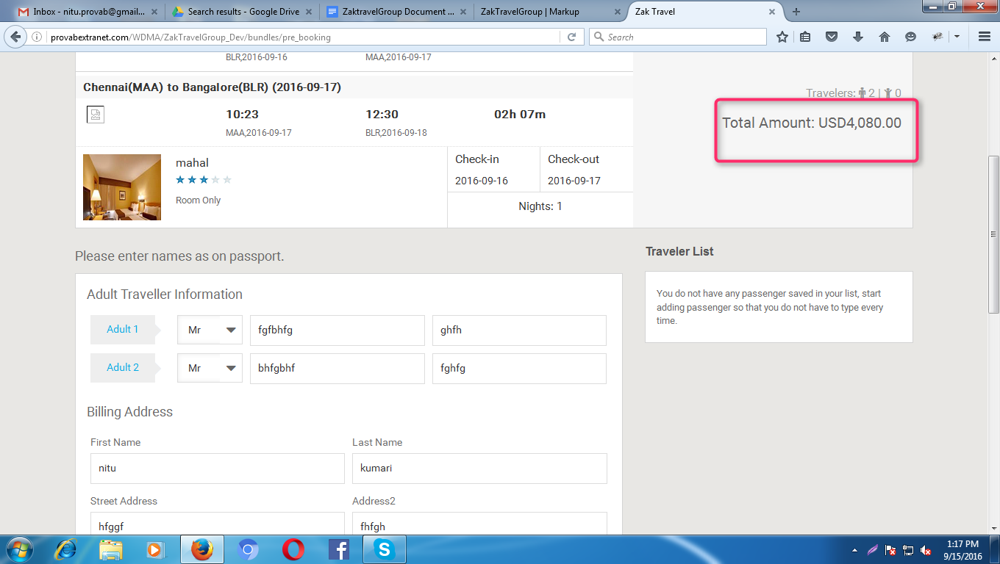

**20.9. Voucher Page:**After providing all the information and click on continue user will get confirmation letter.

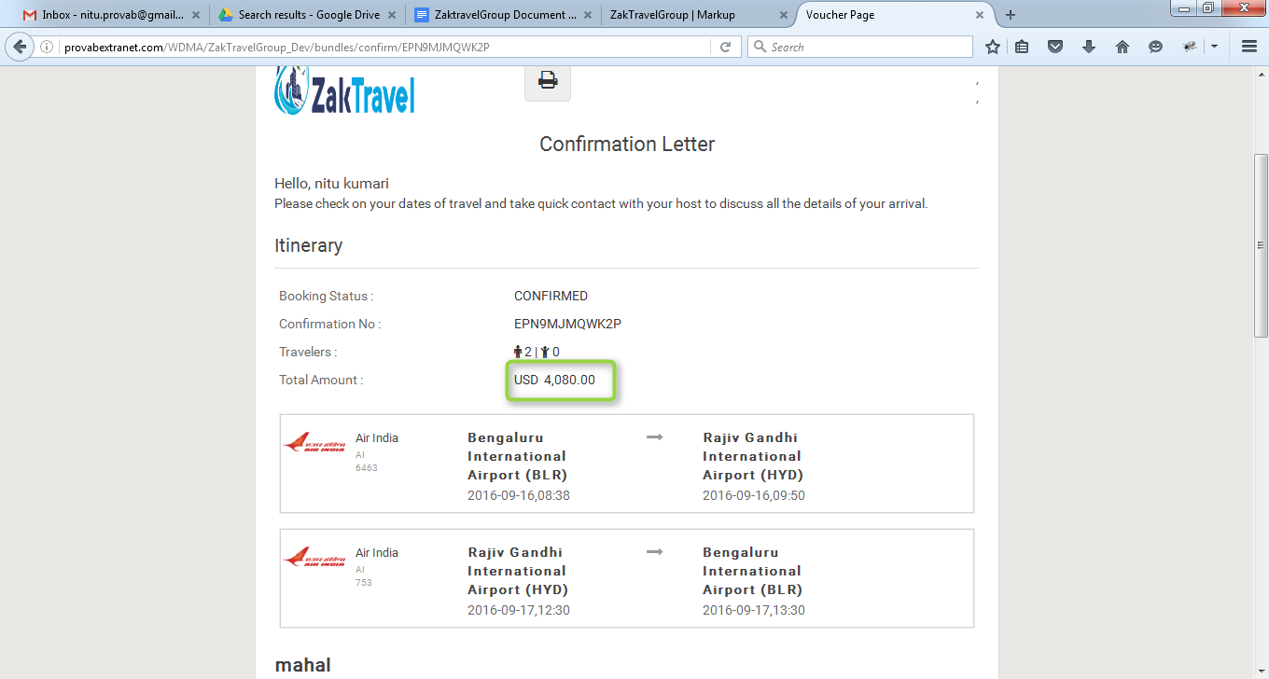

**20.9.1. Without Markup Bundle deals (B2B), (Hotel Flight):** Markup is not added with total fare so whatever the amount is added at the time of rate management that amount will be display only and total fare will display without markup.

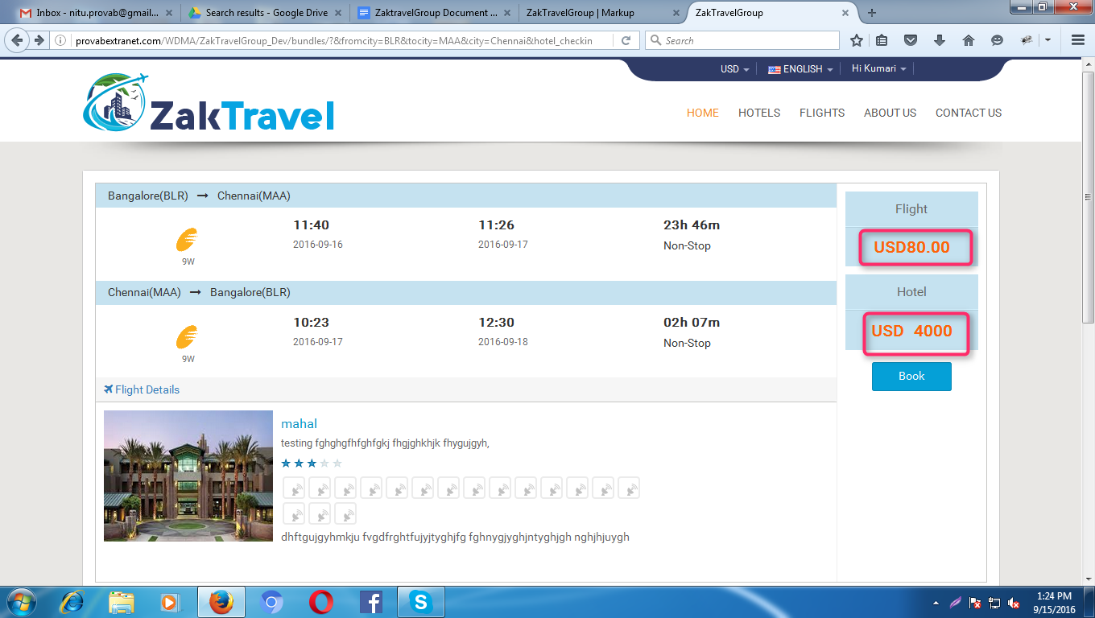

**20.9.2. Add Markup from Admin panel for bundle deals (B2B):** Add the markup from admin panel and the added markup will be displayed in the list.

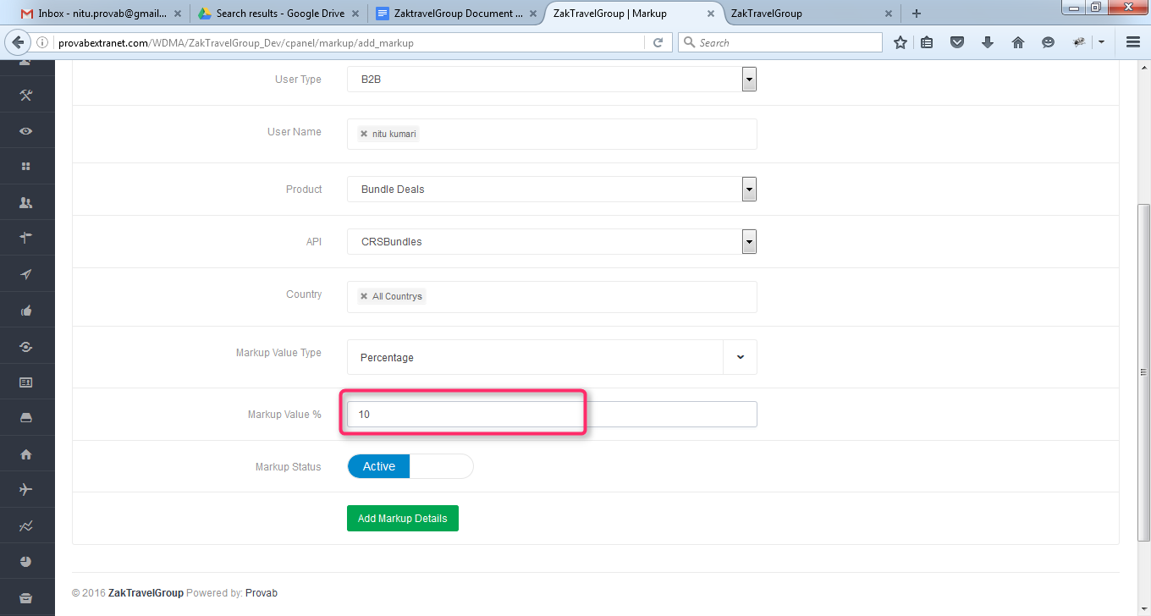

**20.9.3. With Markup Bundle deals (B2B), (Hotel Flight):** Now the added markup will be display with the total fare and markup will be added according to number of days.

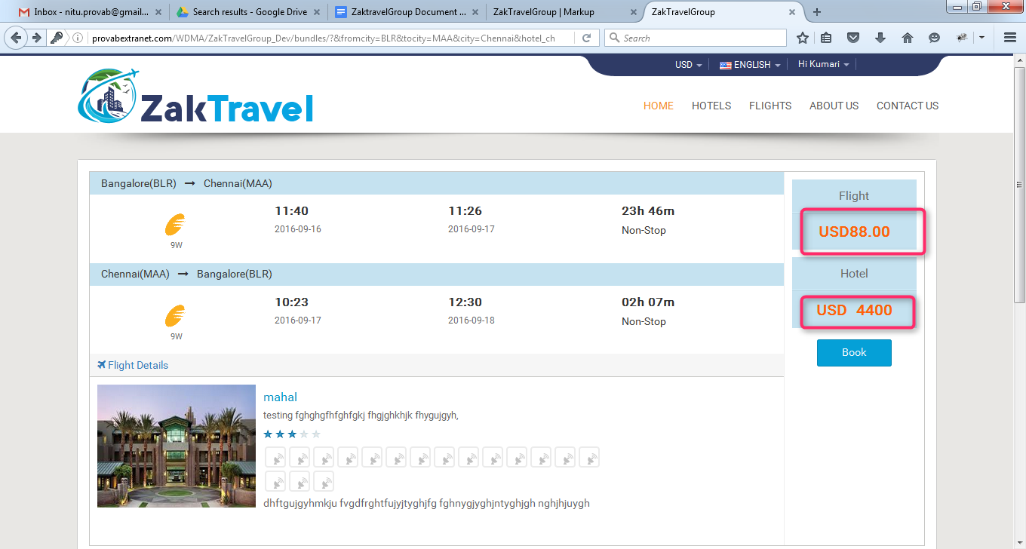

**20.9.4. Without Markup Bundle deals (B2C), (Hotel Flight):** Markup is not added with total fare so whatever the amount is added at the time of rate management that amount will be display only and total fare will display without markup.

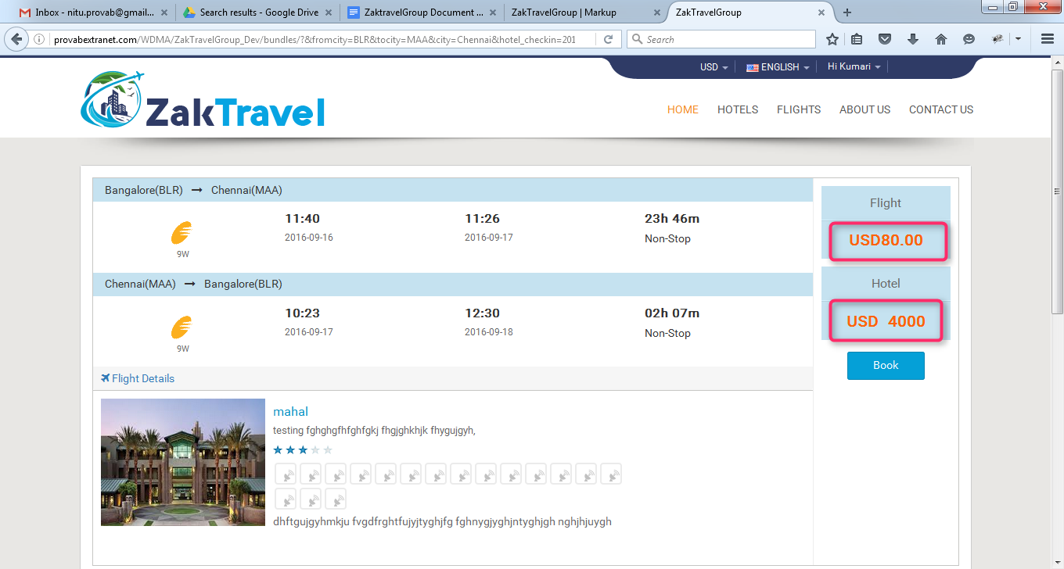

**20.9.5. Add Markup from Admin panel for bundle deals (B2C):** Add the markup from admin panel and the added markup will be displayed in the list.

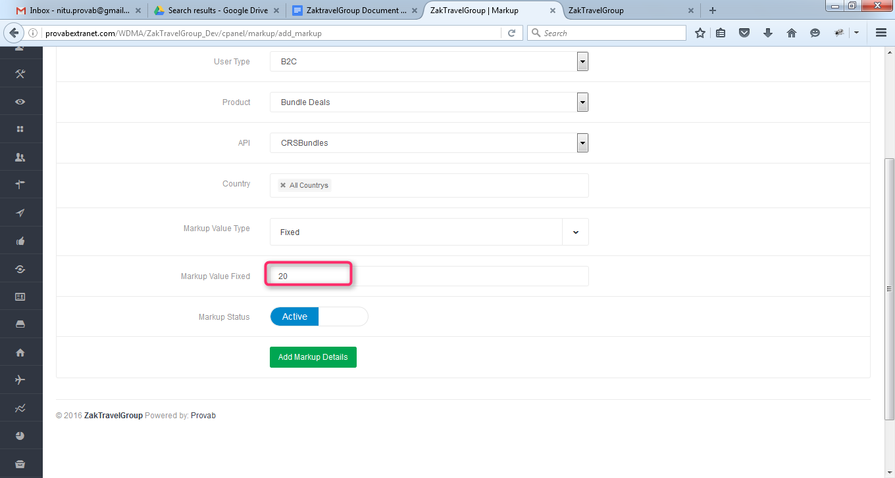

**20.9.6. With Markup Bundle deals (B2C), (Hotel Flight):** Now the added markup will be display with the total fare and markup will be added according to number of days.

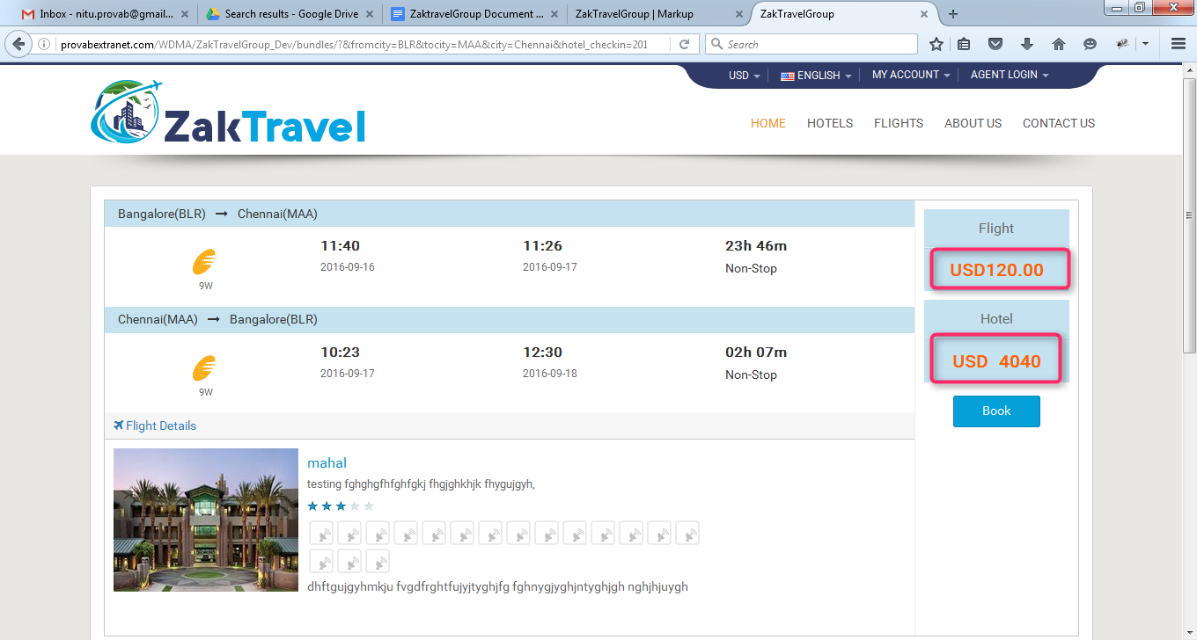

**21.(Hotel Car) :** Admin can  add bundles they need to provide all the information  like city name, departure and return date , trip type, and all the details about bundle (Car Hotel) , need to Activate the bundle and the added bundles will display on front end. After deactivating the deals it will not be display on the front end.

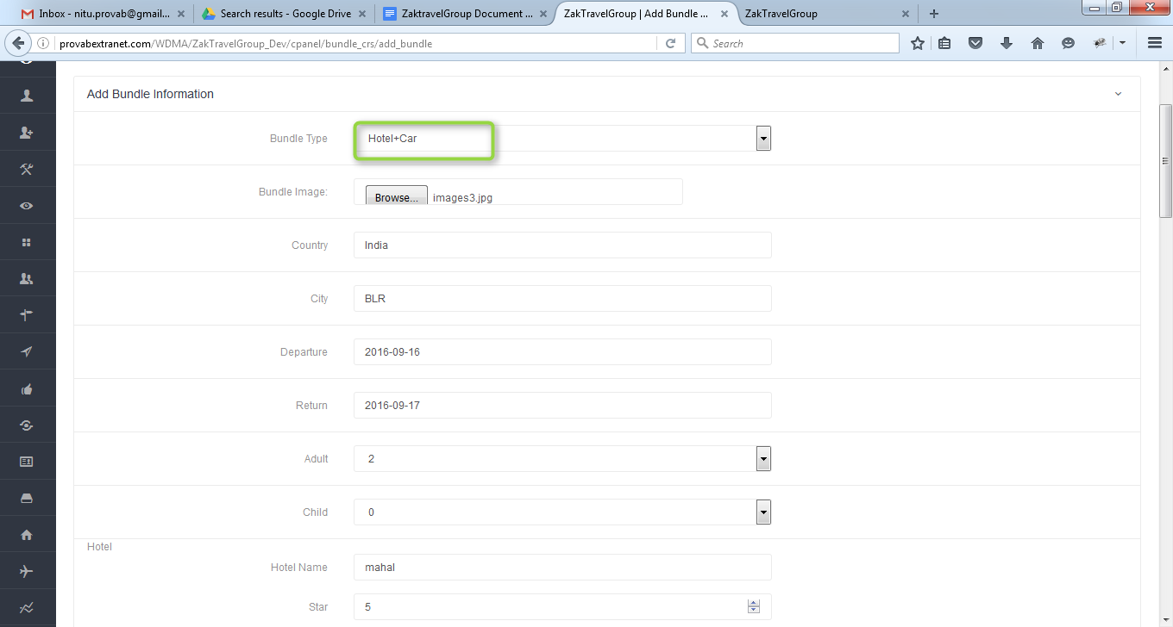

**21.1. Add/View Room type:** Need to add the room type and number of customers.

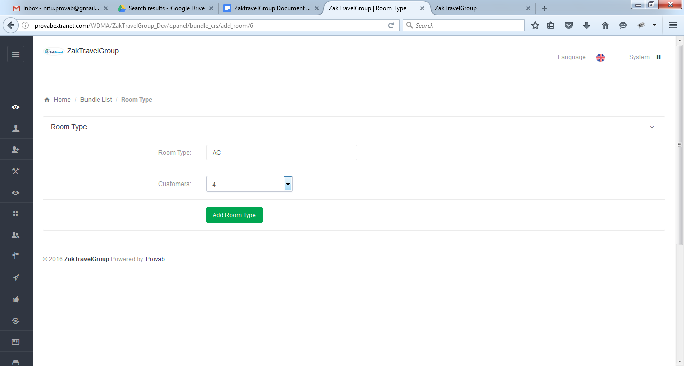

**21.2. Room Management (Add New Room):** In room management add new rooms and hotel price and hotel name will be pre populated because the hotel name is already provided while adding bundle information.

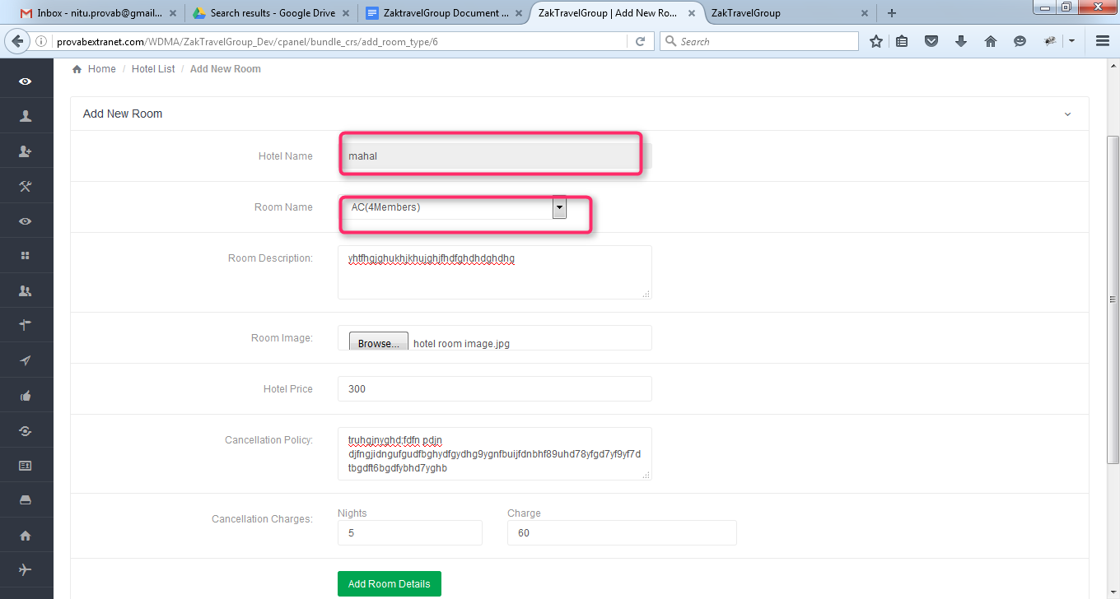

**21.3. Gallery management:** In the gallery management add hotel image and need to upload the same image.

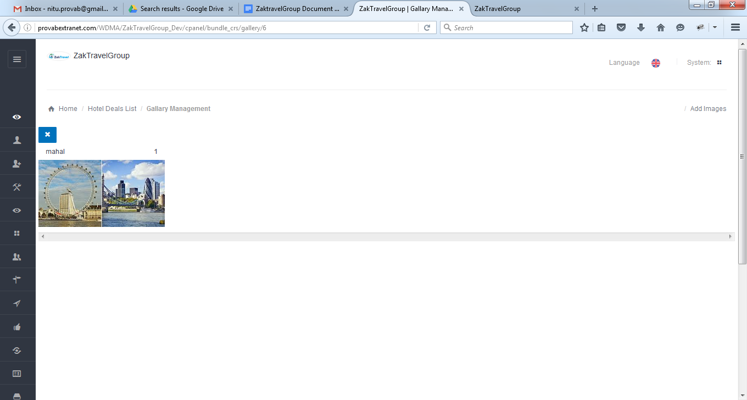

**21.4. Car Pricing:** Here need to add the adult price for the car with Baggage Allowance in kg and how many Suitcases should be carried .And the car will display in the list.

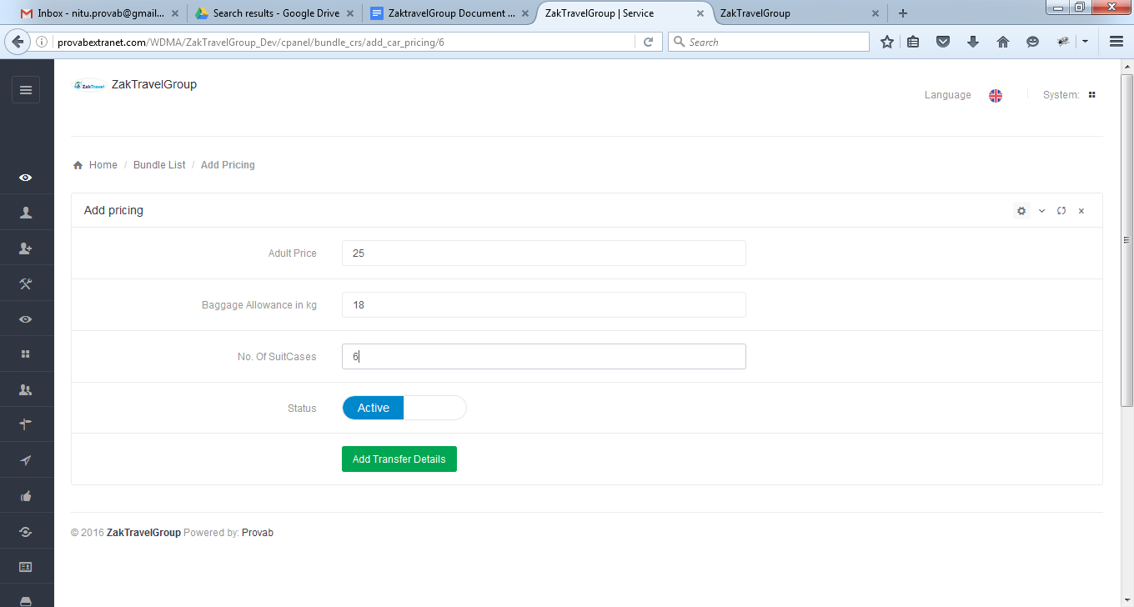

**21.5. Created bundle deals (Hotel Car):**

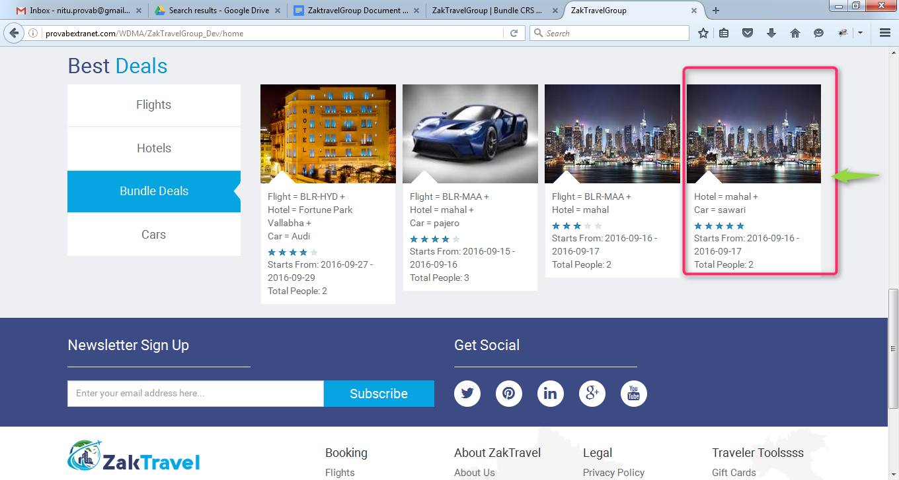

**21.6. Front End:** Created bundle will display on front end from where booking will be done.

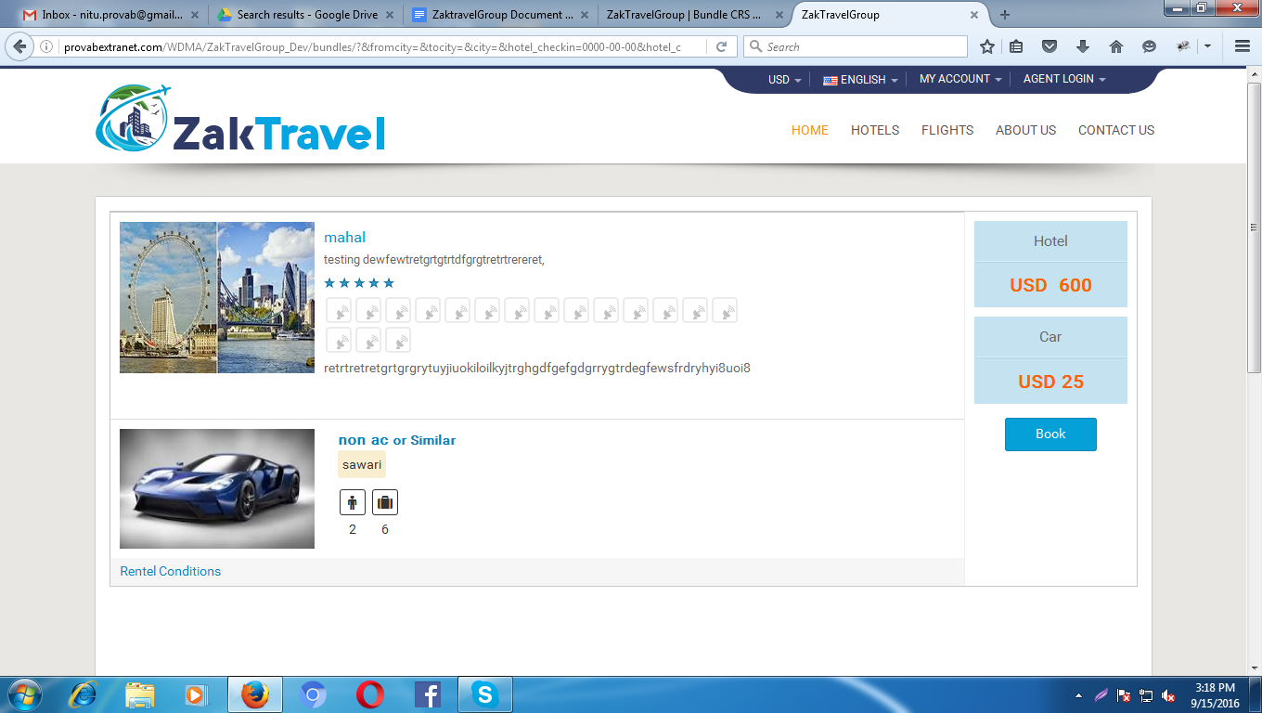

**21.7. Booking Page:** On the booking page all the information which is given by the user and total amount will be present.

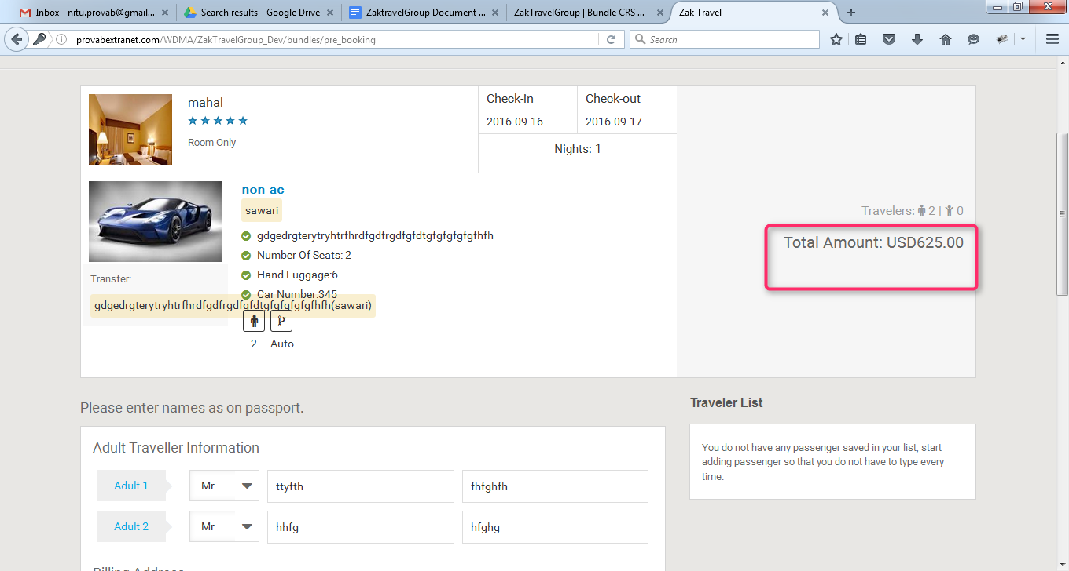

**21.8. Voucher Page:**After providing all the information and click on continue user will get confirmation letter.

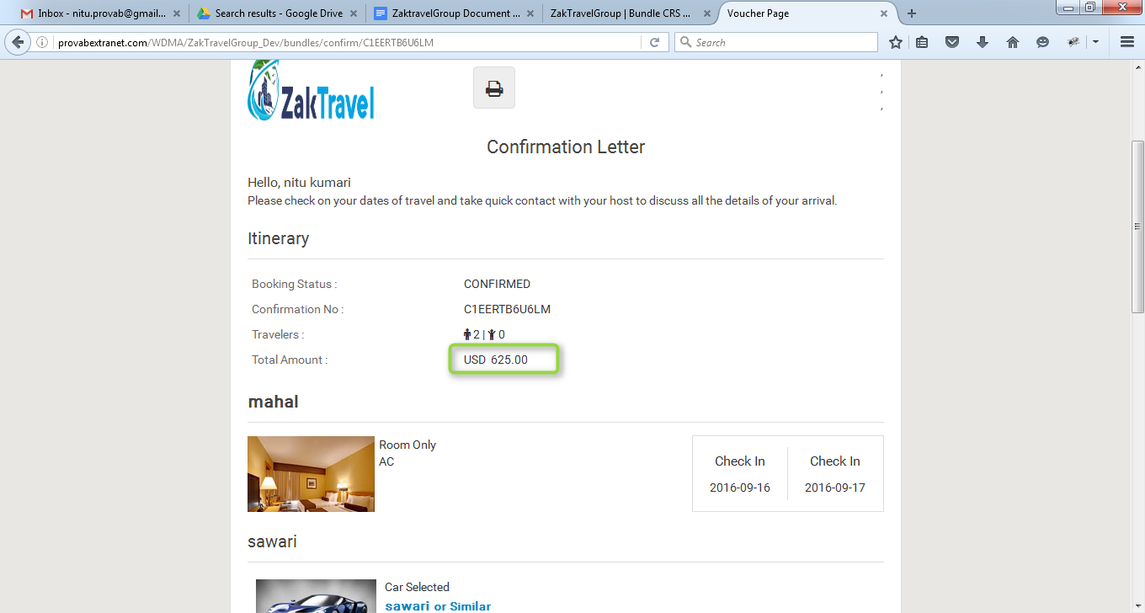

**21.9. Without Markup Bundle deals (B2B), (Hotel Car):** Markup is not added with total fare so whatever the amount is added at the time of rate management that amount will be display only and total fare will display without markup.

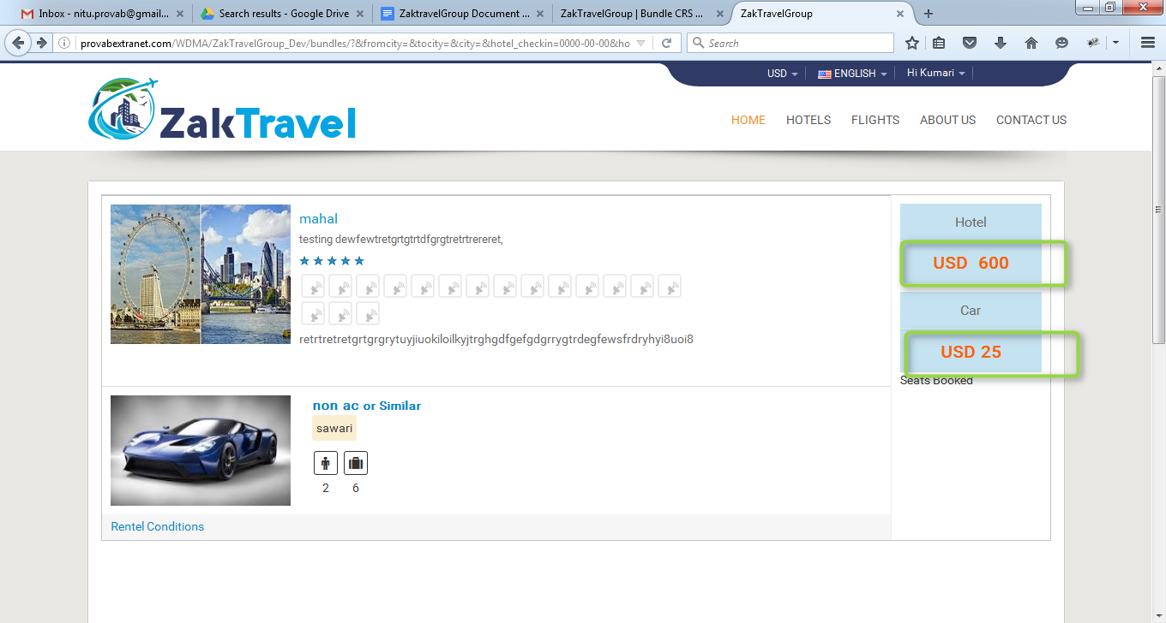

**21.9.1. Add Markup from Admin panel for bundle deals (B2B):** Add the markup from admin panel and the added markup will be displayed in the list.

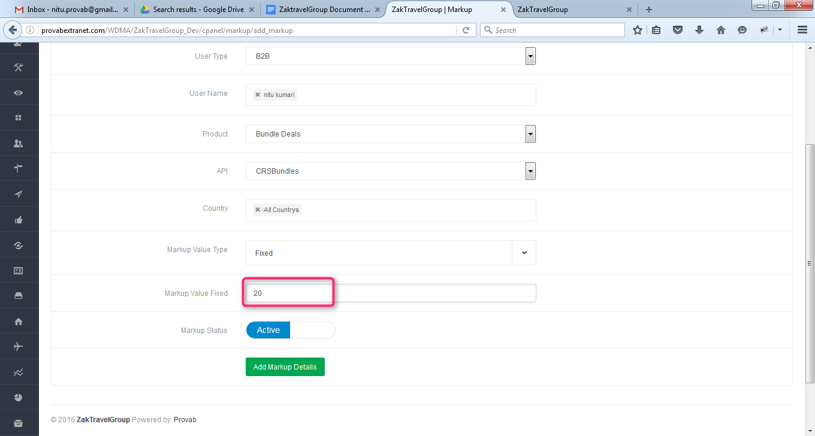

**21.9.2. With Markup Bundle deals (B2B), (Hotel Car):** Now the added markup will be display with the total fare and markup will be added according to number of days.

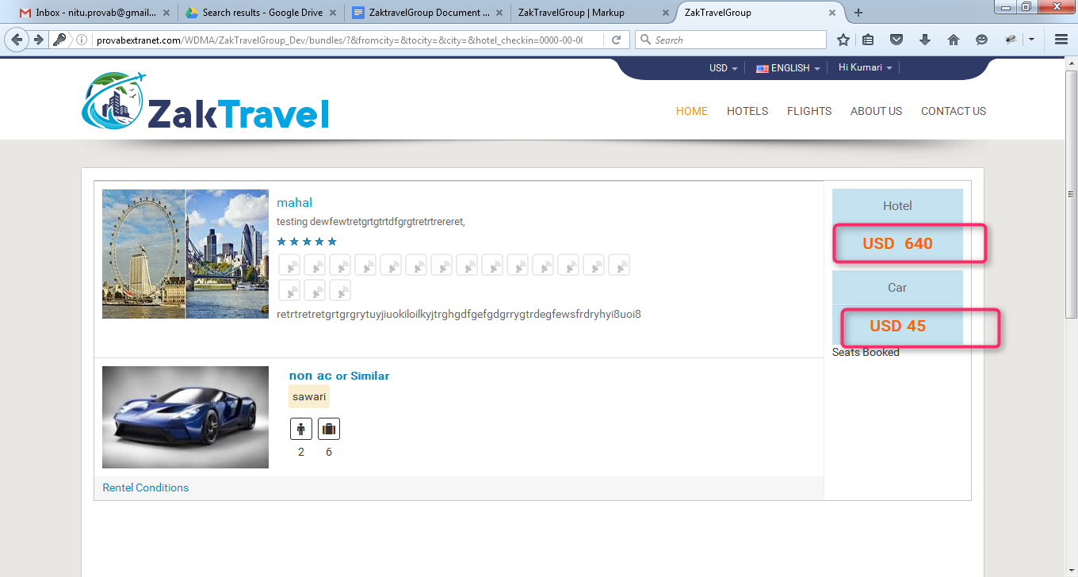

**21.9.3. Without Markup Bundle deals (B2C),(Hotel Car) :** Markup is not added with total fare so whatever the amount is added at the time of rate management that amount will be display only and total fare will display without markup.

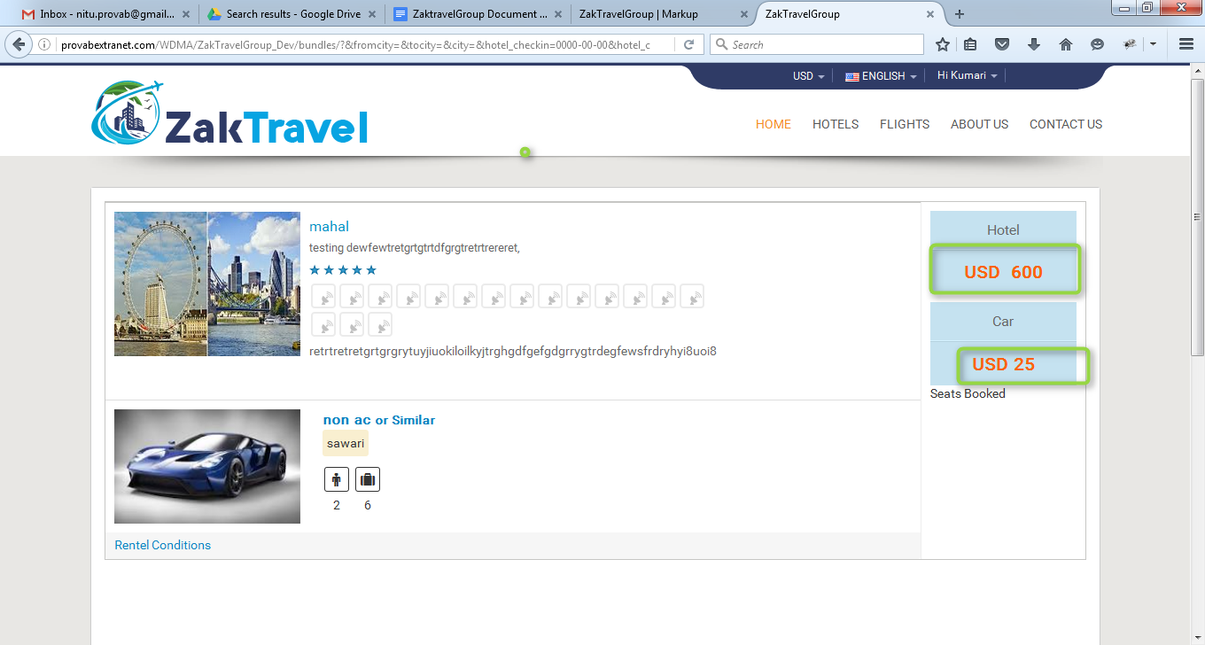

**21.9.4. Add Markup from Admin panel for bundle deals (B2C):** Add the markup from admin panel and the added markup will be displayed in the list.

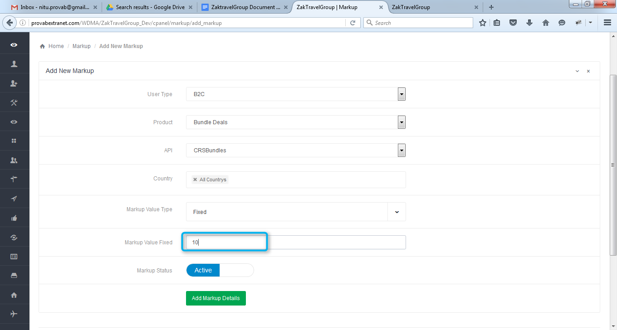

**21.9.5. With Markup Bundle deals (B2C), (Hotel Car):** Now the added markup will be display with the total fare and markup will be added according to number of days.

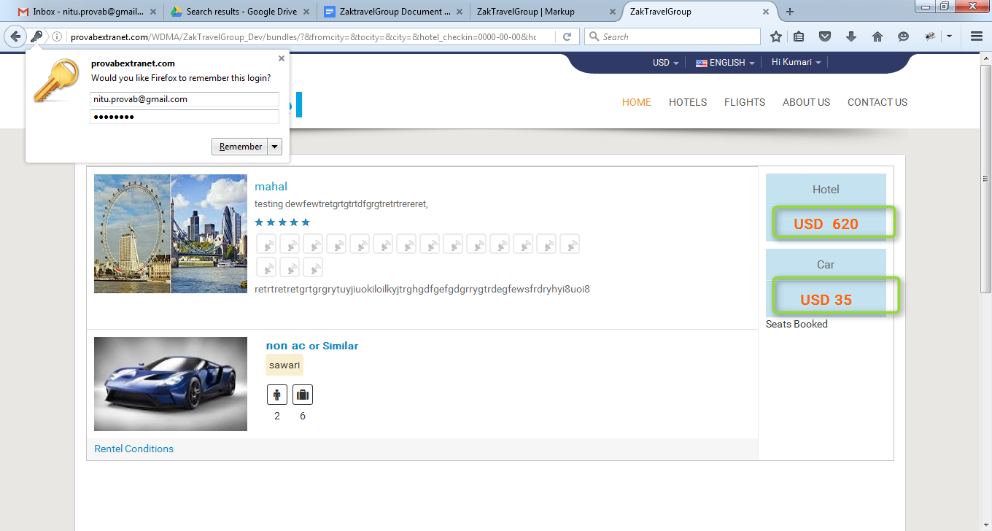

**22. BOOKING REPORTS:** In the booking reportSupplier is able to check how many bookings has been done for (Flight, hotel, Car, bundle) and status, price, profit.

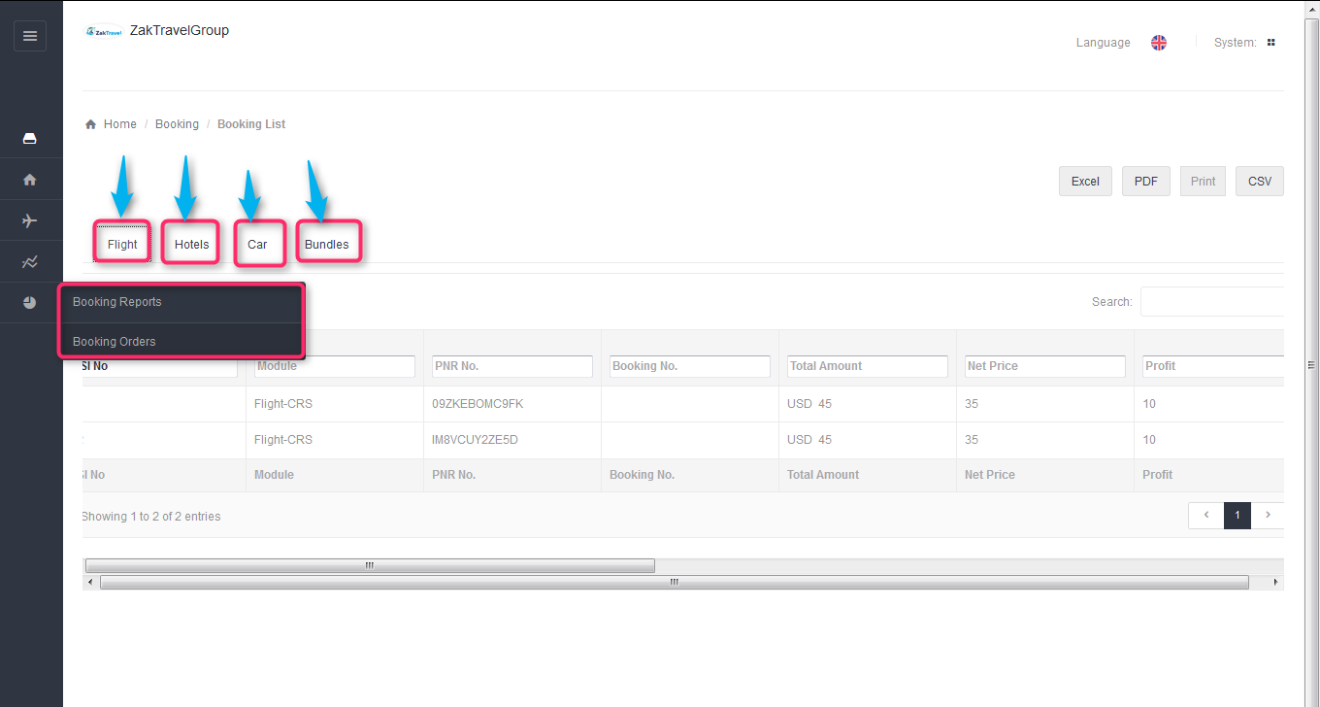

**22.1. Booking list for flight:** After click on the flight tab booked flight list will be displayed.

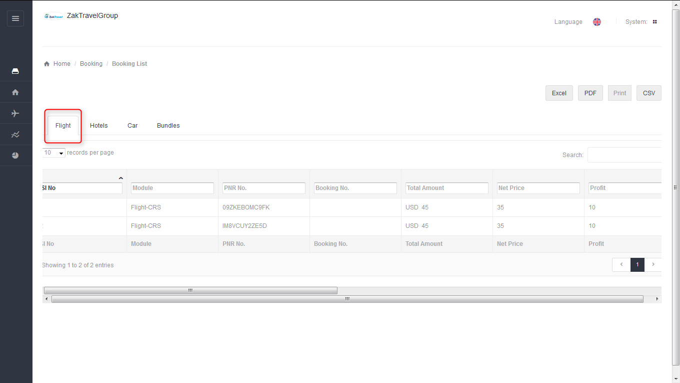

**22.2. Booking list for Hotel:** After click on the hotel tab booked hotel list will be displayed.

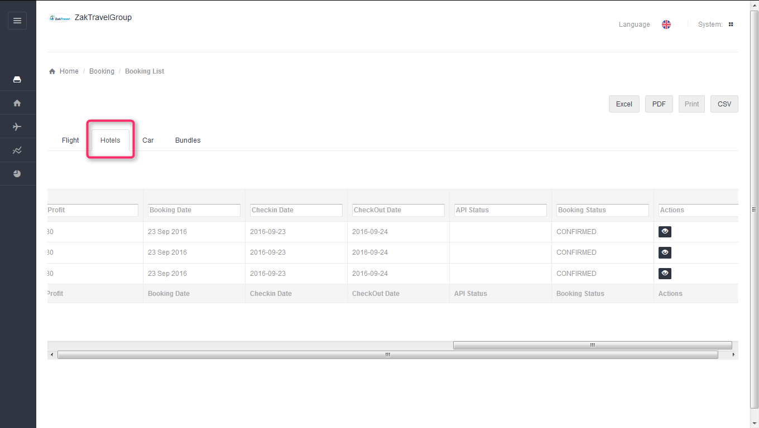

**22.3. Booking list for Car:** After click on the car tab booked car list will be displayed.

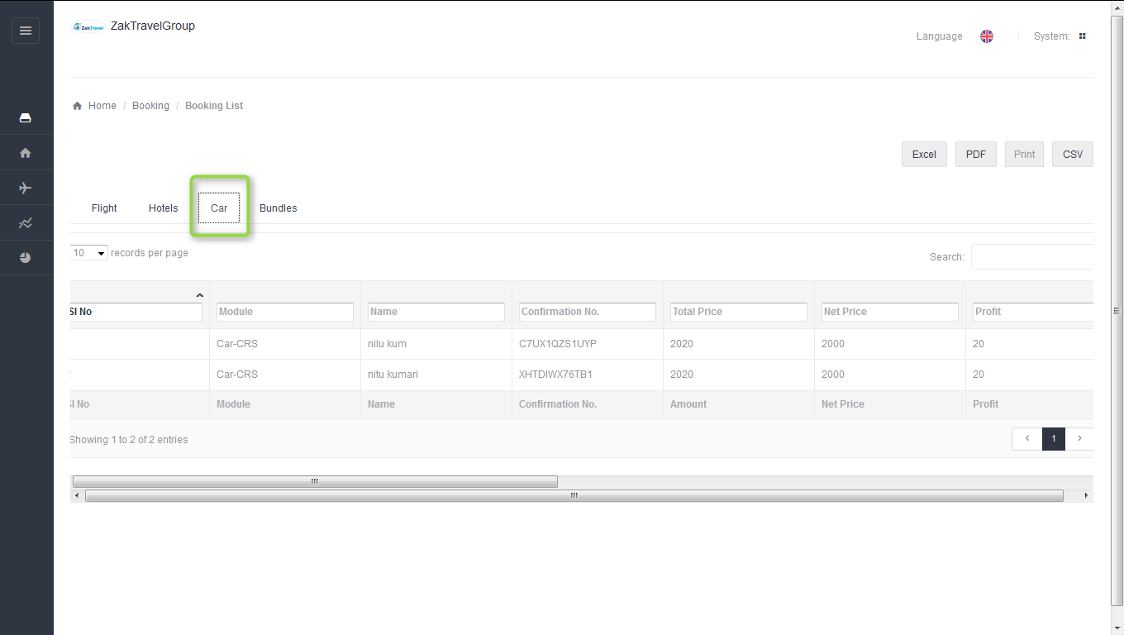

**22.4. Booking list for Bundles:** After click on the bundles tab booked bundle list will be displayed.

